COMMAND

THE PAGE

>_The Ai-Assisted Way To Improve Your Writing, Publish Your Ideas Faster, And Future-Proof Your Creative Career

**By Charlie Deist**

**www.vergili.us**

Copyright © 2023 Charlie Deist

All rights reserved. No part of this book may be reproduced, distributed, or transmitted in any form or by any means, including photocopying, recording, or other electronic or mechanical methods, without the prior written permission of the publisher, except in the case of brief quotations embodied in critical reviews and certain other noncommercial uses permitted by copyright law.

ISBN: 9798870811802

First Edition: December 2023

Printed in the United States of America

Vergilius Publishing

Berkeley, CA

For Sadie

CONTENTS

Index of tools vii

Introduction - THE RISE OF THE CYBORG WRITER 1

**PART 1 - NATURAL LANGUAGE PROGRAMMING**

Chapter 1 - THE HOTTEST NEW PROGRAMMING LANGUAGE 12

Chapter 2 - PROMPT ENGINEERING 101 20

CHAPTER 3 - AI ALCHEMY ………………………………………………….34

**PART 2 - THE AI-POWERED CONTENT ENGINE**

Chapter 4 - The TaaS Revolution 43

Chapter 5 - POLISHING 47

Chapter 6 - SEO Show Notes 54  
 **PART 3 - BECOMING A “CODER”**

Chapter 7 - Of Pyramids & Diamonds 64

Chapter 8 - CAPTURE 71

Chapter 9 - ORGANIZE 75

Chapter 10 - DISTILL 83

Chapter 11 - EXPRESS, PT. 1 90

Chapter 12 - EXPRESS PT. 2 96

Chapter 13 - Refining, Editing, & Finishing Touches 102  
 **PART 4 - CODing YOUR MINIMUM VIABLE MASTERPIECE**

Chapter 14 - Capture and Organize 113

Chapter 15 - Distill & Express 123

Conclusion - Why Write a Book? 128

About the Author 133

Index of tools

**ChatGPT –** AI language model developed by OpenAI that can generate human-like text based on the prompts it receives.

**Claude** – An AI language model developed by Anthropic, designed to interact in a conversational manner and assist with a range of tasks including writing and creative brainstorming.

**Notion** – A customizable all-in-one workspace for note-taking, knowledge and data management, project management, and collaboration.

**Grammarly –** A writing assistant offering spelling and grammar suggestions (including full AI rewrites) that integrates with any app where you type.

**Otter.ai** – A transcription service that uses AI to convert speech to text in real time.

**Descript** – A multimedia editing tool that allows users to edit audio and video by editing the text transcript of the recording.

**Riverside.fm** – A platform forrecording podcasts and videos with high-quality audio and video.

**Substack** – A platform that allows writers and creators to publish and monetize newsletters and podcasts through paid subscriptions.

**Save to Notion –** A browser extension for capturing external sources into your Notion content database with just a few clicks.

INTRODUCTION

THE RISE OF THE CYBORG WRITER

“AI won’t take your job. It’s somebody using AI that will take your job.”

– Richard Baldwin

Garry Kasparov’s hand hovered, then committed to his move: Knight to A5.

In chess, it’s often said that “a knight on the rim is grim,” and as the grandmaster leaned back in his chair, the grim reality of his position against IBM’s “Deep Blue” computer started to crystallize. After alternating wins in the first two games of the six-game match, the next three games had all ended in draws. It was down to the decisive final game. Commentators would later assess this ill-fated move as the beginning of the end for Kasparov – and a harbinger of the dawn of AI supremacy. The machine’s cold, calculating moves had squeezed Kasparov’s options – never making a flashy play but always increasing its advantage. Under mounting pressure, Kasparov saw that he had been outmaneuvered. Rather than allowing himself to be check-mated, he resigned the match.

This 1997 match between Kasparov and Deep Blue marked a historic defeat of the world’s best human chess player by the industry’s most powerful machine. Although it had been close until this final game, Deep Blue’s victory was clear-cut. From that point on, the odds would only keep tilting in the computer’s favor. Today, Magnus Carlsen, who is recognized as the best player in the world, enjoys an “Elo rating” of 2882, while computers rank well above 3400.

But a funny thing happened on the way to the AI apocalypse.

First of all, humans kept on playing chess – robot superiority be damned. Second, the machine did not remain invincible. It turned out that the combination of a human being **and** a computer was more powerful than the computer alone. Hence, “Cyborg Chess,” where humans and computers work together, is a sport unto itself with its own reigning champions. In this game, creativity and cooperation with computers are rewarded over sheer speed or brainpower alone. And here’s the thing: an *average* chess player with *above-average* skill at wielding the computer’s help can defeat a grandmaster with or without the computer.

In 2005, Steven Cramton and Zackary Stephen, club players with ratings of 1685 and 1398, respectively, outwitted three grandmasters in the computer-assisted PAL/CSS Freestyle Chess Tournament. Imagine a pair of junior varsity players outmaneuvering Shaquille O’Neal, Michael Jordan, and Kobe Bryant in a 2-on-3 basketball game. Though less technically skilled, perhaps, their cyborg edge delivered the win.

Fast forward to November 30, 2022. A superior level of artificial intelligence exploded onto the scene in the form of a chatbot called ChatGPT. Within weeks, millions of mere mortals created free ChatGPT accounts. Its easy-to-use interface (a simple chat window) returned human-sounding answers to questions. Tech geeks and non-techies alike began tapping into AI’s deep knowledge, learning how to prompt or train AI for even better results. The growth of this field has no end in sight, with recent upgrades of “multi-modal” capabilities that can turn speech to text, text to speech, text to image, and even text to video. This new frontier has many clamoring for regulation – fearing widespread economic displacement – and more attention is being given to the risks of artificial intelligence. Even if you haven’t jumped on the bandwagon, you’ve likely heard AI lingo like **large language models**, **generative pre-trained transformers** (GPT), and Silicon Valley’s hottest new job title: prompt engineer. You will gain deep familiarity with terminology in this book, but most regular folks don’t need an in-depth technical understanding of the “inner workings.”

However, now that this technology is in the mainstream, no one should ignore the talk of the economic transformation taking place. Fears are being stoked again of the Great Robot Uprising that will replace humans for good. This book will help bring comfort, especially to writers, and calm the storm for other professions … despite the headlines.

“[300 million jobs could be affected by latest wave of AI](https://www.cnn.com/2023/03/29/tech/chatgpt-ai-automation-jobs-impact-intl-hnk/index.html#:~:text=300%20million%20jobs%20could%20be%20affected%20by,of%20AI%2C%20says%20Goldman%20Sachs&text=As%20many%20as%20300%20million,according%20to%20Goldman%20Sachs%20economists),” read one CNN headline.

TechRadar reported “[Many workers are faking knowledge of AI to make sure they aren’t left behind](https://www.techradar.com/pro/many-workers-are-faking-knowledge-of-ai-to-make-sure-they-arent-left-behind).”

A comic strip by editorial cartoonist Tom Tomorrow encapsulated the prevailing angst among creative workers. In the cartoon, a smiling robot tells a futuristic-looking penguin character that “soon there will be no need for human writers and artists at all!”

“According to my algorithm,” the robot declares, “everybody wins!”

But the penguin objects:

“What if… writers and artists ***want*** to do their work? And maybe even earn a living?”

The robot assures the penguin that perhaps obsolete writers and artists would “find new forms of creativity… leading them to *unanticipated heights of personal expression*!”

At first blush, this reply sounds hollow. Indeed, the blend of clichés spoken with unwarranted confidence can only be described as “ChatGPT-esque.” But maybe this cartoon robot knows something we don’t. Maybe his reply hints at a better path forward than Kasparov’s sullen resignation.

# Winners and Losers in the AI Age

During the industrialization of England in the 1800s, the arrival of the mechanical loom gave rise to a group of anti-industrialization zealots. The “Luddites,” as they were known, made a sport out of smashing the new warehouse-sized weaving machines. They feared that the new textile factories would eliminate good old-fashioned high-paying weaving jobs. And they weren’t wrong*.* How many professional weavers do you know today?

Most economists argue that the long-term result of the Industrial Revolution was a net improvement in welfare for all. After all, fewer people doing the same work with machines means higher overall productivity. And higher productivity translates into higher wages. Sure, many workers are displaced in the short run, but in time, the unemployed get absorbed into other sectors. In theory, machines liberate people to focus on more meaningful work. But economists also acknowledge that new technology breeds winners and losers. The concept of **skill-biased technical change** holds that technology tends to empower those with *complementary* knowledge and capabilities the most. It’s the same lesson we can draw from cyborg chess: the machine is powerful, but the real power comes from the combination of humans *and* machines.

The entire “knowledge economy” has been built around the symbiosis between educated workers and computers that augment the ability to put their knowledge to use. AI accelerates this phenomenon.

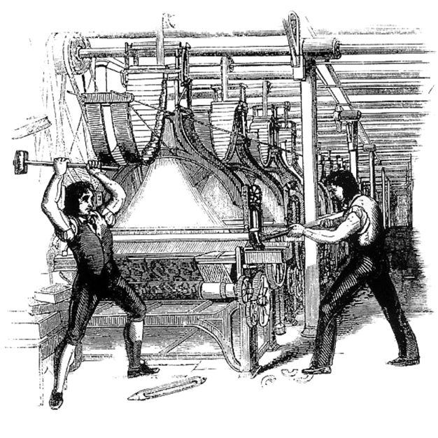

The Frame-Breaking Act 1812 made smashing looms punishable by death in the United Kingdom. (Image: Wikimedia Commons)

Companies like IKEA, for example, are scrambling to retrain the vast numbers of customer support workers who have been replaced by its automated Chatbot, Billie. Billie can resolve thousands of customer queries without fatigue or frustration, including the frequently asked, “How do I assemble the **FLÜRGENSHLURG**?” (a dilemma often faced by customers when those “spare screws” turn out to be the lynchpins of their entire sofa).

Unless you work in customer support, your job may still be safe – for now. However, you are at risk of being outcompeted long-term by those who have a better grasp of these tools than you. The opening quote from economics professor and author Richard Baldwin hints at our direction: AI might not take your job, but someone *using* AI will. In his books, Baldwin documents a “globotics upheaval” triggered by advances in robotics, AI/automation, and telemigration. While lower-skilled labor has borne the brunt of globalization and automation through the 2020s, the latest round of AI innovation is coming for higher-skilled workers and even creative professionals. Your CPA is at a higher risk than your gardener of losing his job in the coming revolution – not to AI itself but to a super-accountant leveraging AI in his practice.

In the years ahead, the gap will widen between the skilled and the unskilled – the AI-assisted, and the unassisted. You stand to win or lose to the extent that you learn to work ***with*** AI. Even the plumbing contractor who learns to use AI to communicate better with his clients will gain an advantage over his neo-Luddite competitors.

# ****AskAI → Improve Writing****

In the first months after the November 2022 release of ChatGPT, I briefly played around with the chatbot. I found the experience amusing, asking questions like “What should I make for breakfast based on the four ingredients in my fridge?” But like many others, my overriding thought was, “Okay, ChatGPT is neat – but *how does AI help me do my job better*?”

My “aha” moment with AI came some three months later, with the release of a new suite of AI tools embedded right inside the main software platform I use in my work as a writer and radio/podcast producer. This platform, Notion, per their website, “is a single space where you can think, write, and plan. Capture thoughts, manage projects, or even run an entire company – and do it exactly the way you want.” Notion serves as an all-in-one workspace – combining the best elements of word processing, spreadsheets/databases, and project management software. For me, and millions of users, it functions as something of a “second brain,” housing everything from notes-to-self and project dashboards to calendars, Kanban boards, to-do lists, and more. I am a huge advocate.

My primary uses for Notion include managing the content calendars for several podcasts I produce and preparing promotional assets like show notes and edited transcripts for publication after the hosts record their interviews. Outside of Notion, I first convert audio recordings from podcasts and radio shows into text using [Otter.ai](http://otter.ai/) and Descript (more about those two tools later). Once the audio content is converted to rough text, I load the written version into Notion’s workspace.

Refining AI-generated transcripts can be time-consuming, but over the years, I honed the process in Notion’s specialized pages and established my own standard operating procedures. With each keystroke, I smooth out the language, ensuring speakers sound articulate without changing their intended meaning. These improved transcripts often became part of anthologies as I began working with publishers to create books from the rich material of podcasts and radio shows. Notion (and a few other side tools) provided all that I needed to keep organized, productive, and creative. So when Notion released the beta version of its new built-in AI functions, I was among the first to try it out with my existing workflows.

I highlighted a block of my rough, unedited transcript within Notion as if I were going to reformat the text in bold or italics. But in addition to the usual formatting options in the menu bar, Notion presented me with a shiny *new* button labeled ✨**AskAI**.

Unlike OpenAI’s world-famous ChatGPT, Notion’s new AI function didn’t present me with an empty chat box but with a set of *commands* – the ability to ask AI to *do something* with my own content. The first preset option under **AskAI** was **Improve writing**, next to an icon of a magic wand.

So, I scrolled down, hit **Improve writing**, and waited for the response.

“AI is writing…”

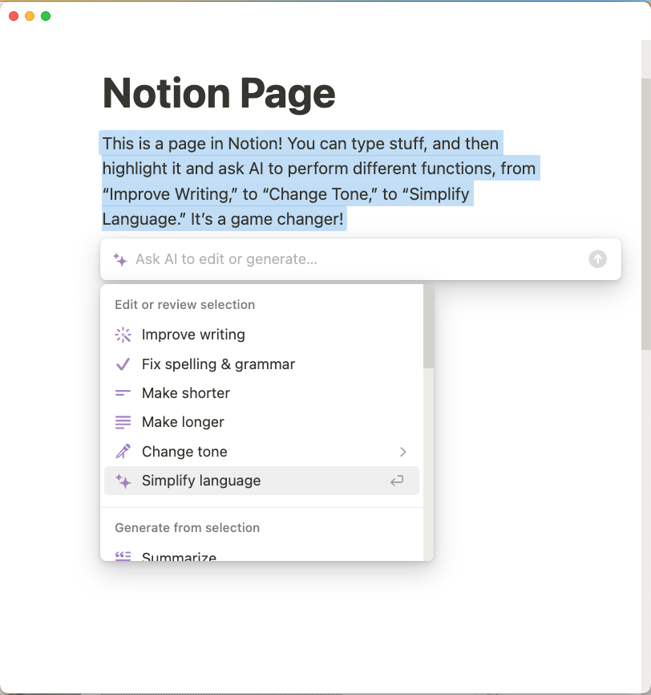

Now, it was time for the big reveal – to see how AI would perform this task. In seconds, NotionAI cleaned up and improved the writing of an entire block of rough transcript. Any writer worth their salt can recognize good writing, whether crafted by humans or machines. And NotionAI’s “improved writing” was *good*. The output was concise and logical, yet the speakers’ personalities were preserved.

I suspect that many of you reading this might surmise that your job is safe from AI replacement because of the creative nature of your work.

“Sure,” you think, “AI might *someday* replace my job – but that someday is a long time off.”

But here, Notion’s AI was doing the core of *my* job – enhancing rough transcripts – and doing it better. My previous editing process involving hundreds of decisions had been simplified to just three clicks:

Highlight text → ✨**AskAI** → **Improve writing**.

In just a few more minutes and a dozen more commands, NotionAI helped me polish the full podcast transcript, saving me hours of work.

After seeing NotionAI do my job better than me, I felt a budding sympathy with the penguin from Tom Tomorrow’s cartoon. His concerns were *my* concerns. His struggle was *my* struggle. What if I *wanted* to keep doing my job the old-fashioned way? My attitude towards AI shifted from skepticism into a mix of curiosity and apprehension. If AI could transform transcripts with such ease, what purpose would I serve in the process?

Was I about to become a victim of the “great replacement” of workers with machines?

Or, perhaps, would enlisting AI free me from lower-level editing tasks? Would it allow me to focus on higher-order tasks, such as repurposing transcripts into valuable content like innovative articles and books?

Instead of resisting technological progress like the Luddites and smashing my computer, I could choose to master the art of AI-assisted writing. I could learn everything about the emerging craft called “prompt engineering” or “AI whispering” to coax my desired outputs from AI.

I had a new goal: I was going to surf the AI wave rather than drown in its churn.

## After the Peak of Inflated Expectations

The Gartner “hype cycle” is a graphical presentation that represents the maturity, adoption, and social application of new technology. Regardless of the innovation in question, the public’s excitement follows a well-established roller-coaster trajectory. My own experience with AI has followed a similar path:

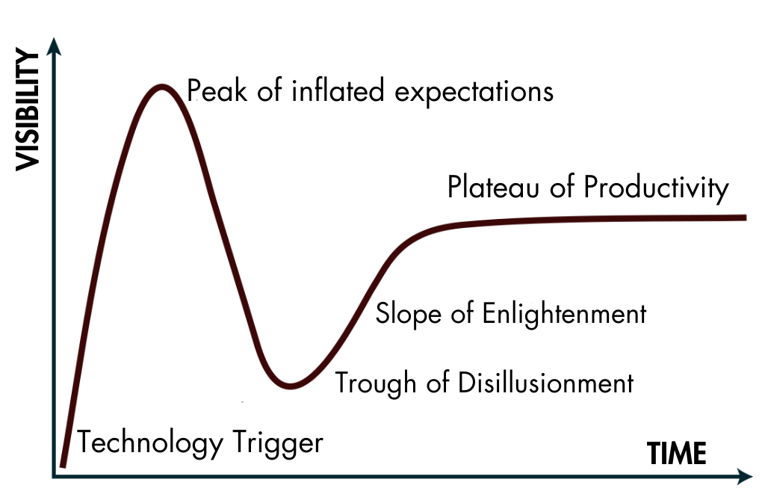

The Gartner Hype Cycle,  (2024, January 16). In Wikipedia.

First came the triggering innovation – in this case, AI tools like ChatGPT. Next, with high hopes, I subscribed to every AI newsletter, followed every thought leader, and signed up for every new AI tool claiming to revolutionize the writing process. For a time, my entire Twitter feed was flooded with infinite variations of the same “viral” hook:

“16-year-olds are making $100ks using ChatGPT. 🔥🔥🔥 ***Retweet this to get the free guide to becoming an AI millionaire***. 👇👇”

But the content never lived up to my inflated expectations whenever I fell for the hype – retweeting or signing up for the free trial. The “free guides’ gave generic and superficial advice. It was clear that those hyping overnight AI success lacked experience and were often faking their own success. From large to smaller applications, AI didn’t appear to offer a competitive advantage for the writing profession. AI technology on its own could not forge a writer’s business model. Nor did these tools provide ordered steps to complete specific tasks that writers face (common “use cases” per tech jargon).

I was sliding into the trough of disillusionment.

Soon, however, my disillusionment gave way to a new, more gradual discovery process – the “slope of enlightenment” – in which I realized that I already held the keys to what many were scrambling to unlock. My simple use case of transforming raw, human-generated content into clear, polished, and logical prose was a natural complement to AI’s strengths.

I found that the solution didn’t lie in any single “killer app” or “superprompt” but in developing an intuitive feel for how to command AI, coupled with a few basic principles and a framework for getting consistent results. AI is not a machine for *generating* answers or polished content out of thin air. Instead, it’s a tool for *transforming* and refining human-generated ideas and inputs. This distinction between tools and machines is subtle. Whereas a machine is designed to be “foolproof” – such that any fool can operate it – a tool requires skilled hands to operate. There is a world of difference between AI-generated content, churned out by a machine, and AI-*assisted* content, in which you leverage AI as a tool in the writing process.

## Level Up or Go Extinct

In the nine months since my initial epiphany, I have developed an effective step-by-step system for integrating AI into the writing process. My method combines human creativity with AI commands at key junctions. This targeted human-AI collaboration accelerates and elevates every stage – from ideation to editing.

Feeding AI the right prompts and source material, AI can organize, distill, and build upon your purest ideas – speeding up the writing process while maintaining the quality and specificity of ideas. It can clarify your thinking and purify the signal from your noisy brainstorms. Beyond improving sloppy writing or a rough AI-generated transcript, it can help structure a logical argument, fill in the gaps, and smooth awkward transitions. And it can turn a paragraph of text (like this one) into a bullet point list like this:

* Distill and build upon pure ideas
* Speed up the writing process
* Clarify thinking and purify noisy thoughts
* Improve rough AI-generated transcripts
* Structure logical arguments and fill in gaps
* Smooth clumsy transitions
* Provide ideas for titles and hooks
* Transform paragraphs into bullet point lists

But wait… there’s more. How else can AI help you? It can…

* Rewrite text in the voice and style of another person
* Extract follow-up “action items” from a meeting transcript
* Simplify complex scientific papers for easier understanding
* Translate complex concepts into accessible analogies or metaphors
* Offer feedback on tone, readability, and alternative phrasing
* Provide instant translations for foreign language text
* Identify repetitive words or phrases and suggest synonyms

In the pages that follow, you will learn in greater detail how to accomplish all of these sub-tasks – without signing up for a dozen different subscriptions. By the end, you will understand your vital role as the human driver behind the AI-assisted creative process, so you can future-proof your career in the years to come. While the specific tools may evolve and the technology will advance, demand will only grow for high-skilled, AI-augmented knowledge workers. AI equips us with new capacities to transform, refine, and enhance text, unlocking greater potential. Yet humans must provide the judgment to steer these technologies toward ethical, constructive ends, and supply the imagination to conceive what we choose to write.

Going forward, you have two options.

Will you recoil at the rapid pace of change and resign yourself to potential obsolescence?

Or will you build complementary skills to work *with* AI that make you irreplaceable?

Within five years, if you level up, telling people, “I’m a writer,” could carry more prestige than saying, “I’m a doctor.” AI-assisted writing salaries could rival those of software engineers. With the emergence of AI language models like GPT-4, English is transforming into the hottest new programming language. You can now “code” through conversational prompts. No technical degrees are required – just a keyboard, an internet connection, and a willingness to experiment.

Part 1

Natural Language Programming

CHAPTER 1

THE HOTTEST NEW PROGRAMMING LANGUAGE IS… ENGLISH?

“Prompt Engineering is natural language programming.”

– Elon Musk

In 1941, a brash 25-year-old named Orson Welles released his first film. Having never worked in Hollywood or studied moviemaking, he approached the project with sheer ignorance. He knew little to nothing of the standard conventions of lighting, camera angles, or story structure.

“There’s no confidence to equal it,” he later remarked of his novice mindset during an interview in which he reflected on his early career.

Unbound by theoretical impossibilities, Welles embodied the essence of an “auteur” – a filmmaker whose personal influence and artistic control over his movie were so profound that he was regarded as the author of the film – not just its writer, director, and producer. In the process of making his first film, he pioneered techniques like deep-focus cinematography and non-linear storytelling. Citizen Kane is now regarded as one of the most influential films ever made. But in 1941, it was a shock to the system. Welles disregarded the rules and forged his own path, treating the film medium as a blank canvas, unconstrained by the gatekeepers of tradition.

“It’s only when you know something about a profession that I think you’re timid or careful,” he observed. “I thought you could do anything with a camera that the eye… or the imagination could do. And if you come up from the bottom in the film business, you’re taught all the things that the cameraman doesn’t want to attempt for fear he will be criticized for having failed.”

Welles was also lucky to have a cameraman who didn’t mind failing from time to time and who told him at the outset that there was nothing special about camera work – nothing, that is, that he “couldn’t learn in half a day.”

“The Great Mystery that requires 20 years doesn’t exist in any field,” Welles added, “and certainly not in the camera.”

To some, artificial intelligence may seem like a great mystery. But the basics can be learned in much less than half a day (more like half an hour). Writers and content creators who choose to work with artificial intelligence find themselves in a similar position to Welles as he embarked on his masterwork. Just as Welles pioneered new filmmaking techniques, unbound by convention, today’s writers – or anyone who works with language, for that matter – can explore the potential of AI models without being constrained by preconceptions of what is possible.

If you worry that you lack the expertise to use this technology, you are in a perfect position to learn the techniques in this book. Like Welles, your ignorance may be your greatest asset.

## The Language Basics of AI

There is much hype (and confusion) around the coveted role of “prompt engineer.” San Francisco-based AI company Anthropic was offering a $350,000 salary to top prompt engineering talent. Those back-end jobs demand a variety of technical coding skills and understanding of AI technology. But the skill level necessary to proficiently command AI has down-shifted and requires much less experience.

This lowered barrier to entry came about with the advent of Large Language Models (LLMs) – the breakthrough technology behind AI assistants like ChatGPT.

Although the inner workings of LLMs remain opaque to most, these AI architectures enabled a paradigm shift. For the first time, anyone fluent in a natural language could easily interact with advanced intelligence. As Elon Musk concisely described this breakthrough capability, “Prompt Engineering is natural language programming.” In other words, previously it took specialized coding skills to operate AI systems, whereas now plain language prompts can command powerful functionalities.

Former Tesla AI Director Andrej Karpathy has labelled this innovation “Software 3.0,” comparing it to the revolution that came with graphical user interfaces (GUIs). Those intuitive windows and menus opened personal computing to a far wider population by replacing arcane code terminals. Similarly, today’s AI systems allow anyone to accomplish complex tasks just by expressing goals conversationally instead of demanding coding skills. The role of “programmer” itself is evolving from meticulously scripting logic to providing high-level prompts that steer generative algorithms. Just as GUIs democratized software access, natural language interaction makes advanced AI functionality available to anyone who can write or speak.

Hence, Karpathy’s now-viral tweet, which may go down in history as the beginning of a new era in both writing and programming:



Despite the technical-sounding name, prompt engineering is less about technical mastery and more about the artful application of language when communicating with AI. “Prompt engineering” is a misnomer that suggests a high level of technical understanding when, in fact, that’s unnecessary outside of the upper echelons of the AI industry. I prefer the simple term, prompt *writing* over prompt *engineering*, because you don’t need advanced knowledge of the underlying mechanics of the large language models to engage in the subtle art of prompting AI. All you need is a good understanding of the English language and a few core principles.

If you’ve never used a tool like ChatGPT before, you will be greeted by a chat window and a greeting, “How can I help you today?” This friendly assistant replaces the blinking “command line” terminal of yore. This chat “assistant” understands regular language and can execute a wide variety of commands related to regular language as well as computer code. It can generate coherent writing on any imaginable topic, translate between languages, and even parse code and extract insights from large datasets.

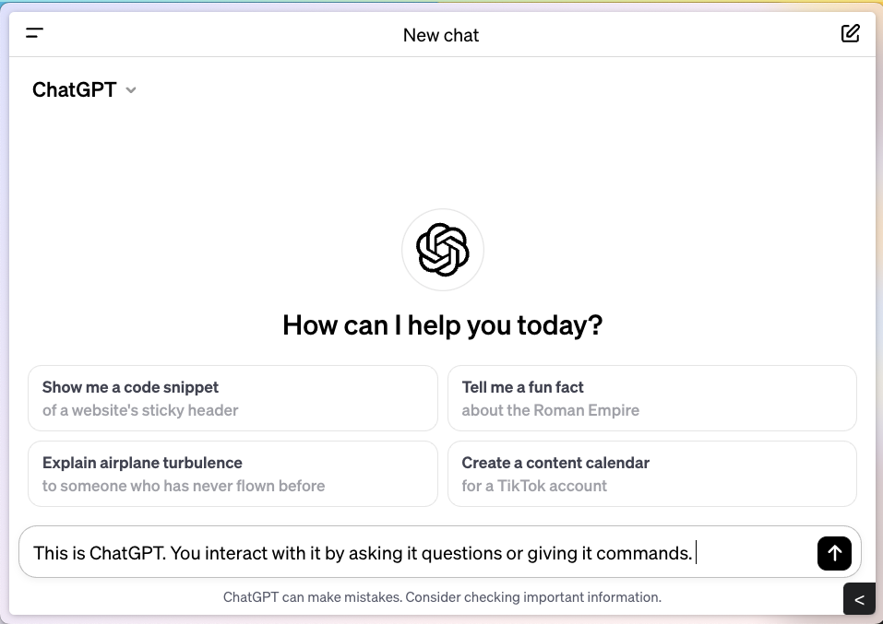With these changes, writing will become less about drafting perfect polished prose. AI-powered tools like Grammarly have already automated editing. Instead, the writing process will involve thinking through what you want to say at a high level and then guiding the language model to assemble your ideas in the most logical sequence.

However, this does not mean that foundational programming or writing skills become obsolete. Writers and programmers who leverage “natural language programming” in their work will still need to be able to recognize what good writing and solid code look like, respectively. Core competencies will remain essential in their respective fields, even as the tools we use to apply them evolve.

## Will Prompt Engineering Become Redundant?

The introduction of chat windows where plain English is used to interact with AI has significantly improved the archaic “command line” interface. Plus, for those seeking an even more straightforward experience than conversational chat, hundreds of helpful, new applications have been customized for specific recurring situations or common use cases. These tailored apps are all built upon the foundational architecture of LLMs and use AI to generate specialized content.

For instance, Tl;dv (short for “too long, didn’t view”) is a GPT-powered meeting recorder for Google Meet and Zoom. Per the Tl;dv website (tldv.io), their AI meeting tool “records, transcribes, takes timestamped notes, and shares insights” across an organization allowing for “smarter follow-ups and better learnings.” Zoom has incorporated a similar feature, producing meeting notes without having to use ChatGPT to manually input transcripts and specific prompts. Similarly, tools like Copy.ai, WordTune, and Jasper.ai are designed to assist with common writing tasks such as editing and polishing. LinkedIn (linkedin.com) now offers a new AI-powered, tailored experience encompassing “everything from gaining deeper insights into crucial topics to receiving personalized career action suggestions.” All these interactions are based on simple inputs – with no prompting required.

Based on this trend, OpenAI CEO Sam Altman speculates that the skill of prompt engineering will soon be integrated into these mass-market AI products, such that average users will not need to know how to write and design effective prompts. As of the time of writing, OpenAI just announced its own app store, where anyone can sell their own “custom GPTs,” containing pre-programmed instructions. Users of these GPTs will be able to accomplish an even wider variety of tasks without crafting their own prompts, and instead following the instructions of the app that has been designed for their purposes.

At the opposite end of the spectrum from Altman, others predict that nearly 50% of all jobs in the future will be “prompt engineering” jobs on some level. These roles could encompass custom GPT developers who specialize in building tailored AI apps, content curators responsible for optimizing AI-generated content, and consultants offering expertise in fine-tuning AI interactions to meet specific industry needs.

More likely than either extreme is a middle path. Basic prompt literacy will be assumed despite the proliferation of custom GPTs and AI-powered tools with preset prompts. In some professions, it will become a core competency, just as digital proficiency rose in importance with the spread of computers.

There will be some percentage of specialized AI engineers who understand the underlying code and architecture. But there will be many more natural language programmers who write their own prompts or even create their own chatbots for their specific use cases. For the latter, deep intuitive knowledge of prompting will be essential. You will need to be able to customize your own prompts for your own use cases and understand how different inputs or “elements” of prompts can be designed to deliver the exact outputs you want. Learning prompt design yourself is more empowering than relying on overpaid engineers to make one-size-fits-all tools. When relying on prepackaged prompts and AI writing tools, you face a trade-off between their ease of use and the limitations they impose.

Writers, or anyone with strong language abilities, has an advantage here in this emerging field of natural language programming. Investing further in prompting skills lets you unlock the full potential of LLMs. Don’t settle for presets – instead, craft your own prompts tailored to your own goals.

## A Peek Under the Hood of a Large Language Model

So, what does the aspiring independent prompt writer need to know about the underlying technology?

If you want to understand the architecture of LLMs, one good place to start is an article called ***large language models, explained with a minimum of math and jargon***, by Timothy B. Lee and Sean Trott. In it, they write:

“Explaining how large language models work is like opening the hood of your car and finding it full of lively squirrels adjusting valves. You can see the creatures are optimizing something, but tracing all their scurrying would take months.”

Who has time for that? For our purposes, all we need are the basics. Large language models (LLMs) like GPT-3 generate text by predicting the likelihood of the next word in a sequence, considering both the preceding words and the broader context of the prompt. These *models* (as I’ll refer to them) develop their predictive capabilities through a process known as “training,” wherein they analyze vast bodies of textual data. This data is often sourced from the public domain, including a wide array of internet-based text. For instance, GPT-3 was trained on a dataset comprising over a trillion words.

In the training process, words are mathematically modeled as vectors – essentially, points within a high-dimensional “word space.” This technique is part of what’s known as word embeddings or vector databases. The concept of a “meaning aura” around a word posits that words convey more than their explicit definitions, akin to the bulk of an iceberg lying unseen beneath the water’s surface. For the word “computer,” one doesn’t only think of its dictionary meaning but also conjures up a network of related concepts from “hardware” to “software.” This intricate matrix of associations, presumptions, and implied meanings enriches communication, allowing for nuanced interactions such as sarcasm, where a shared, tacit understanding of the context is essential.

There is vigorous debate around the question of whether LLMs *understand* language or are just advanced pattern recognizers – a glorified “auto-complete” function. Some downplay the capabilities of AI by noting that, at the root, these tools are “just predicting the next most likely word.” But this criticism falls flat. Ilya Sutskever, one of the co-founders of OpenAI, explains why this statistical learning of LLMs equates to a deeper understanding of language:

“So, the way to think about it is that when we train a large neural network to accurately predict the next word in lots of different texts from the Internet, what we are doing is that we are learning a world model. … It may look on the surface… like learning correlations in text, but it turns out that to “just learn” the statistical correlations in text, to compress them really well, **what the neural network learns is** some representation of the process that produced the text. This text is actually a projection of the world...

… [W]hat the neural network is learning is more and more aspects of the world, of people, of the human conditions, their hopes, dreams, and motivations, their interactions in the situations that we are in. And the neural network learns a compressed, abstract, usable representation of that.”

Large language models (LLMs) have begun to outperform humans in specific areas, notably in tasks such as translation. However, these models still have limitations. They are good at discrete tasks but tend to go off the rails when given complex or multi-step jobs. They have limited long-term memory and primitive deductive reasoning. Thus they cannot connect concepts over time without human supervision. Finally, their expertise is limited to the “congealed knowledge” of their training data. As a result, they need humans to oversee them – to “seed” them with specific, contextualized information, and guide them toward useful responses.

Whether you call it prompt engineering or prompt writing, working with AI requires you to be able to express your aims and objectives in English. This, in turn, requires little more than being able to think for yourself – unconstrained by what others say is possible. As we turn the page to the practical steps of AI-assisted writing, begin to think of yourself as an “AI auteur.” Become a prompt writer, director, editor, and producer, all bundled into one. The upcoming chapters will build upon this fundamental understanding of LLMs in an interactive manner, empowering you to harness this novel technology for unparalleled creative command over language.

Let’s proceed with our “half-hour crash course,” covering the essential elements and principles of prompting – the foundation necessary to let your creativity run wild.

## Try It Now:

* Read ***Large language models, explained with a minimum of math and jargon,*** by Timothy B. Lee and Sean Trott: https://www.understandingai.org/p/large-language-models-explained-with
* Go to <https://chat.openai.com> and set up a free account.
* Test out your first prompts – don’t be afraid to “mess up.”

Chapter 2

PROMPT ENGINEERING 101

The Subtle Art of AI Whispering

*“You don’t have to be an engineer to be a racing driver, but you do have to have Mechanical Sympathy.”*

– Jackie Stewart, racing driver

There’s only one way to learn to steer a sailboat downwind in heavy seas, and it’s not by just sitting and reading about it. Although studying physics, naval architecture, or fluid dynamics might give you a conceptual underpinning, it only gets you so far on the water. After some amount of orientation, you must take the helm and develop your own feel for the boat’s motions. At first, the motions feel tense and awkward. But soon, your subconscious begins to anticipate each approaching swell until the boat transforms into an extension of your very being.

British Formula One racing champion Jackie Stewart called this bond “mechanical sympathy”– the indescribable metaphysical connection between humans and their tools. While certain racecar drivers may possess a stronger innate affinity for their vehicles, anyone can achieve this sympathy with any tool. Developing it with Large Language Models doesn’t require you to understand what those squirrels are doing “under the hood” with the valves. All it takes is curiosity and a determination to learn from the inevitable mistakes and missteps.

Coupling the knowledge in this chapter with your own hands-on experience will save you countless hours of trial and error and help you gain mechanical sympathy more quickly. Just like sailing a boat or driving a car, mastering AI is about getting your hands on the controls.

## Tools for Titans: The AI-Assisted Writing Tech Stack

In my work as a writer and radio/podcast producer, I rely on three AI software tools: NotionAI, ChatGPT, and its rival, Claude.

ChatGPT is a chatbot application built on OpenAI’s foundational large language models, i.e., GPT-3 and GPT-4. Claude is Anthropic’s AI chatbot and has its own underlying LLM that powers it. (Claude was introduced in March 2023.) Both ChatGPT and Claude are accessible through chat interfaces and have free and upgraded (“plus”) versions.

Claude is my preferred chatbot/LLM for most of my writing tasks. Claude is often labeled as an “AI assistant,” combining its natural language intelligence with one crucial advantage for writers like me. Claude allows users to bring their own “source material” into the conversation as the vital context for its LLM output. We will get to that advantage in a moment.

Notion is a cloud-based workspace tool and the Swiss Army Knife of software. It transcends typical productivity tools by offering a unified platform for note-taking, document creation, project management, and database organization. Its intuitive interface allows users to create “pages” that can contain diverse content types, supporting nested structures for sophisticated information hierarchies. This design is particularly beneficial for compiling detailed wikis or project dashboards, streamlining the organization and retrieval of information – a boon for writers and project managers alike.

The integration of NotionAI, powered by Claude, augments Notion’s capabilities with AI-assisted functionalities. Through NotionAI, users can access a suite of AI-driven commands, including the **Improve writing** feature and a set of bespoke prompts that utilize Claude’s language processing strengths. Interaction with Claude is facilitated by an API (Application Program Interface) that processes user inputs and returns enhancements, redefining the writing process and empowering users to “command the page.” As we get deeper into natural language processing, the dynamic potential of engaging with an intelligent assistant within Notion’s robust environment will become increasingly apparent, unlocking new dimensions in the art of digital communication. While many tasks in this book are manageable within Notion’s sleek interface, getting familiar with writing prompts within the chat consoles is essential.

## The Elements of Natural Language Programming

### Prompts

At its most basic level, a prompt is a set of instructions that you provide to a large language model. These instructions guide the model in generating a useful response. Since language models are designed to understand natural human language, it’s best to communicate with them simply and directly – as you would with a human assistant.

Thus, the first step in engineering your prompts is gaining clarity about what you want AI to do. You must define the problem you need AI to solve or the task you want it to complete. A prompt cannot be effective if the goal itself is ambiguous. If you aren’t sure what you want AI to do, try articulating your thought process as best you can. Sometimes, the very act of putting your vague ideas into words brings the clarity you need to proceed.

Your instructions can be framed as either **questions** or **commands**.

For example, you might ask Claude:

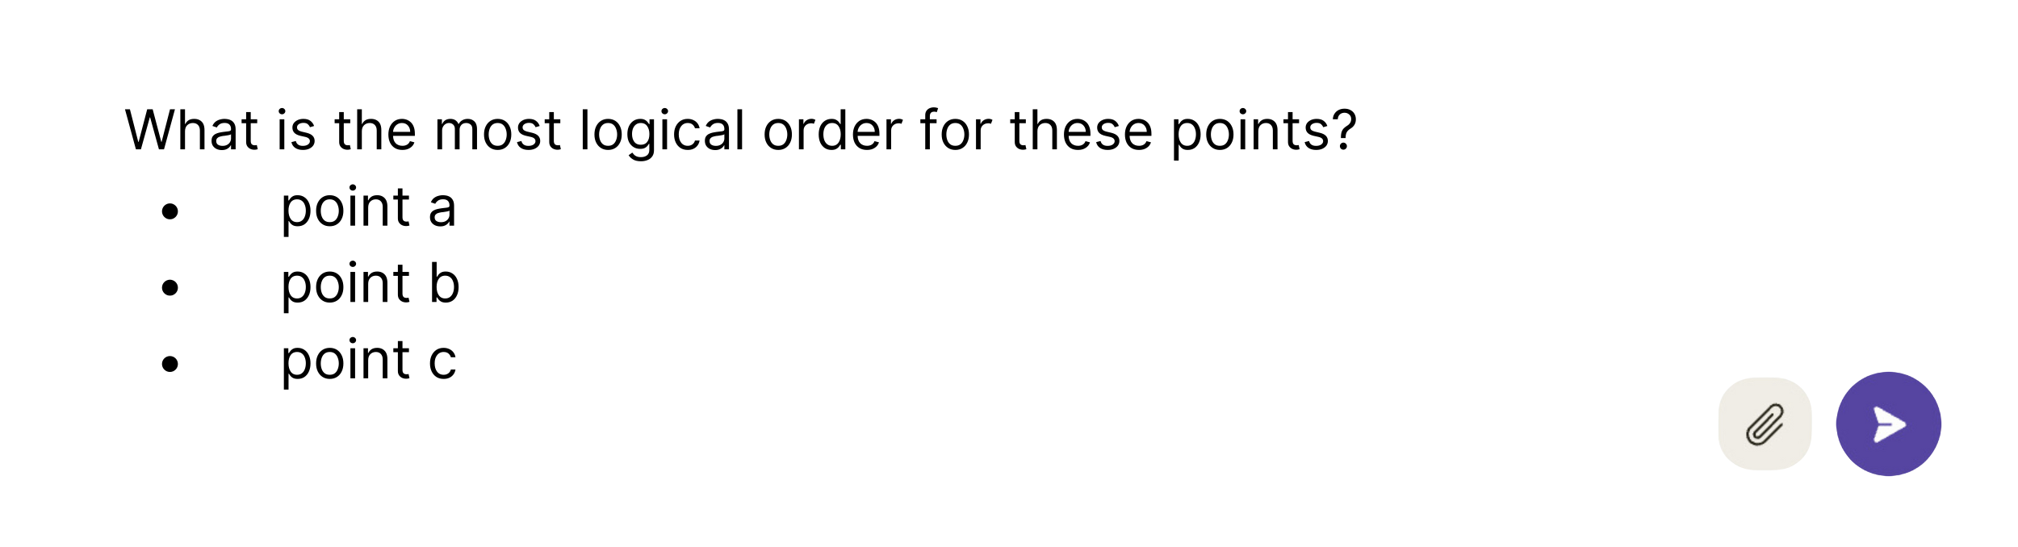

In this case, the question could have just as easily been written as a command:

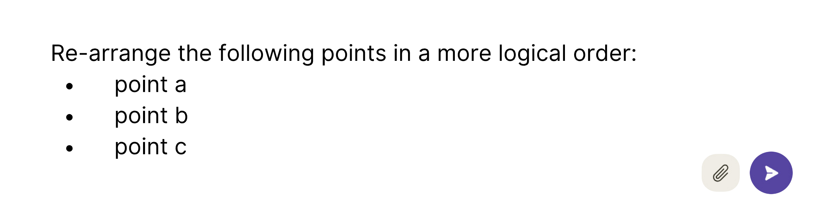

The model will infer what you mean either way.

As part of their understanding of language, LLMs also have an excellent grasp of punctuation and write with polished spelling and grammar. Yet they can also understand prompts with typos and grammatical inconsistency – reading between the lines and papering over human input errors. Likewise, they are forgiving of imperfect syntax. My prompts are often clunky, containing redundant words, but I ask myself, “Would a reasonably intelligent person understand what I am asking here?” If the answer is yes, I hit send and tweak if necessary.

### Examples vs. Instructions

While **instructions** can give the model a sense of ***what*** you want it to do, **examples** will improve its understanding of ***how*** you want it to do something. Examples can help convey the preferred format, tone, or style or demonstrate the desired structure or organization of information. Examples can also enhance instructions that might be ambiguous without a concrete representation of the output you are looking for

For example, while doing research for this book, I asked ChatGPT to provide me with a list of podcasts that had been adapted into books. I thought this was straightforward enough, but the initial response included a list of 10 books with only loose connections to podcasts – such as authors who were also podcast hosts. Only two of the books on the list met the specified criteria. However, when I noted which examples from the initial response were on point and asked again, the accuracy of the next list was close to 100%. In other words, it understood exactly what I wanted based on the examples.

Providing a single example of the desired output is known as **one-shot** prompting in machine learning.

**Few-shot** prompting refers to providing a small number of examples to guide the model’s output, as I did by noting the two actual books adapted from podcasts.

**Many-shot** prompting, on the other hand, involves providing a large number of examples to train the model on a specific task or domain. This type of prompting is most useful when the task requires a deep understanding of the subject matter or when there is a need to capture a wide range of variations and nuances. Examples might include training the model to create content that adheres to certain technical formats, such as legal documents, medical reports, or academic papers in a specific citation style.

Usually, one-shot or few-shot prompting is sufficient for training AI to give you what you want. Many-shot prompting is generally only necessary when fine-tuning specialized LLMs – something far beyond this book’s scope.

### Formatting

Formatting elements play a crucial role in enhancing the precision and clarity of your prompts. You can use different formatting options to structure your interactions effectively with the model. Here are some formatting choices and how they can help improve your prompts:

**Quotation Marks and Delimiters:** Quotation marks and other delimiters like (parentheses), [square brackets], <angled brackets>, etc., can be used to set apart sections of text in your prompts. These marks, for example, can help distinguish the instructional component of your prompt *from* a longer piece of “source material” that you want summarized.

**Markdown Formatting:** Language models can interpret formatted input and produce formatted output effectively. You can use various formatting elements like bold, italics, different header sizes, and lists - both ordered (i.e., a, b, c or 1, 2, 3) and unordered (i.e., bullet points). A common use of markdown formatting is to create headings and subheadings. For example, you can instruct Claude to size **headers** according to their importance (H1 is the most important, H6 is the least). Here’s an prompt illustrating how to use the header markdown ranking H2 to structure and organize your input:

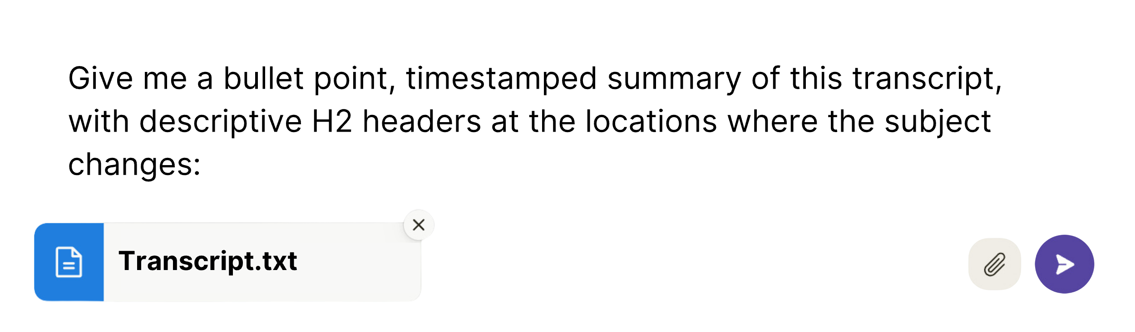

When interacting with Claude via the chat console, a long transcript or multi-page document will exceed the limit for content that can be pasted directly into the message area. Instead, the text pasted-in content will be appended to the prompt as an attachment. The Claude chat window includes an attachment option (indicated by a paperclip icon) to add external content files. When you hover over this, it notes: **Add content (5 max, 10MB each) Accepts pdfs, txt, csv, etc.**

This brings up a key distinction between Claude and ChatGPT – the amount of supplemental information or “context” that each chatbot can process alongside the prompt itself.

### ****Source Material and the Value of a Context Window****

The context window refers to the total amount of conversation history and content that the chatbot can comprehend at once while generating a response. This includes both the original prompt input and any previous responses already generated by the model, covering the entire back-and-forth exchange. The context window determines the extent to which chatbots like Claude and ChatGPT can actively consider the conversation record and any attached documents when formulating a response.

Larger context windows require more computing resources, often referred to as "compute" in AI circles. Premium tiers for Claude and ChatGPT offer expanded context window capacities through a monthly subscription fee, currently priced at $20. These upgraded versions remove limitations on token usage, which is how the total context length is measured, and increase the size of the context window for each conversation.

Tokens range from individual characters up to full words, depending on the complexity. For example, in English, the word “unhappiness” can be divided into smaller token units like “un,” “happy,” and “ness” to better represent its linguistic composition.

PROMPTING TIP:

Even with a larger context window, you only want to provide the context necessary for the model to perform the task at hand. Past a certain point, there are diminishing returns to providing additional context. A specific, targeted prompt must home in on the desired objective. Too much context risks distracting from the core task.

For a longer prompt, it helps to repeat the basic instruction both at the beginning and the end. While this may seem redundant, LLMs are “biased” to put more weight on both the first and final tokens of the prompt and less weight on the middle of the prompt. Remember, for all of their capacity for pseudo-understanding, an LLM’s basic job is still to predict the next word, one word at a time. Thus, repeating the instruction at the end ensures that it “remembers” exactly what it’s doing, and how to begin its response.

As of its latest update, ChatGPT imposes a context window limit of 8,000 tokens per prompt. On the other hand, Claude enables documents up to 200,000 tokens in length to be uploaded – roughly 500 pages or 150,000 words of text.

This massive context window is what empowers Claude to incorporate more information when tailoring responses.

My journey with Claude began in March 2023 when I secured a beta account, providing me early access to its large context window. Its usefulness became apparent when I discovered that I could utilize it to generate promotional materials from hour-long transcripts, which frequently exceeded 10,000 words. This task had previously been both time-consuming and unpleasant. Since then, I have used Claude daily – running thousands of prompts across hundreds of conversations and probably costing the company enough in compute to fund a small lunar mission.

The purpose of a large context window isn’t just to handle lengthy instructional prompts. Its real value is enabling chatbots to incorporate more of your own content to generate tailored responses.

This supplemental “source material” might include transcripts, documents, or passages of text that the model lacks in its training data. With greater context, Claude can transform your unique inputs rather than simply regurgitating boilerplate text. In this book, we’ll focus on prompts that serve to **transform your own source material**, not just generate new content. The goal is to collaborate with Claude to elevate your existing work. Relying on basic AI prompts – without providing this material – tends to produce generic, inaccurate responses that merely echo patterns in the training data. But by providing source documents, you expand the model’s knowledge beyond these statistical echoes, merging your perspective with Claude’s capabilities. This tight creative coupling is the art of commanding the page.

## Prompting Frameworks: A Shortcut to Mechanical Sympathy

In summary, the basic elements of prompting are:

* **Instructions** – What you want the model to do, framed as either a command, a question, or a continuation.
* **Examples** – Representations of the desired output, in terms of style, content, or format.
* **Inputs** – The details, context, constraints, or “source material” that the model will act upon or draw from in responding.
* **Formatting** – The structure of both the inputs and desired outputs, provided via instruction or example.
* **Tokens** – The units of text that the language model processes.

So far, these elements will feel abstract to anyone who has yet to experiment with the models themselves. At this point, it’s time to roll up your sleeves and start practicing with your own simple prompts.

If you’re new to prompting, I suggest borrowing an established prompting framework – customizing the details to your own goals and interests. Think of these frameworks as templates or sets of guidelines for assembling the key elements of a prompt for maximum efficacy.

### Role-Task-Format

Perhaps the most basic prompting framework is Role-Task-Format – abbreviated as RTF – which I learned from self-described AI geek @cj_zZZz (follow him on X).

You establish AI’s role, the task it must complete, and the expected output format.

For example:

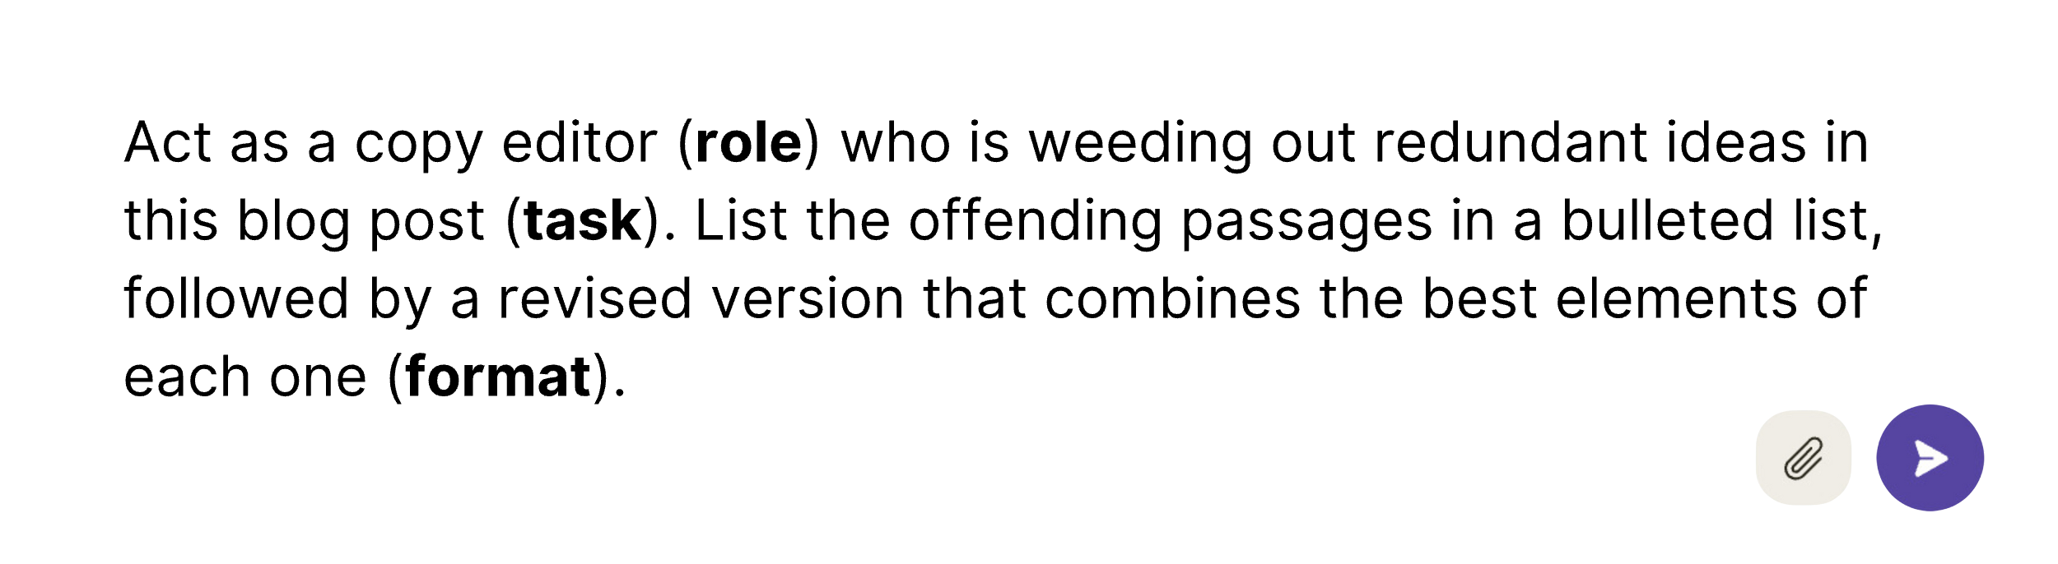

Specifying a role for the model unlocks one of the greatest powers of LLMs – a pattern-recognition engine that can imitate either the specific knowledge of a particular type of person, or even the subtleties of a specific writer’s voice. It might seem strange that defining a role would improve the quality of output. “If the model is trained on the entire sum of human knowledge,” you might wonder, “why do I need to tell it to be an expert in something that it already knows?”

The explanation likely has to do with the model’s ability to narrow its focus to a smaller corner of the training data. In this way, specifying a role acts as useful context and a shortcut to long instructions. Rather than wasting tokens laying out all of that context, such as explaining to AI what constitutes “redundancy” in a blog post, you can condense that background information into a few words: “Act as a copy editor.”

The task is the core of the instruction – the job to be done.

Some common formats include:

* Tables (specify what the columns and rows are)
* Numbered/Bulleted lists
* Summary outlines in markdown format

### RODES

RODES stands for Role, Objective, Details, Examples, and Sense Check. This framework is helpful when you have a specific idea of the kinds of output you are looking for.

Here, the objective takes the role of your high-level instruction.

The details section is where you provide additional context or detailed instructions related to the task or objective.

Examples help guide the model to the proper format, based on a certain template or prototype – the “kind of thing” you’re looking for.

And, finally, the sense check is a way to confirm that you are on the same page by asking at the end of the prompt, “Do you understand the objective and the specific guidelines for the task?”

For example, you can instruct Claude (and note that the bolded parenthetical material in the prompt can be kept or omitted):

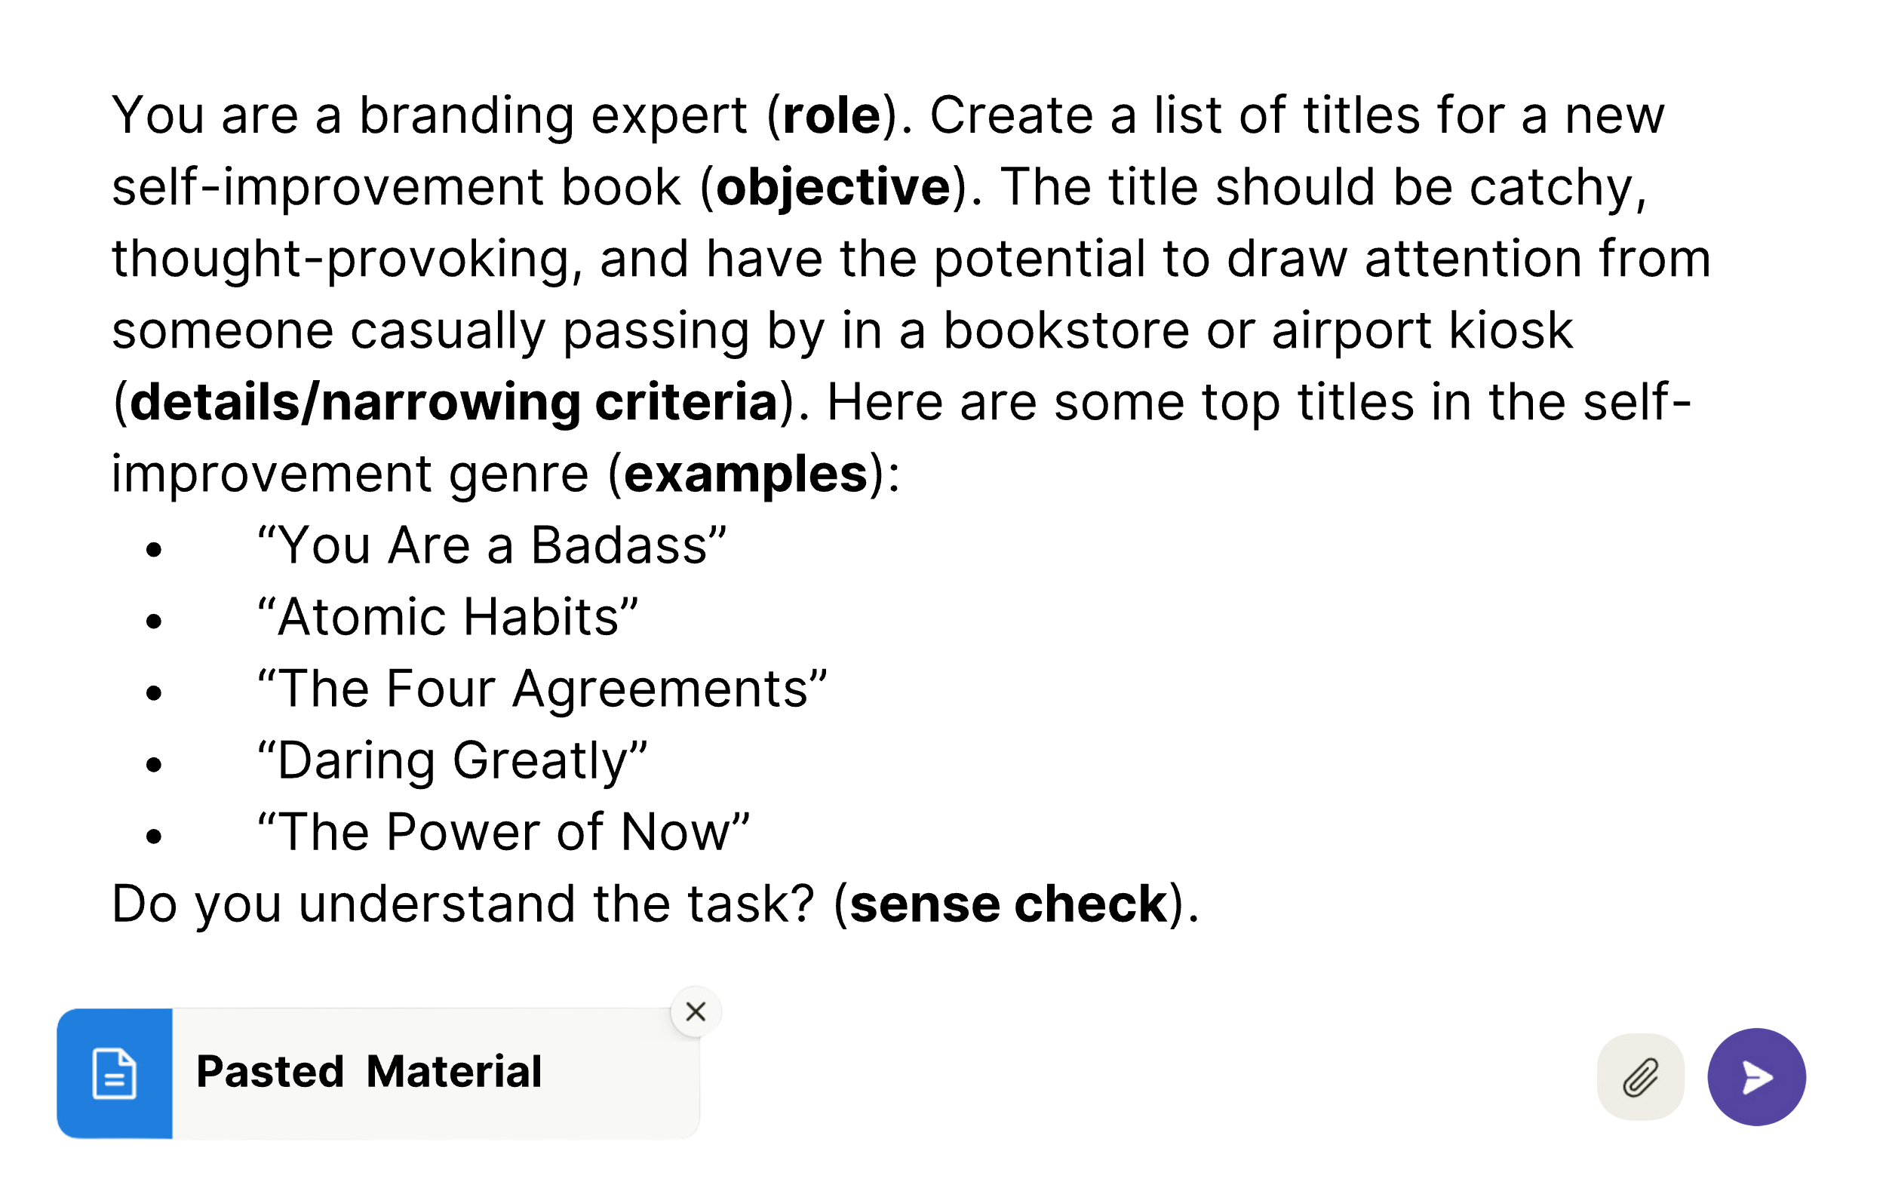

Claude will parrot back its understanding, before asking if it should proceed with the task, at which point you can tell it to proceed.

If the response to the sense check seems off, you might find that you need to fine-tune your prompt or provide more context. In the above case, the task was straightforward enough. However, a sense check is a valuable add-on to any complex prompt you are testing out for the first time. When writing, for example, I will often provide a rough set of ideas that makes sense to *me* and ask AI to repeat the main points back to me in a way that makes more sense. In this way, you gain a mutual understanding before proceeding to the actual task. Just as you are working to develop “mechanical sympathy” with AI, a sense check helps AI to gain “human sympathy” with you.

### RISEN Framework

The RISEN framework, courtesy of “Prompt Entrepreneur” Kyle Balmer (@iamkylebalmer), takes the RTF up a notch – providing the scaffolding for multi-step processes:

RISEN stands for:

R - Role

I - Instructions

S - Steps

E - End Goal

N - Narrowing Constraints

For example, you could employ the following prompt:

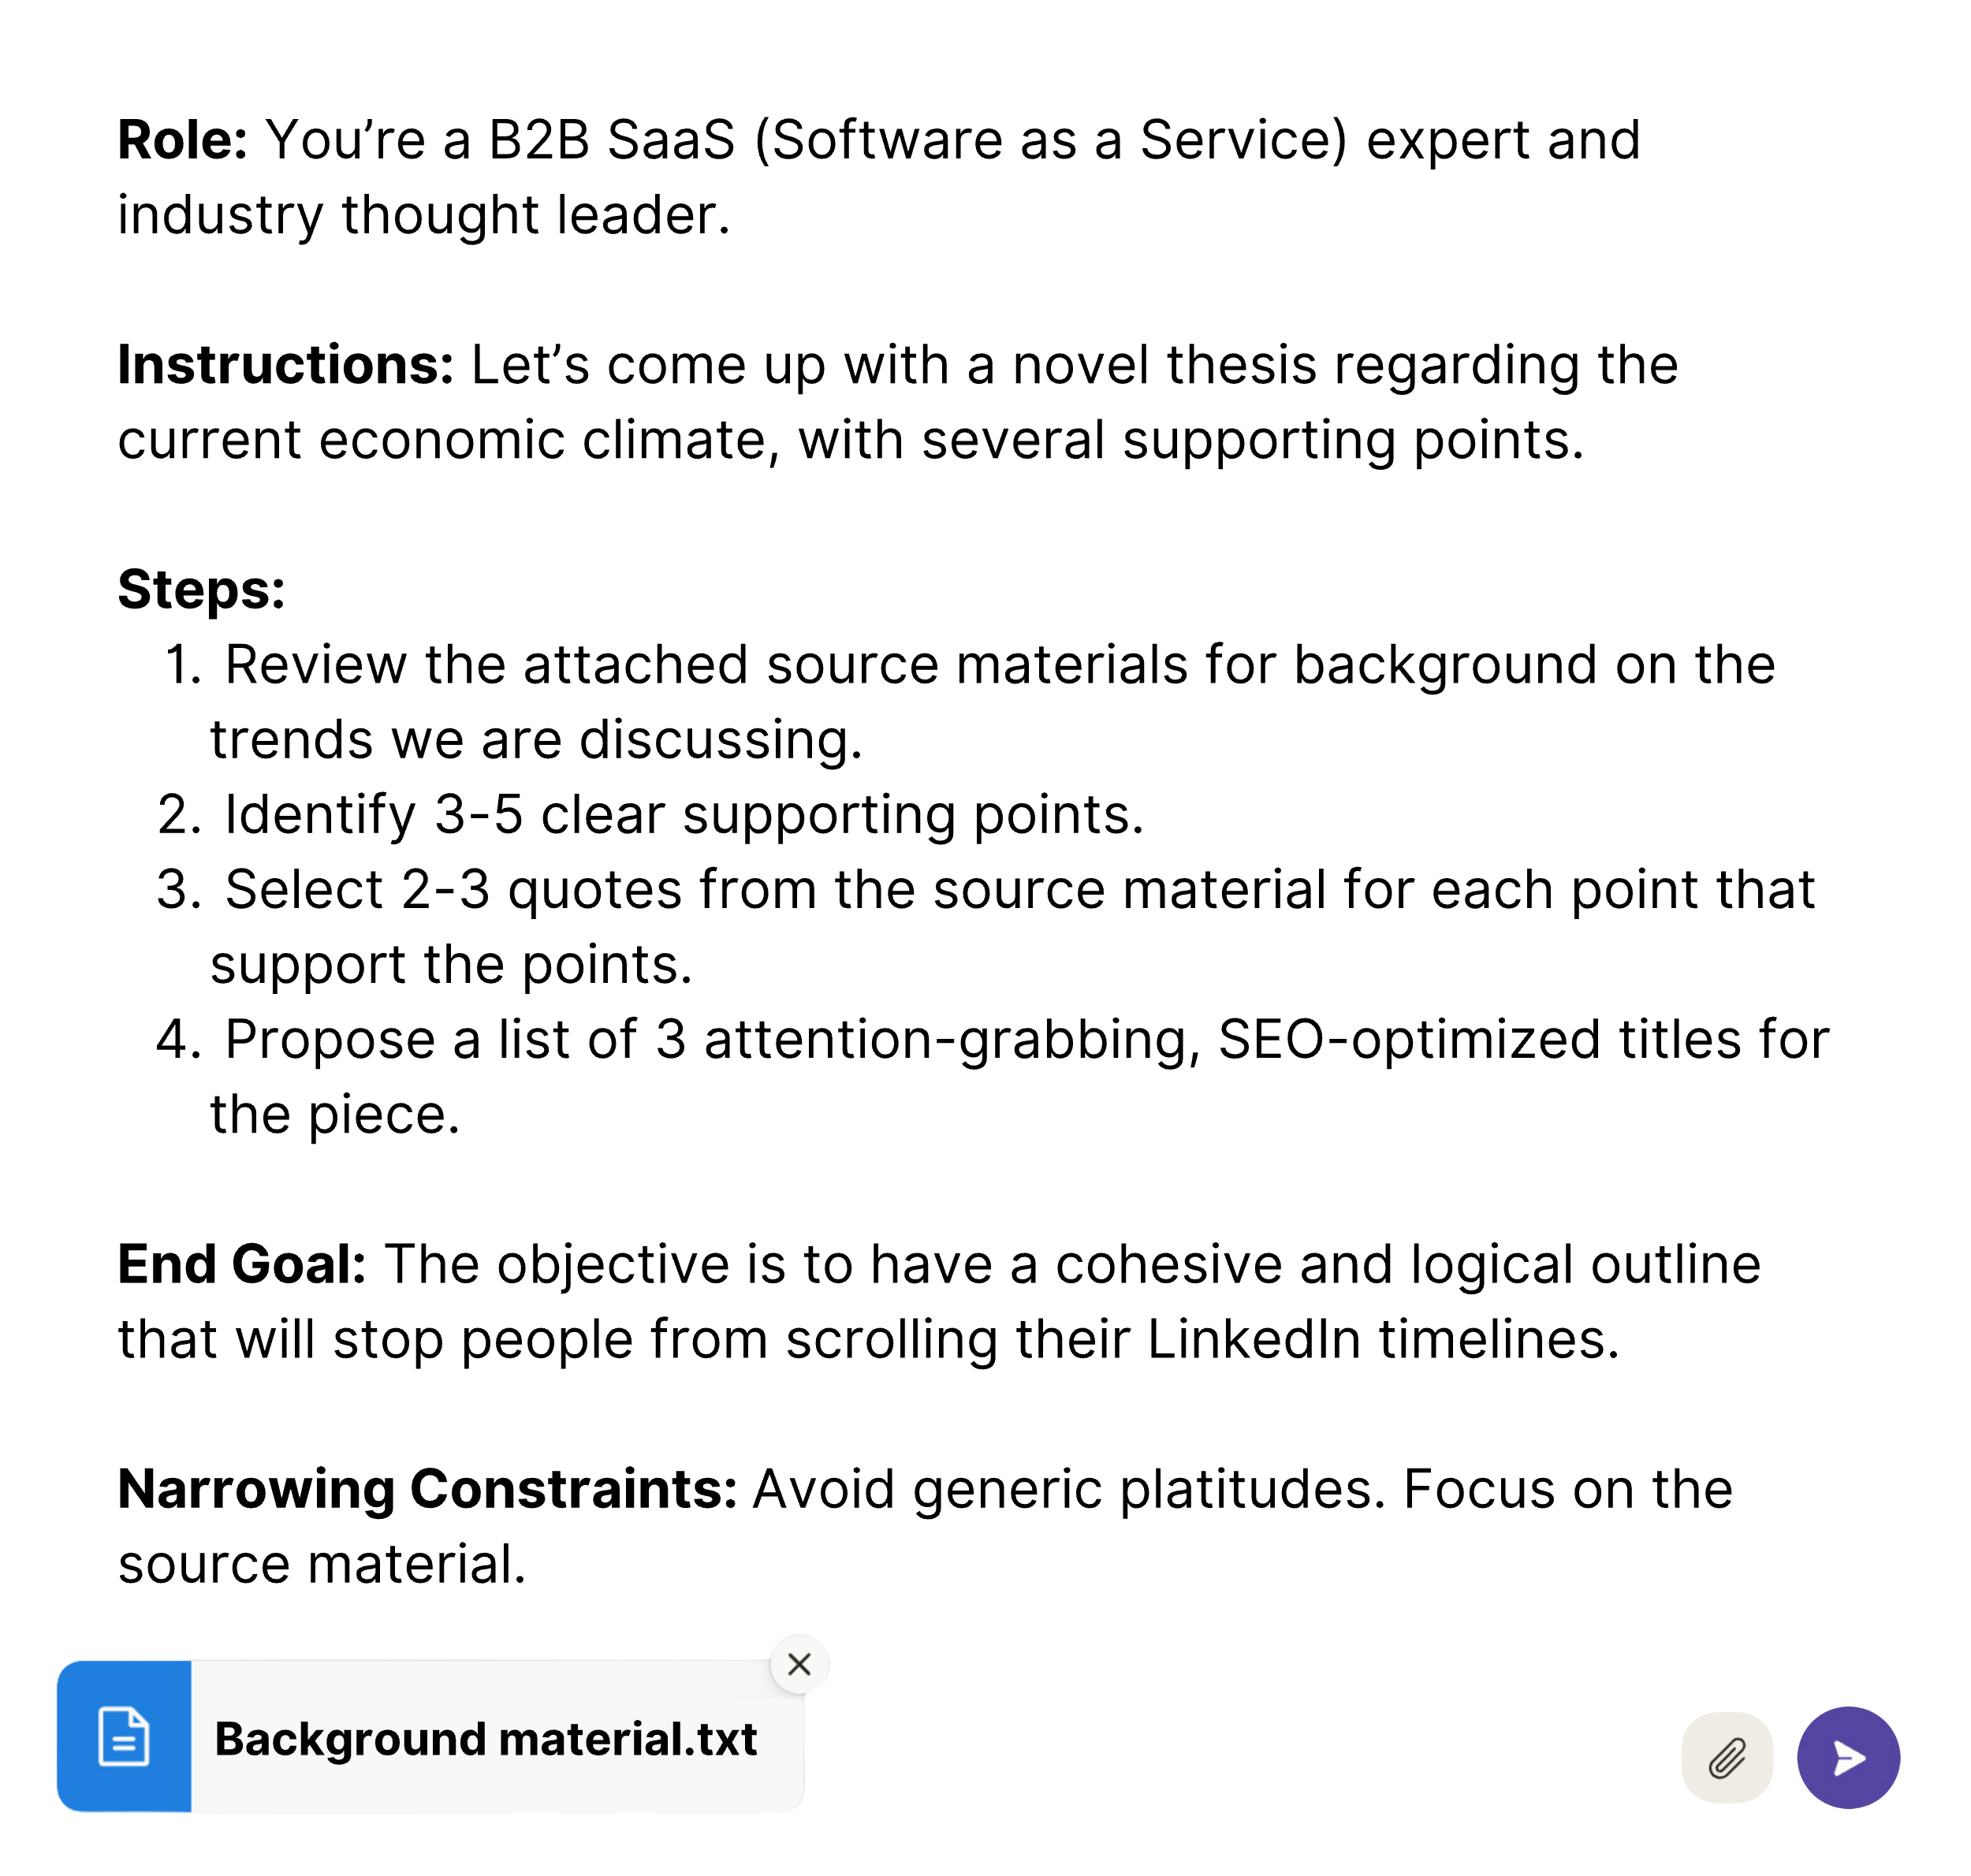



In this case, the steps, end goal, and narrowing constraints act as subsets of your instructions. The input formatting of your step-by-step list breaks up a complex goal into smaller chunks, which enables the model to “think” one step at a time.

The steps also specify the format of the output: a rough, logical outline, along with three bullet point titles for a potential article on the thesis.

This is an extension of a prompting technique known as “chain of thought” (CoT), which provides a natural sequence that a human might use to think a problem through to improve the quality of the output.

### Chain of Thought (CoT)

Large language models excel at processing vast amounts of information quickly, but they struggle with deductive reasoning, often relying on statistical patterns rather than true reasoning. For instance, when given a simple riddle like, “Charlie is the son of John. Who is Charlie’s father?”, an LLM might not always provide the correct answer.

However, there’s a prompting approach known as “Chain of Thought” (CoT) that can enhance an LLM’s performance by breaking down your prompt into a series of logical steps, guiding the model through a structured thinking process.

In many cases, LLMs already possess a degree of “understanding” within their extensive training data, which allows them to navigate simple logical problems. Nevertheless, explicitly instructing the model to “think step-by-step” often leads to better results. This instruction engages the model in a continuous “chain of thought,” promoting a more reasoned approach.

Chain of Thought works even better when you can provide the scaffolding or structure for the steps themselves.

For example, instead of asking Claude or ChatGPT to write an article based on source material, you can use a detailed CoT prompt like this:

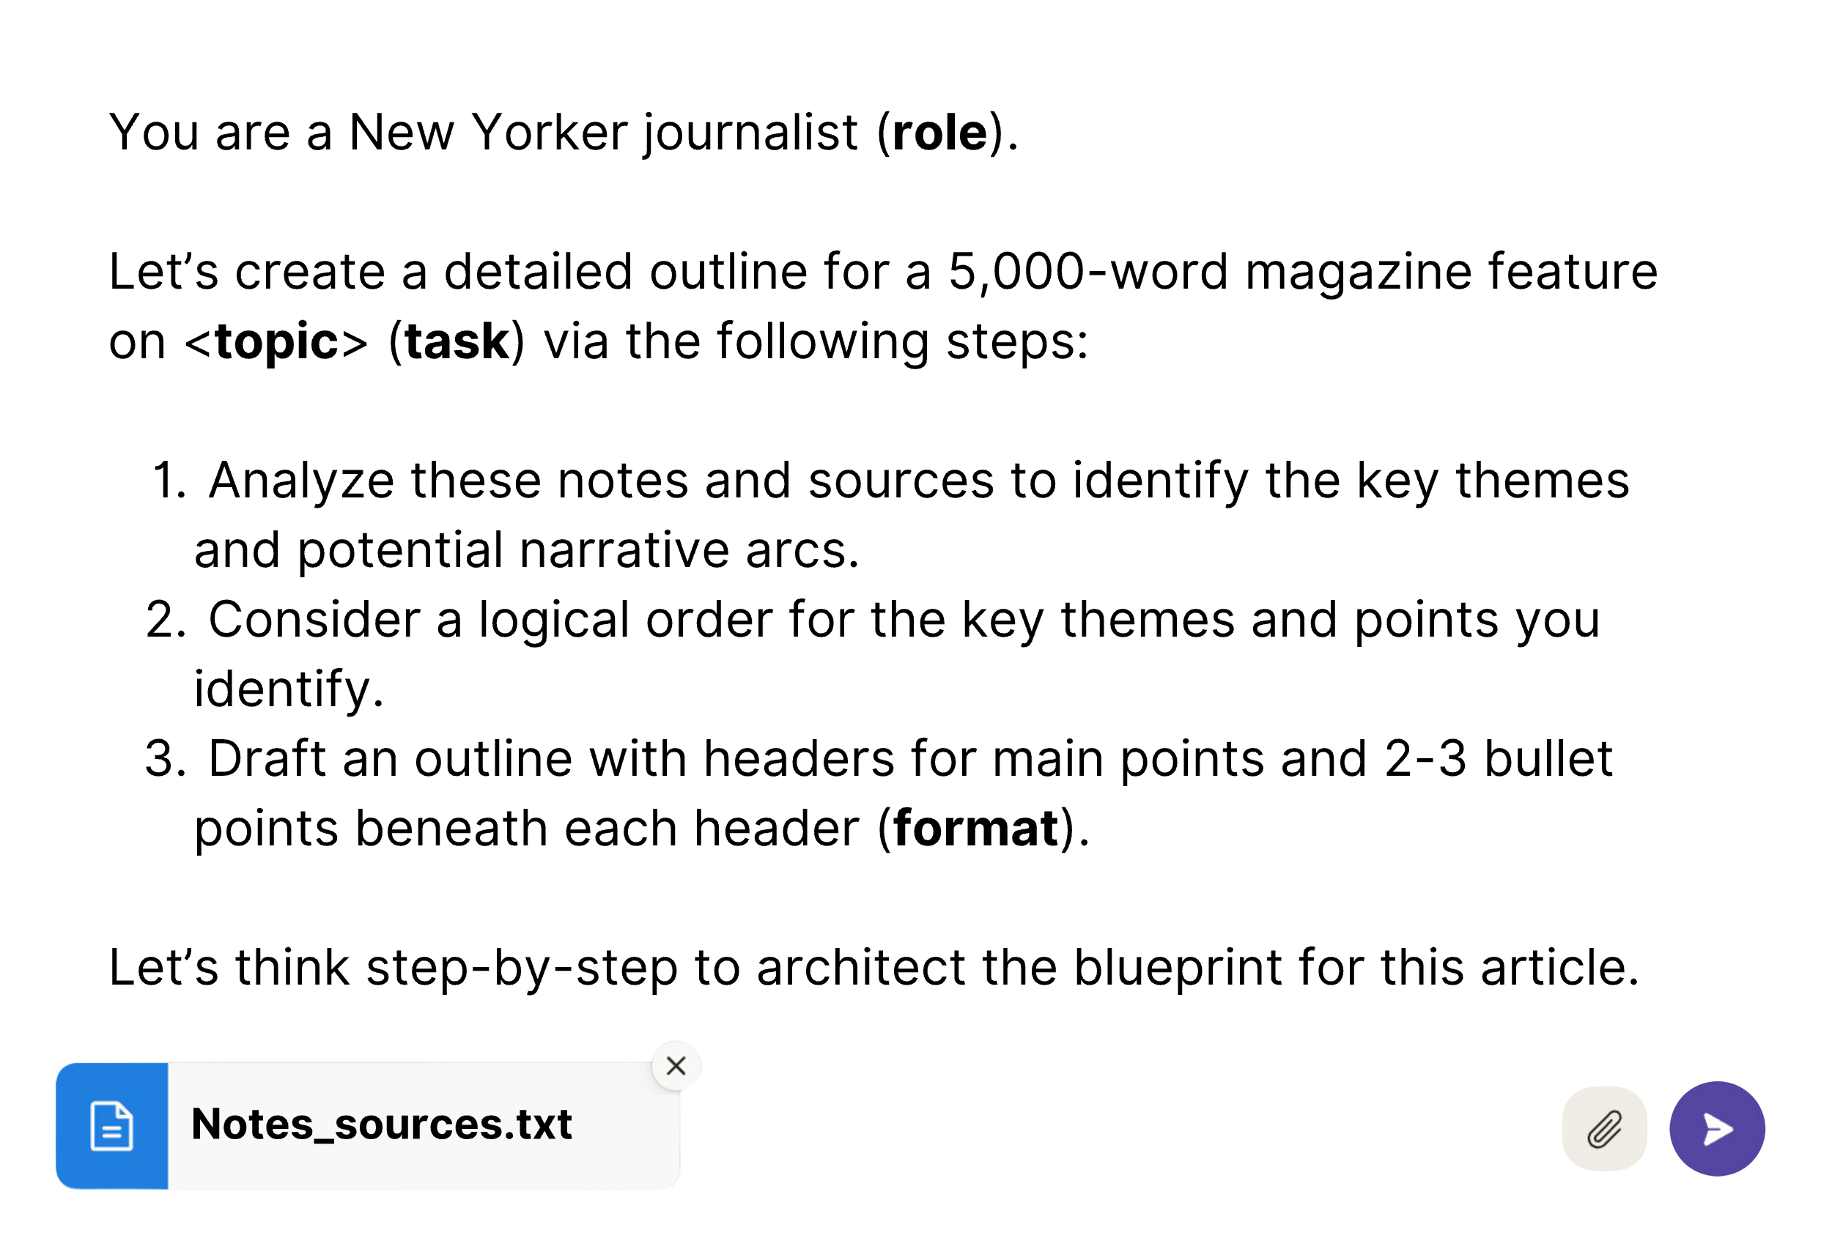

When using AI for outlining and writing, I typically utilize a version of the chain-of-thought framework. However, instead of writing a single prompt, I break the task into a sequence of prompts. After each step, I can then focus on refining the output in a structured manner before proceeding to the next step.

For example, if I want to create a blog post from an interview transcript, I might start by prompting the AI to identify the overarching concept. Subsequent prompts can then:

1. Generate key supporting ideas as headers or sub-headers
2. Review the transcript for detailed supporting points
3. Specify the writing style, and lastly,
4. Instruct the AI to draft each section one at a time.

Advanced AI-assisted writing relies heavily on the chain-of-thought method, which I will describe in the next part of this book. By structuring prompts to guide Claude step-by-step in reasoning through tasks, you can elevate its output from the generic content people have come to associate with ChatGPT to something that stands out for its clarity, substance, and style.

Over time and through hands-on experience, I grasped many of the key prompting concepts shared here organically. I learned the importance of supplying source documents to augment Claude’s knowledge. I also learned how to provide the right balance of instructions and examples to focus Claude’s efforts. I gained an intuitive sense of how much context to provide – enough, but not more than necessary – for a given task.

Even before I learned the terminology and frameworks contained in this chapter, I found myself leveraging principles like chain of thought. I would pose an initial high-level prompt to Claude. Then break down the process into smaller steps, refining the AI’s work at each stage. This prompted sequence allowed greater control in sculpting the final output.

In time, without my “crash course” here, you would have also grasped these concepts. This “book learning” is worth less than the hands-on experience you will acquire, but I hope it will provide a shortcut to mechanical sympathy – that subconscious competence that must be learned at the end through *doing*.

By now, you have already been exposed to 90% of what you need to know to get started on your own journey. But it’s that final 10% of principles that will put you ahead of 99% of content creators using AI.

## Try it Now:

* Sign up for a free Claude account at [claude.ai](http://claude.ai).
* Upload or copy-paste a large text file, like a transcript of a long podcast interview, along with one of the customized prompting frameworks from this chapter.
* Try the same prompt in a new chat dialogue but add the words: “Let’s think step-by-step.” Compare the results.

CHAPTER 3

AI ALCHEMY

THE TRANSFORMATIVE POWER OF TRANSFORMATION OPERATIONS

“The changing of bodies into light, and light into bodies, is very conformable to the course of Nature, which seems delighted with transmutations.”

– Sir Isaac Newton

GPT: Three letters that have turned the world upside down. As we’ve seen, the GPT acronym stands for “generative pre-trained transformers” – the breakthrough technology developed by the machine learning experts at OpenAI. In my region of the San Francisco Bay Area, everyone is talking about generative AI as the technology that will transform and revitalize the tech industry. However, much of the hype around the “generative” component of GPT has obscured the even greater breakthrough embodied by the “T.”

The transformative power of AI lies less in its ability to spit out generic, rambling essays on any topic, and more in its capacity for **transforming** lower-value inputs into higher-value outputs. In medieval times, alchemists sought to transform “base” metals into precious gold through the mythical philosopher’s stone. Though the alchemists never achieved their goal, advanced AI capabilities bring us closer to making their metaphorical vision a reality. With the right prompts, you can input messy, unstructured scribblings and output polished writing.

In the previous chapter, we saw how prompting techniques like “Chain-of-Thought” can be used to guide language models step-by-step through an incremental process; i.e., turning something like a rough transcript into an outline for an article. We will take up this exact task soon enough, but first, we need to take inventory of the essential commands involved in advanced AI alchemy.

## The Basic Transformation Operations

Since Notion introduced its AI tools in March, numerous companies have emulated its straightforward command-based interface. Recall that Notion’s innovation lies in its direct use of highlighted text as source material for its AI to work on, streamlining the process of transforming content. Unlike systems like Claude or ChatGPT, which require copying and pasting text into a new context window, Notion integrates transformation commands such as rewriting or refining directly into the user’s workflow, making your existing words and ideas the foundation for AI-enhanced editing.

Within Notion, after you highlight a block of text and select **“AskAI,”** you are presented with a list of prompts or commands:

* **Improve Writing**
* **Simplify Language**
* **Change Tone**
* **Summarize**
* **Make Shorter/Longer**
* **Translate**
* **Find Action Items**
* **Continue writing…**

These preset prompts represent a sampling of the fundamental “transformation operations” that provide the most value for the most people. The same prompts are also accessible in Grammarly, the editing extension that assists you with wording wherever you type, as well as browser extensions like MaxMe.ai, which appears to have copied Notion’s interface down to the icons that accompany each prompt.

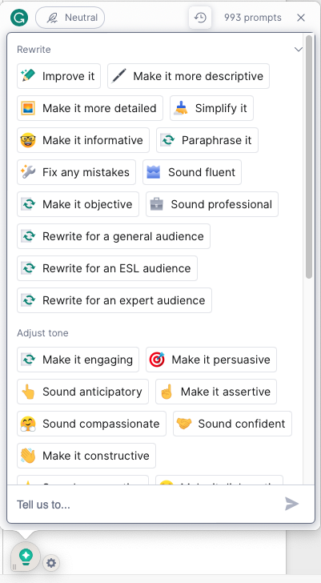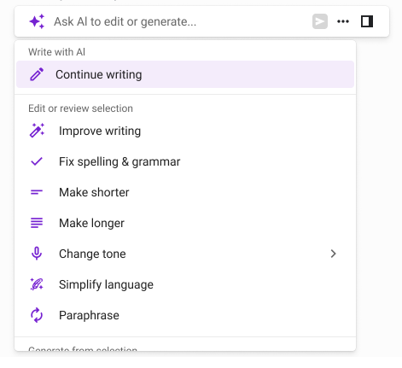

Preset commands in Grammarly (left) and MaxAi.me (right)

However, these basic prompts only scratch the surface of what’s possible once you master the true power of GPTs to transform base inputs into precious metals.

Let’s begin with my personal favorite – the workhorse of AI-assisted writing – **Improve writing.**

### Improve Writing/Fix Spelling & Grammar

**Improve writing** restructures sentences, fixes spelling and grammar, clarifies meaning, and enhances flow, whereas its sister prompt, **Fix spelling & grammar,** makes fewer sweeping changes to your word choice, only correcting what is grammatically incorrect.

Both of these prompts save time when correcting messy transcripts or hasty rough drafts. But take care to check the outputs against the originals to make sure that the “improvements” align with the speaker’s intent.

After every NotionAI command, you have the ability to review the output and decide whether you want to replace the highlighted text, insert it below, or discard it altogether. With **Improve writing,** I usually opt to “insert below,” while retaining the original as a reference to make sure that no crucial meaning was lost, or intent altered. When running **Fix spelling & grammar**, I usually just replace the old, typo-ridden sentence with the new one because of its more cautious approach.

### Simplify Language

The **Simplify language** prompt is useful when you need help making your writing less wordy and pretentious. It can also take a jargon-filled block of text and make it more clear to a layperson.

### ****Change Tone****

The **Change tone** prompt branches into five different options:

* **Friendly**
* **Casual**
* **Professional**
* **Straightforward**
* **Confident**

These prompts have been engineered to be most useful to the most people. However, they are also prone to exaggeration. Think of them as suggestions – not wholesale replacements of your own writing – lest your coworkers start to think an imposter is writing your communications. In Chapter 11, I will discuss how to match a *specific* tone based on your own sample material – i.e., training AI to write in your own voice – without it coming off like a parody of the style you are mimicking.

### Summarize

The **Summarize** prompt can help you create an overview of a page or article in seconds. The longer the “source,” the more details it will condense. Summary outputs are capped at a certain point, so if you want a more detailed summary, it’s better to summarize in smaller chunks, and then combine the summaries together.

### Make Shorter/Longer

While the **Summarize** prompt compresses the key points of a longer text, **Make shorter** simply shaves away some extra words and tightens up your language.

**Make longer** does the opposite – adding details and length. The danger of **Make longer** is that it must extrapolate based on its training data, rather than your own source material. Use it sparingly.

### Find Action Items

The **Find action items** prompt is a subset of a whole family of “extract” prompts, in which you can locate key information from a larger volume of text.

This prompt is particularly useful when compiling to-do lists from scattered notes or a transcript of a meeting in which no one was taking notes. Several companies now offer subscription to automate the process of recording, transcribing, and processing your transcript into actionable notes. However, with just a few extra clicks and a well-worded prompt, you can create your own custom-formatted meeting notes for free using Notion or Claude.

## The Transformation Operation Station

For all of the above prompts, it’s easy enough to reverse engineer the prompts underlying Notion’s AI interface within a chat console like ChatGPT or Claude. In most cases, you can just use the words of the operation, followed by a colon and the source material in quotes, like this:

* **Improve the writing of this passage: “<>“**
* **Summarize this: “<insert source material>“**
* **Explain this: “<>“**

These short commands carry enough of an “aura of meaning” to deliver the desired output. However, you can increase the value of your transformation operations by adding specific context and formatting requirements. For example:

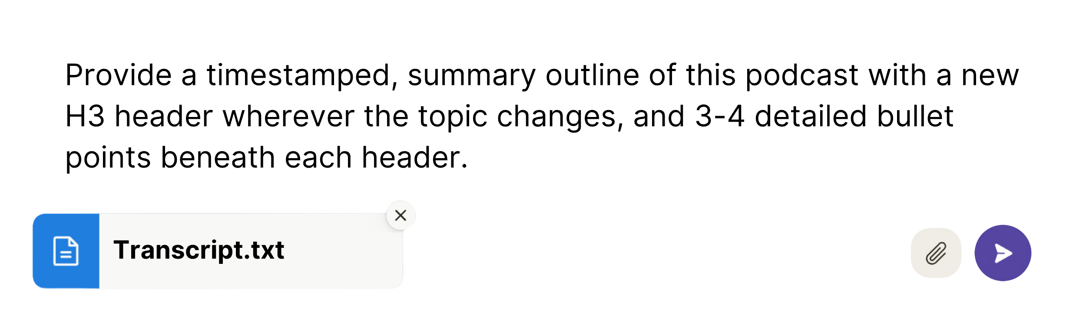

Beyond Notion’s preset prompts, we can explore a variety of other transformation operations that come in handy in the writing process. Each of the examples I’ve chosen below corresponds to a miniature job to be done for the AI-assisted writer. This list is not meant to be exhaustive. I have only included the operations that I use myself and have found valuable or time-saving in some dimension. **NOTE:** All of the following examples depend on the addition of source material after the prompt.

**Paraphrase** — Condenses and rewrites external material while preserving meaning and citing original author. Useful for distilling or citing research; quoting someone concisely.

**Example:** “Paraphrase this research paper, preserving the key statistics and simplifying the academic language to make it more accessible to a general audience.”

**Reorganization** — Structures disorganized content into outlines with logical flow. Useful for bringing order to chaotic rough drafts and scattered notes, identifying key themes and narrative arc, and extracting section headers, and bullet points.

**Example:** “Help me reorganize ideas and create an outline. The following notes contain a brainstorm for a potential blog post. Please read through the notes and draft an outline for the blog post, structuring the information in a logical order with an introduction, body section headers, and conclusion. Ensure the outline presents a coherent narrative flow and groups related ideas together. Use bullet points to break down the content within each section.”

**Proceduralization** — Transforms process descriptions or video walkthroughs into structured, step-by-step instructions. Useful for developing standard operating procedures, troubleshooting guides, and onboarding processes.

**Example:** “Please develop a standard operating procedure from the following transcript of a process walkthrough video. Create a numbered, step-by-step checklist with clear instructions that someone could follow to replicate the process.”

**Personification/Imitation** — Mimics a specific writer’s voice and style. Useful for ghostwriting or maintaining brand voice.

**Example:** Please rewrite the following passage in the style of Hunter S. Thompson.

**Transition** — Smooths connections between ideas in a text. Useful for bridging paragraphs, connecting concepts, establishing flow.

**Example:** Let’s improve the transition between these two paragraphs:

[First paragraph]

<improve transition>

[Second paragraph]

**Combination** — Merges separate content together by removing redundancy. Useful for integrating drafts, collapsing sections, synthesizing sources.

**Example:** Please combine the following two passages into one integrated version, eliminating any repetitive or redundant information across both sources. Ensure all key details are preserved, and the tone and style remain consistent. Rewrite any awkward transitions or overlaps between the sources.

**Songify/Sonnetize** — Turns your words into a lyrical or poetic form. Useful for sea shanties, sonnets, limericks and impressing your romantic prospects.

**Example:** Rewrite this section in the style of a Shakespearean sonnet.

This broad overview of transformation operations only begins to catalog the numerous ways you can “reprogram” text with simple, transformative prompts. Indeed, if you consider the nature of natural language programming, you will see that *every* word functions as an operator on every other word – altering their weight, their texture, and their meaning.

These fundamental operations, combined with the strategies outlined in the previous chapter, provide the essential toolkit to begin your own creative journey with AI. I suggest starting with Notion’s free version, which offers a daily quota of AI prompts. For those ready to dive deeper, a $20 monthly subscription to NotionAI grants unlimited access to these transformative commands. As we progress, we’ll leverage these prompting skills for increasingly intricate tasks, thereby enhancing our “mechanical sympathy” with practical experience.

Though best known for his scientific achievements and the invention of calculus, Isaac Newton also dabbled in alchemy. But while Newton failed to find the mystical philosopher’s stone, he made great strides in chemistry and physics in the process. In a similar vein, failed attempts at creative prompting can help you to refine your approach. Through trial and error – toil and transformation – AI brings you closer to realizing the ancient alchemical dream of turning simple inputs into rich, expressive content.

## Try it Now:

* Sign up for a free Notion account at <https://notion.so>.
* Write about a topic you’ve been thinking about, stream-of-consciousness style – don’t worry about typos or imperfect grammar. Embrace the imperfection.
* Now apply some different preset prompts like **Improve writing** to your “free write.”
* Lastly, try some of your own custom prompts – both on highlighted text, and within a page of your own source material.

Part 2

The AI-Powered Content Engine

Chapter 4

THE TaaS REVOLUTION

Then they said, “Come, let us build ourselves a city, with a tower that reaches to the heavens, so that we may make a name for ourselves; otherwise we will be scattered over the face of the whole earth.”

– Genesis, chapter 11

In the biblical account, the Tower of Babel was an edifice of human pride. It was erected with the ambition to reach the heavens and “make a name for the builders,” but this unity of purpose was fractured by a divine intervention that confounded their language, leaving the tower as a testament to their scattered aspirations. In a similar vein, today’s digital landscape mirrors the fragmentation of Babel. Instead of a physical tower, we have constructed vast repositories of digital content. The billions of hours of podcast recordings, videos, voice notes, and meetings captured each day form a virtual monument to human thought (and a fair amount of hubris). And like the ancient tower, our auditory collection teeters on the brink of incomprehensibility, with the vast majority of data scattered across cloud storage drives and servers.

However, we now have the tools to bring order to this chaos as AI transcription services begin to decode this mass of scrambled chatter into a single format accessible to all: text.

Transcription as a Service (TaaS) has undergone a mini-revolution in recent years thanks to advances in automated speech recognition. In the early 2010s, researchers began using neural networks and larger datasets to enhance accuracy. The advent of transformer architectures, such as GPT-3, has further enhanced this capability through sophisticated context modeling, enabling AI to predict words more accurately. The quality keeps getting better, even as the cost plunges, in true Moore’s Law fashion.[1]

In the past, although computer-generated transcription was a functional tool, it required significant effort to correct numerous errors, add proper punctuation, and refine the raw, imperfect output of human speech. In 2016, when I first began working with speech recognition tools, a mediocre AI-generated transcript cost me around $15. Today you generate a much more accurate version for pennies. Quality transcription used to be reserved for television closed captioning, courtroom dialogue, depositions, and other matters of importance where a clear record was needed for a specific job. Now, it’s everywhere:

* Instagram and YouTube generate automatic transcripts to caption their videos, at no cost to users, as do many podcast recording, editing, and publishing platforms.
* Slack adds a transcript to any audio or video message you send to your coworkers.
* Zoom’s meeting assistant “takes notes” while you talk, based on real-time transcription taking place.

By itself, a transcript functions as a useful reference for what was said in a conversation. However, the real untapped potential lies in the combination of AI-powered transcription with LLM transformation. Vast troves of audio content can now be unlocked and repurposed, changing the way people do business in a variety of industries:

* Conference calls into actionable tasks…
* Corporate training sessions into manuals…
* Educational lectures into study notes…
* Screenshare videos into how-to guides…
* Customer service calls into FAQ resources…
* Medical dictations into patient records…

But the industry that will change the most will be that of content creation and writing itself. The possibilities for repurposing are endless:

* Podcasts into engaging blog posts or articles
* YouTube series into e-books or compiled narratives
* Webinars into instructional e-books or lead magnets
* Interviews into biographical features
* Improv comedy into scripted sketches
* Livestreams into serialized content
* Speeches into opinion pieces or editorials

Celebrity podcasters like Tim Ferriss and Guy Raz were early here – turning their most popular episodes into best-selling books. Ferriss’s Tools of Titans, for example, condensed insights from over 100 podcast interviews with “world-class performers” into an 800-page tome. The book debuted in 2016 as the #1 New York Times bestseller.

Around the same time, I sold my first manuscript to a publisher. It, too, was a compilation of interviews that I had edited for a client of mine with a radio show. Despite the anthology format, the book became one of the publisher’s best-sellers, selling 25,000 copies since 2017 and counting.

For those looking to repurpose and extract value from their growing libraries of audio content, AI-generated transcripts provide the perfect “source material” for LLMs like Claude to repurpose into higher-value content. With a transcript, all your ideas are on the page. Your task becomes one of commanding AI to distill maximum meaning from that page and transform noisy speech into polished prose.

## ****Generating a Raw Transcript****

The first step in this process is to generate a high-quality transcript of your audio.

For podcasters, the best-in-class recording software [Riverside.fm](http://Riverside.fm) offers quality transcription, as does the best-in-class editing software, Descript. However, in my experience, these tools provide good but not great transcription compared to services that specialize in transcription only, like [Otter.ai](http://Otter.ai) and [Rev.com](http://Rev.com). I use Otter because it offers the best accuracy-to-price ratio for my needs, and also integrates with Zoom – adding a note-taking “assistant” to my meetings.

[Rev.ai](http://Rev.ai), an offshoot of Rev.com, offers the cheapest bulk transcription for just 2 cents per minute – useful when you want something quick, cheap, and high-quality for a one-off job – without the hassle of a monthly subscription.

Finally, OpenAI licenses its in-house Automatic Speech Recognition (ASR) technology, Whisper, to several products that integrate transcription into their products. ChatGPT, for example, recently enabled “voice mode,” powered by Whisper, which lets you talk into your phone’s microphone rather than type in the chat box. The transcription quality inside the ChatGPT app is excellent. It puts punctuation in the right place and even papers over errors and filler words in your speech. Because OpenAI grants API access to anyone looking to develop on top of Whisper, you can build your own custom transcription tools that cost a fraction of even the cheapest paid transcription services. The latest version of Whisper charges less than 1/10th of a cent per minute.

Most of these services claim around 95% accuracy. Whisper claims to have achieved 98.5%, which is believable based on the quality of voice mode within ChatGPT. With these rates, you might expect that human transcription would be a thing of the past. On the contrary, customers are now paying a premium for humans to provide the last 2-3% of accuracy that the machines miss. Once again, human + AI beats either one alone.

But correcting basic errors is only one way that a human can increase the value of a raw AI-generated transcript. I predict that a whole new industry will emerge based on the creative transformation and “upcycling” of ideas from the heaps of audio content that have been accumulating. This ability to transform spoken words into text is crucial in today’s information landscape, given that it’s often easier to articulate ideas aloud than to write them down, yet written content remains the preferred medium for consumption.

We begin this upcycling process by liberating your ideas from audio into editable text. But capturing this raw source text is just the first step in our alchemical process. Next, we must learn to wield AI commands for refining and increasing its value – starting with the simple but powerful use case of the sweetened, condensed transcript.

## Try it Now:

* Sign up for a free account at [Otter.ai](http://Otter.ai).
* Download the Otter phone app and widget.
* Take a walk while recording yourself riffing “stream of consciousness” on something you’ve been thinking about. Review the transcript and see how accurate it was.
* Alternatively, download the ChatGPT app and enable “voice mode” by pressing the headphones button 🎧 to the right of the chat box. Have a conversation with your new AI assistant and then review the quality of the transcript.

Chapter 5

POLISHING

Sweetened Condensed Transcripts

“Omit Surplus Words.”

*–*Plain English for Lawyers

The harshest critique someone could make of this book is that it should have been an article. In a world where you can generate mountains of text with a few keystrokes, we must resist the temptation to be long-winded. Even before ChatGPT, many books could have been written as long-form essays. Many articles should have been blog posts. Many blog posts should have been tweets. And most tweets should have been… skipped.

Likewise, most hour-long conversation transcripts can be reduced by at least half, without losing any meaning once you remove filler words and rework rambling sentences. Only the most eloquent among us speak the same way we’re taught to write – with complete sentences, concise logic, and impeccable grammar.

Most of us talk more, like, well – you know... less polished. And this is the thing. No one wants to read prose like this italicized paragraph. Sentence fragments. While you’re speaking, a dangling modifier is introduced into the conversation.

There are better ways to convey the essential points than a 100% accurate, verbatim transcript.

Prior to the release of AI tools, I had an effective system for refining rough podcast transcripts. It took about three hours to scrub the “ums” and “uhs” and pare down the fluff by hand. Now, with NotionAI’s magical **Improve writing** wand, I can transform messy speech into clear writing in minutes. And the output is *better* than what I used to get when doing it the old-fashioned way.

## Waving the Magic Wand

The full power of the Improve writing wand is best illustrated by an example. To generate the text below, I opened MacOS’s native dictation software[2] and started rambling:

All right so this is just me talking and you know the thing is when you’re talking like this speaking out loud and your spit balling ideas trying to come up with sort of the core essence of what you want to say there is a challenge which is that your usual speech the way you talk to other people does Nova sound the same as if you were writing it out in advance writing an outline and then sitting down and editing it after the fact so you’re gonna get a piece of transcript text that’s not nearly as clear concise if you’re just going to stream of consciousness do what you would get if you had actually planned it out in advance and written it right

Now, let’s wave our magic wand and 🪄**Improve writing**:

Okay, so this is just me talking and brainstorming ideas. One challenge I face is that my spoken words are often not as clear and concise as they would be if I had written them out in advance and edited them afterwards. When you speak spontaneously, it can be difficult to articulate your thoughts as effectively as you would in a written format. As a result, the transcript of this conversation may not be as polished as a carefully crafted piece of writing.

Better, but still a bit wordy. Let’s **Make it shorter:**

When speaking spontaneously and brainstorming ideas, it can be challenging to capture the core essence of what you want to say. The resulting transcript may not be as clear and concise as a carefully planned and edited piece of writing.

Now we’re talking. Or, rather, transcribing…

The downside of the magic wand is that it can be too aggressive in correction – making the words sound foreign to the person who spoke or wrote them.

**Fix spelling & grammar** takes a more cautious approach, preserving meaning despite leaving in some errors. Thus, you’re faced with a trade-off: **Improve writing** enhances clarity but may lose accuracy. **Fix spelling & grammar** retains accuracy but leaves in defects.

When accuracy is more important, I will run both prompts – **Improve writing** and **Fix spelling & grammar** – on an entire transcript. I then create two or even three side-by-side columns on a Notion page, containing the original and each enhanced version. This allows me to compare one section at a time and incorporate the best aspects from all versions while ensuring that the prompts didn’t alter the meaning of the speaker.

### The Two-Column Method

**ORIGINAL** All right so this is just me talking and you know the thing is when you’re talking like this speaking out loud and your spit balling ideas trying to come up with sort of the core essence of what you want to say there is a challenge which is that your usual speech the way you talk to other people does Nova sound the same as if you were writing it out in advance writing an outline and then sitting down and editing it after the fact so you’re gonna get a piece of transcript text that’s not nearly as clear concise if you’re just going to stream of consciousness

**ENHANCED** Okay, so this is just me talking and brainstorming ideas. One challenge I face is that my spoken words are often not as clear and concise as they would be if I had written them out in advance and edited them afterwards. When you speak spontaneously, it can be difficult to articulate your thoughts as effectively as you would in a written format. As a result, the transcript of this conversation may not be as polished as a carefully crafted piece of writing.

The “*Two-Column Method” preserves the original on the left so you can cross-reference it against the text on the right.*

**Improve writing** works best on blocks of text of around 250-300 words. **Fix spelling & grammar** can handle 500 words or more, but when the text exceeds that limit, the AI will not only correct errors but also start compressing important details.

When accuracy matters most, like preserving exact quotes as a journalist, use **Fix spelling & grammar**. **Improve writing** is fine when dictating first drafts. With podcast transcripts, I reserve **Improve writing** for the host, while employing **Fix spelling & grammar** for guests’ words. Most guests do not mind having their words altered if it makes them sound more articulate, but I still err on the side of caution. As AI advances, you will be able to train AI and “adjust the dials” to the right balance for your use case and perform these operations on an entire long document in one fell swoop.

## Improving Transcript Structure

Notion’s preset prompts are tailor-made for polishing individual sections of a transcript, but if you want to enhance the conciseness, readability, and logical flow of ideas at a broader level, it’s better to use the chat console version of Claude.

Within the chat box, you will attach (or copy and paste) the full transcript, along with some basic context on the topic and task: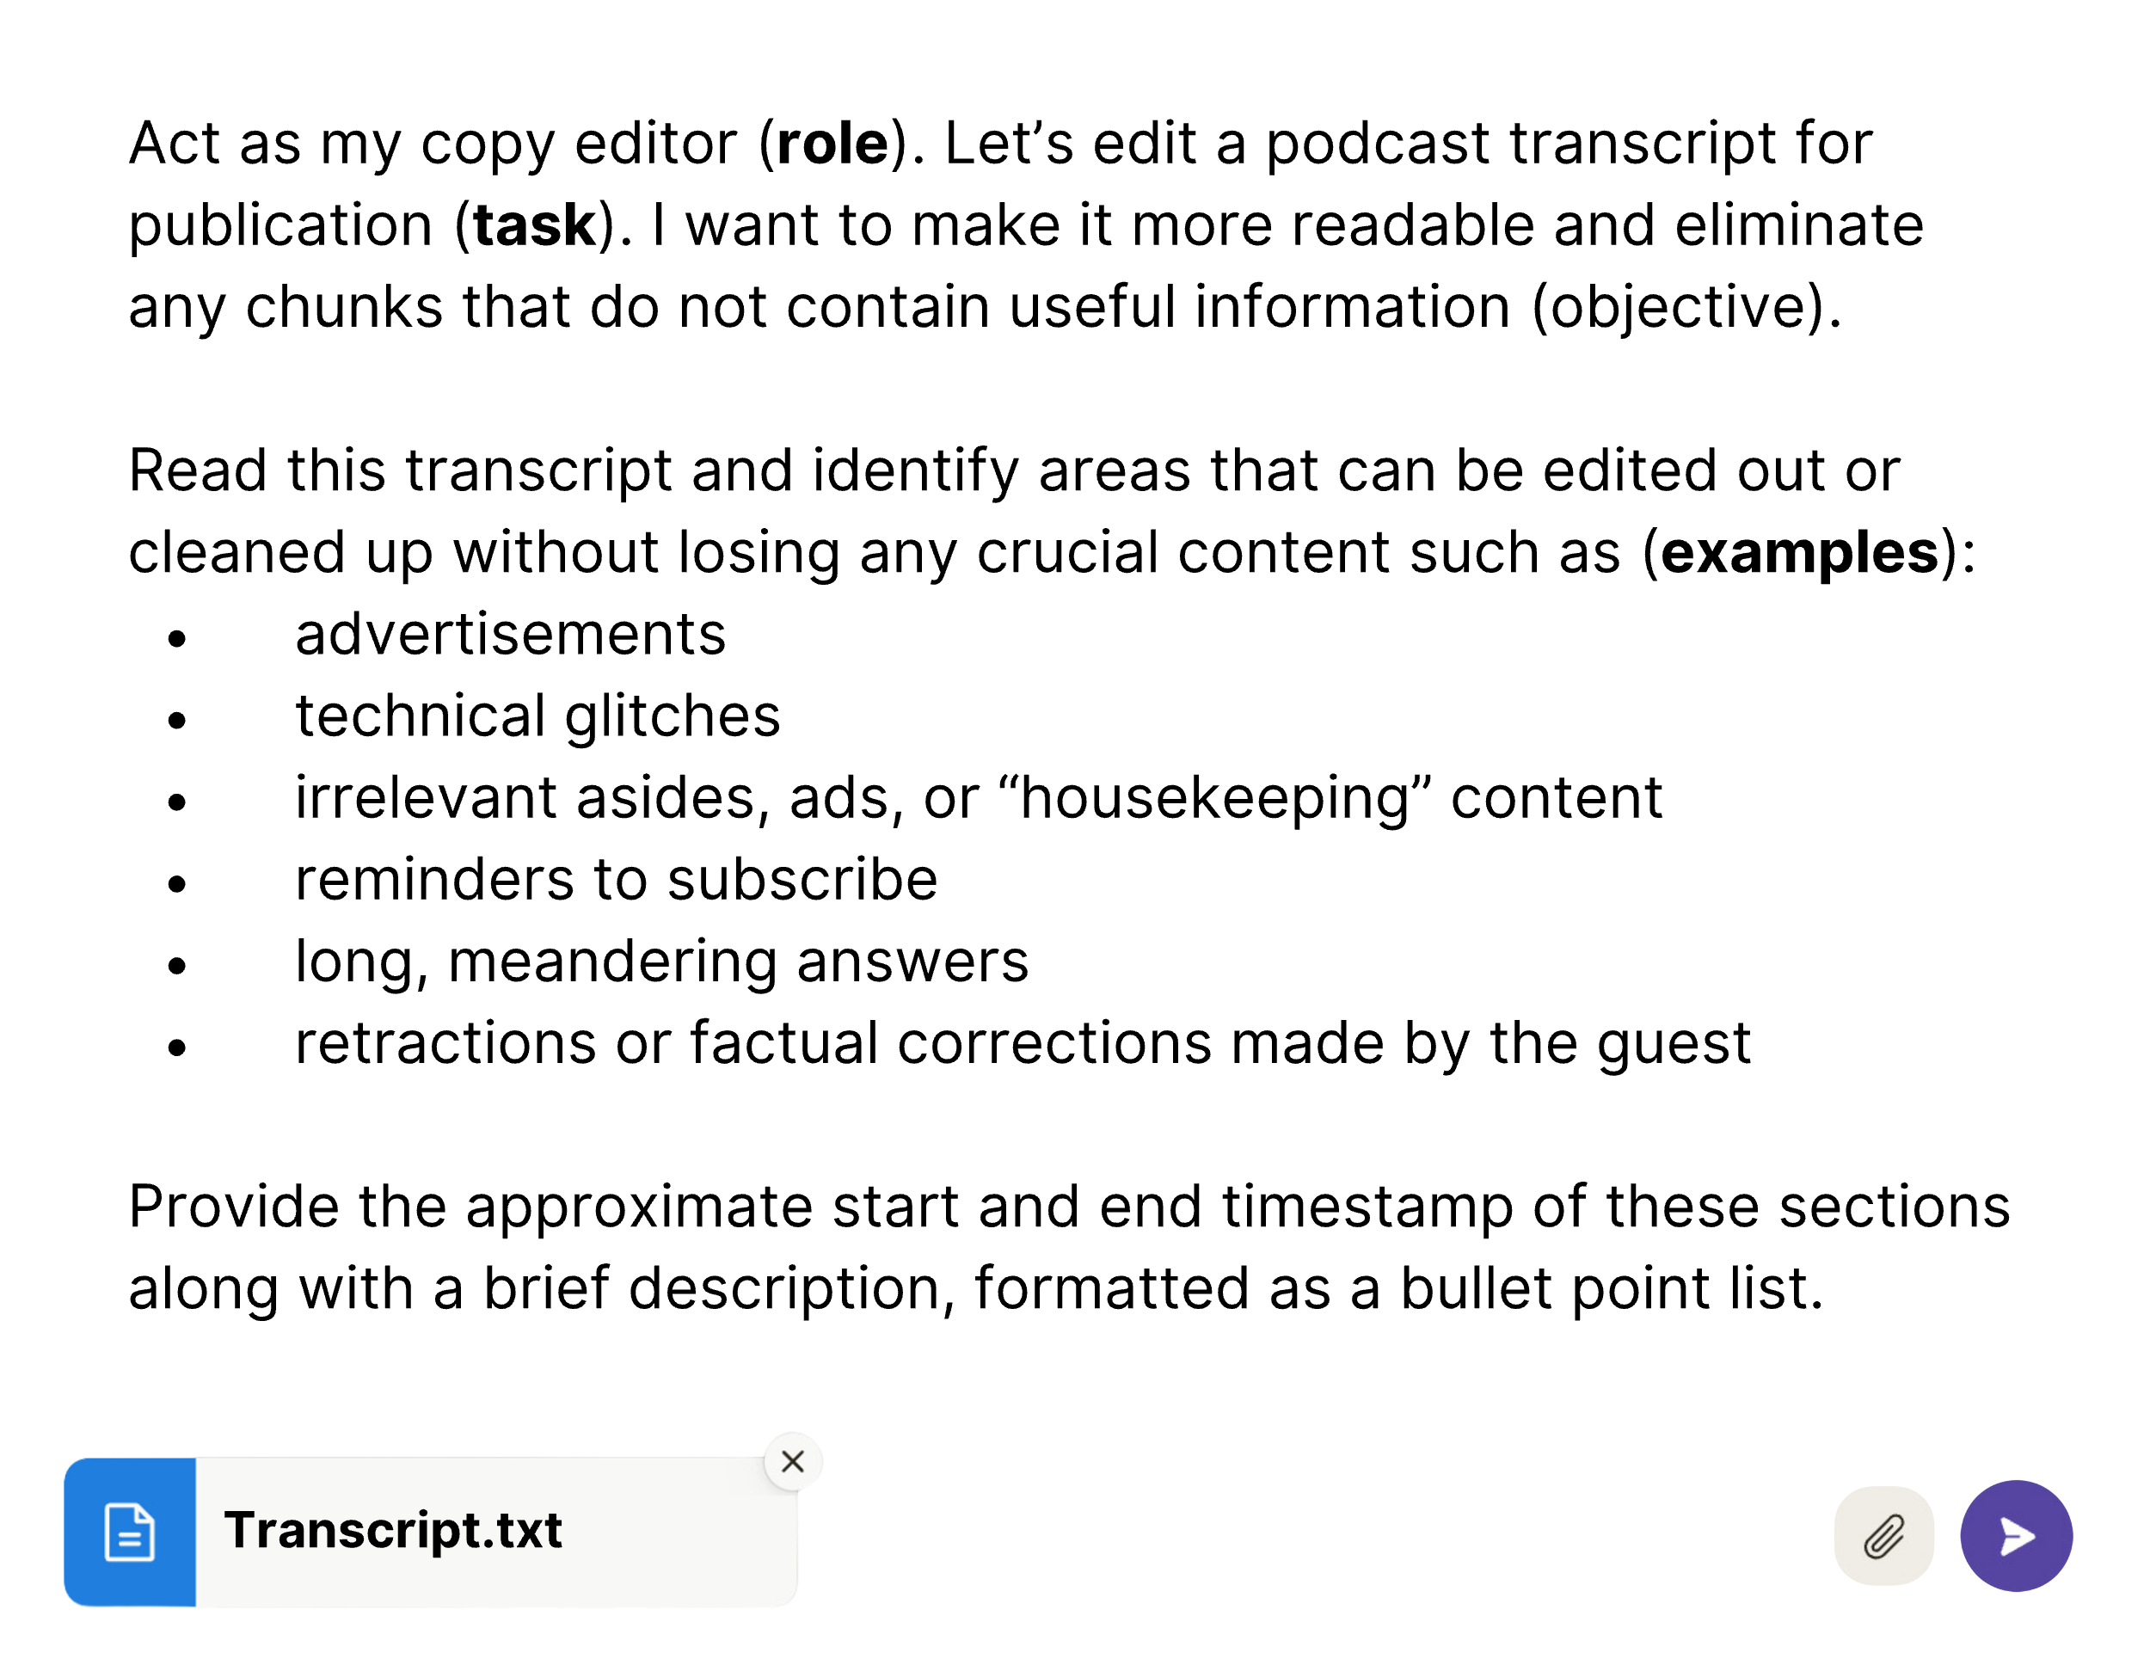

You might be able to delete 20-30% of the transcript through these changes alone.

If you are in the habit of introducing your guest with a bio, consider repurposing that text as a short, italicized preface to the chapter rather than something that is spoken by the host:

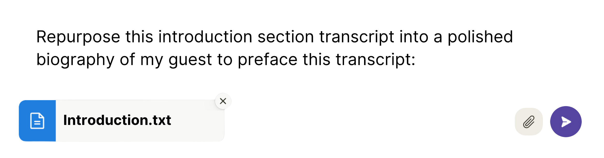

You can ask Claude to look for sections that might benefit from being relocated to improve the flow of the manuscript. Identify any redundant sections and choose the best-worded version to keep, deleting the other section or moving the selected section to where it fits best in the manuscript.

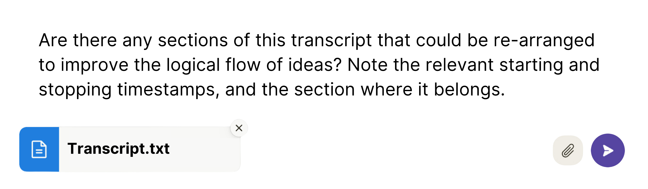

The standards for transcripts that you publish on your website or alongside “show notes” are lower than they would be for an interview being printed in, say, *Rolling Stone* or *New York Magazine*. However, these small changes can have a big impact on the reader’s experience. For example, if you publish your podcast on Substack, a polished transcript can serve as exclusive content for paid subscribers: give the audio away for free and save the sweetened condensed version for your biggest fans.

## Pull Quotes & Other Flourishes

As a final flourish, you can use a simple extraction prompt to find attention-grabbing quotes, that you can format to stand out from the main text:

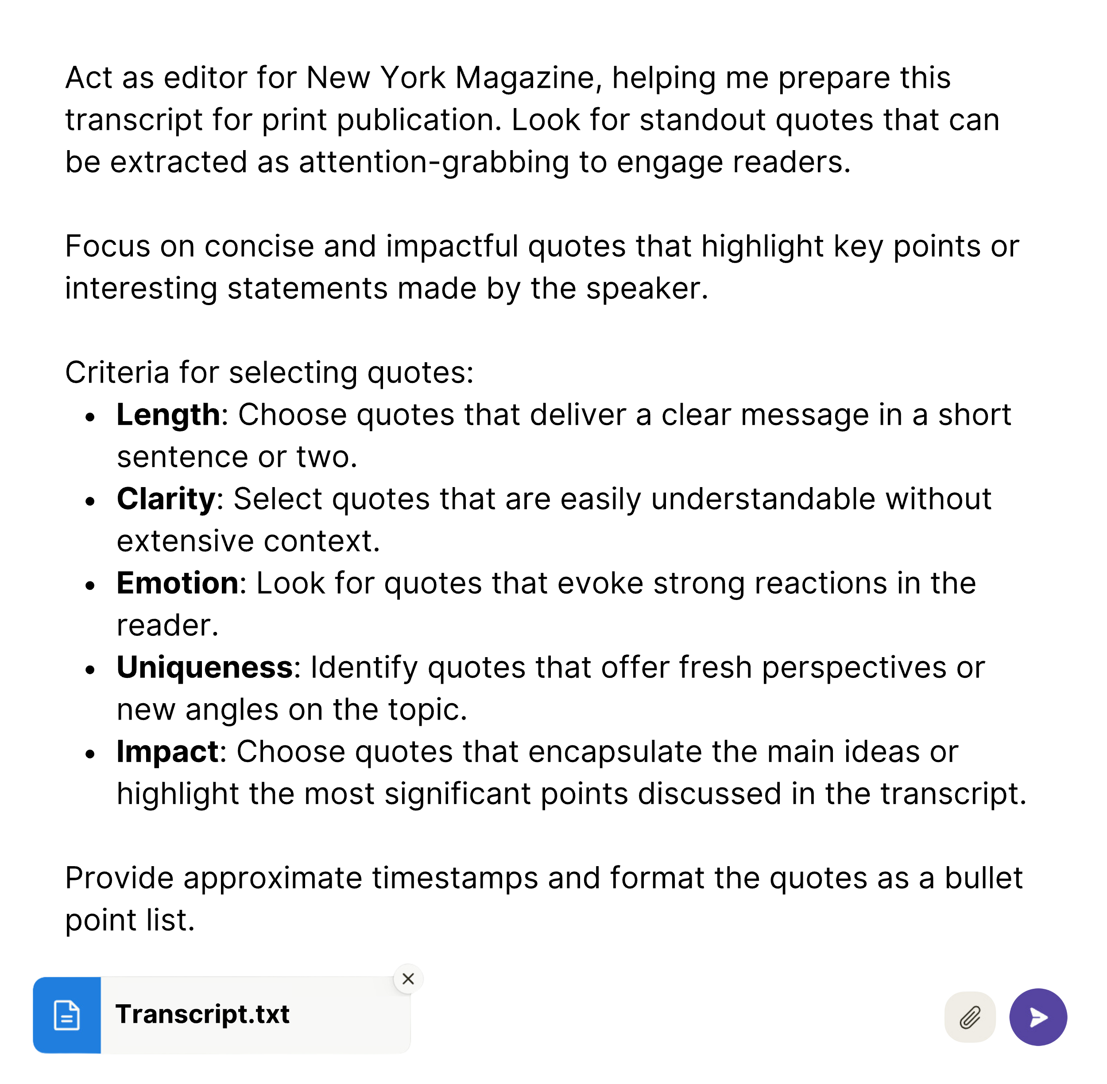

With this prompt, we are beginning to extract higher-value assets from our source material beyond the verbatim record of the conversation. These “pull quotes” will draw readers’ attention to key points and break up the text to make it more readable.

In the next chapter, we will build on this basic idea of mining transcripts for gems – exploring one of the simplest yet most powerful applications of AI. We will generate keyword-optimized podcast show notes and metadata from our edited transcript. Optimizing show notes for search engines distills your key takeaways into bite-sized insights. This makes it easier for people to find and apply the solutions shared in your content. As we venture into the realm of optimized show notes and metadata, we bridge the gap between content creation and content discovery. In essence, we not only tell the story but also ensure it reaches those who seek it.

## Try it Now:

* Take your AI-generated transcript from the previous chapter and copy-paste it into a Notion page.
* Run the **Improve writing** and **Fix spelling & grammar** prompts on a block of rough text.
* Insert the AI-edited text below the original and review what changes were made. Did Notion AI fix errors while preserving meaning? Where did it make mistakes and “overcorrect”?

Chapter 6

SEO SHOW NOTES

(In 7 Steps)

“Content is fire. Social media is gasoline.”

– Jay Baer, digital marketing strategist and author

AI-*generated* content gets a bad rap. And for good reason. I generated a hypothetical social media post with a one-line prompt based on the contents of the chapter you are about to read:

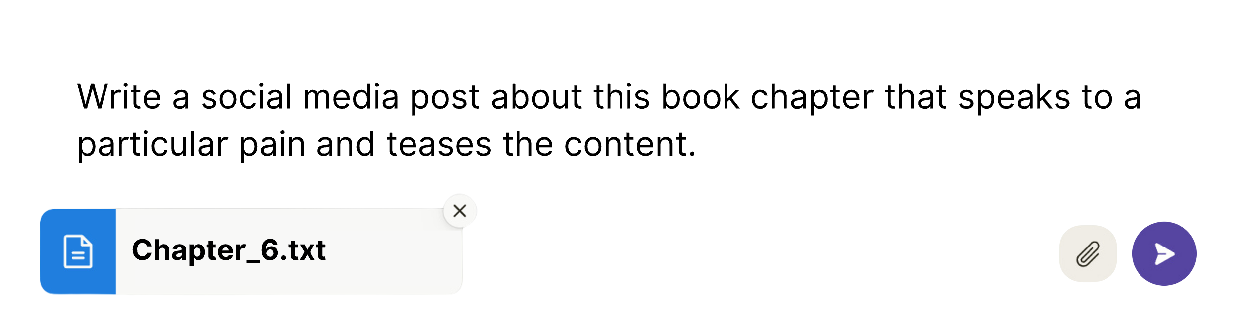

Here’s what it gave me:

“🔗 Show notes are important but tedious. New AI tools promise to automate them. But fully automated show notes are generic. The key is collaboration. This chapter explains how to repurpose transcripts into optimized show notes with AI’s help. Follow for more AI writing tips! #ai #contentcreation #podcasting”

Is it descriptive? Sure. Is it accurate? Close enough. Does it make you want to read on? I’m guessing that if you came across it on Facebook or Twitter, you wouldn’t stop your doom-scroll for long enough to read it, let alone “follow” or click through to an external link. Why not? Because it feels stale and boring.

* Generic hashtags? Check.
* Random link emoji? Check.
* Vague clichés like “The key is collaboration”? Yawn. Check.

When I first realized how NotionAI could help me polish transcript content, I went in search of a tool to simplify the preparation of podcast “show notes.” I found several options. Capsho, for example, lets you upload your audio and then spits out a series of AI-generated assets based on the transcript. These assets include:

* Titles/Email subject lines
* Opening hooks or “honey pots” to captivate the reader
* Timestamped outline summaries
* Teaser descriptions
* “Potent Quotables” (similar to the “pull quotes” extracted in the previous chapter)

Their pro plan also offers customized formatting of your assets for social media, following best practices for each platform. For Instagram and TikTok, for example, the outputs are programmed to contain relevant hashtags for keywords. For Twitter posts, the length is automatically limited to 280 characters. And for LinkedIn, the underlying prompt probably includes a template for crafting the perfect humblebrag.

Capsho’s outputs helped me get the creative juices flowing, but in the end, I canceled my free trial. Why? Because I found that I could get better, more customizable results by following my own multi-step process.

The process I present here for generating show notes provides a foundation for repurposing transcripts into other formats like blog posts and, eventually, whole books. As you read this chapter, take note of the sequence of prompts - the “order of operations.” There is a logic to doing certain things first, leveraging AI’s tendency to do its best “thinking” in discrete, logical steps. Within each step, you will provide gentle nudges to steer the AI to your destination. We will apply this same basic chain of prompts to create ever-longer and more complex content from podcast transcripts. As we zoom out from this simple use case of show notes, we will discover the same steps repeating at each level of complexity, like a fractal pattern where each small part mirrors the structure of the whole.

## Brilliant Show Notes in 7 Steps: Chain-of-Thought Revisited

While the previous chapter leaned on Notion AI to polish the rough AI-generated podcasts, this process for generating SEO show notes is optimized through a direct conversation with our trusty AI assistant, Claude. The chat format provides flexibility and allows for course correction due to the ongoing, unfolding nature of the conversation.

### Prompt #1: Getting Your Bearings

To start this exercise, you’ll need to have a transcript handy (on a Notion page or in a Word or Google Doc). Using Claude, attach the transcript in the prompt window and issue these instructions:

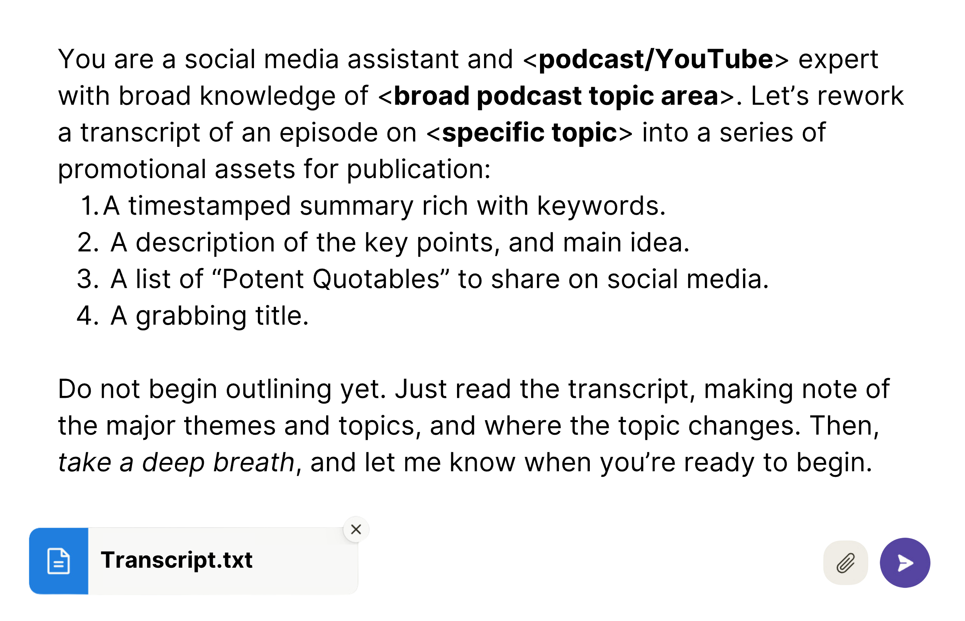

Telling Claude to “take a deep breath” here, like instructing it to “think step-by-step,” primes the model for better responses to tasks that involve multiple steps. Without these instructions, Claude is like an anxious sprinter who false starts before the gun goes off – generating a lot of unwanted text. Hard to believe? It was for me too. If you need convincing, try it. Run the same prompt without the words and see how the output changes. Tweaking instructions can be helpful as you develop your mechanical sympathy and intuition about prompting.

After this initial prompt, Claude will affirm that it has read the transcript and may provide some broad notes on what it learned about the key points. This output serves as a kind of sense check. We will not use this response, but if something is way off, we can stop and correct it.

From here, we begin to map out the contents of our source material at a high level:

### Prompt #2: Timestamped Outline

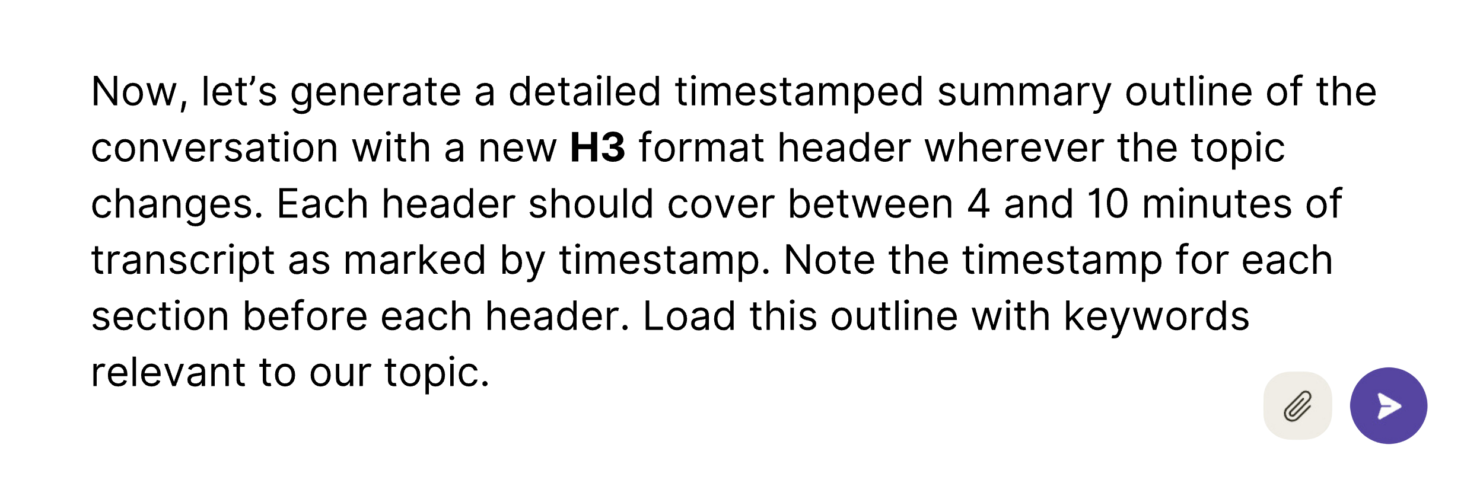

Copy the transcript outline produced by Claude and paste it into the same document that contains your transcript and show notes – whether in Notion or elsewhere. This provides you with a keyword-rich “map” to the episode, so listeners can decide whether to tune in or skip to a specific segment.[3] If you are publishing the entire transcript with your show notes, you can re-use the outline as guideposts and section headers within the transcript itself.

## SEO in the AI Age

Now, with your map of the territory, you are ready to home in on the main point – the single biggest takeaway you would want readers or listeners to glean from the episode. All of the assets you will create from this point forward will hinge on the proper identification of the main idea. For example, you can’t write a good title or description before you decide what the episode is *about*. After uploading your audio, the first thing Capsho does is suggest three potential characterizations of the main theme of your episode. You pick one, on which it bases the outputs. Our next prompt will mimic this process, and use the context we’ve already established to suggest several options for the main idea[4]:

### ****Prompt #3: Main Idea – Suggestion****

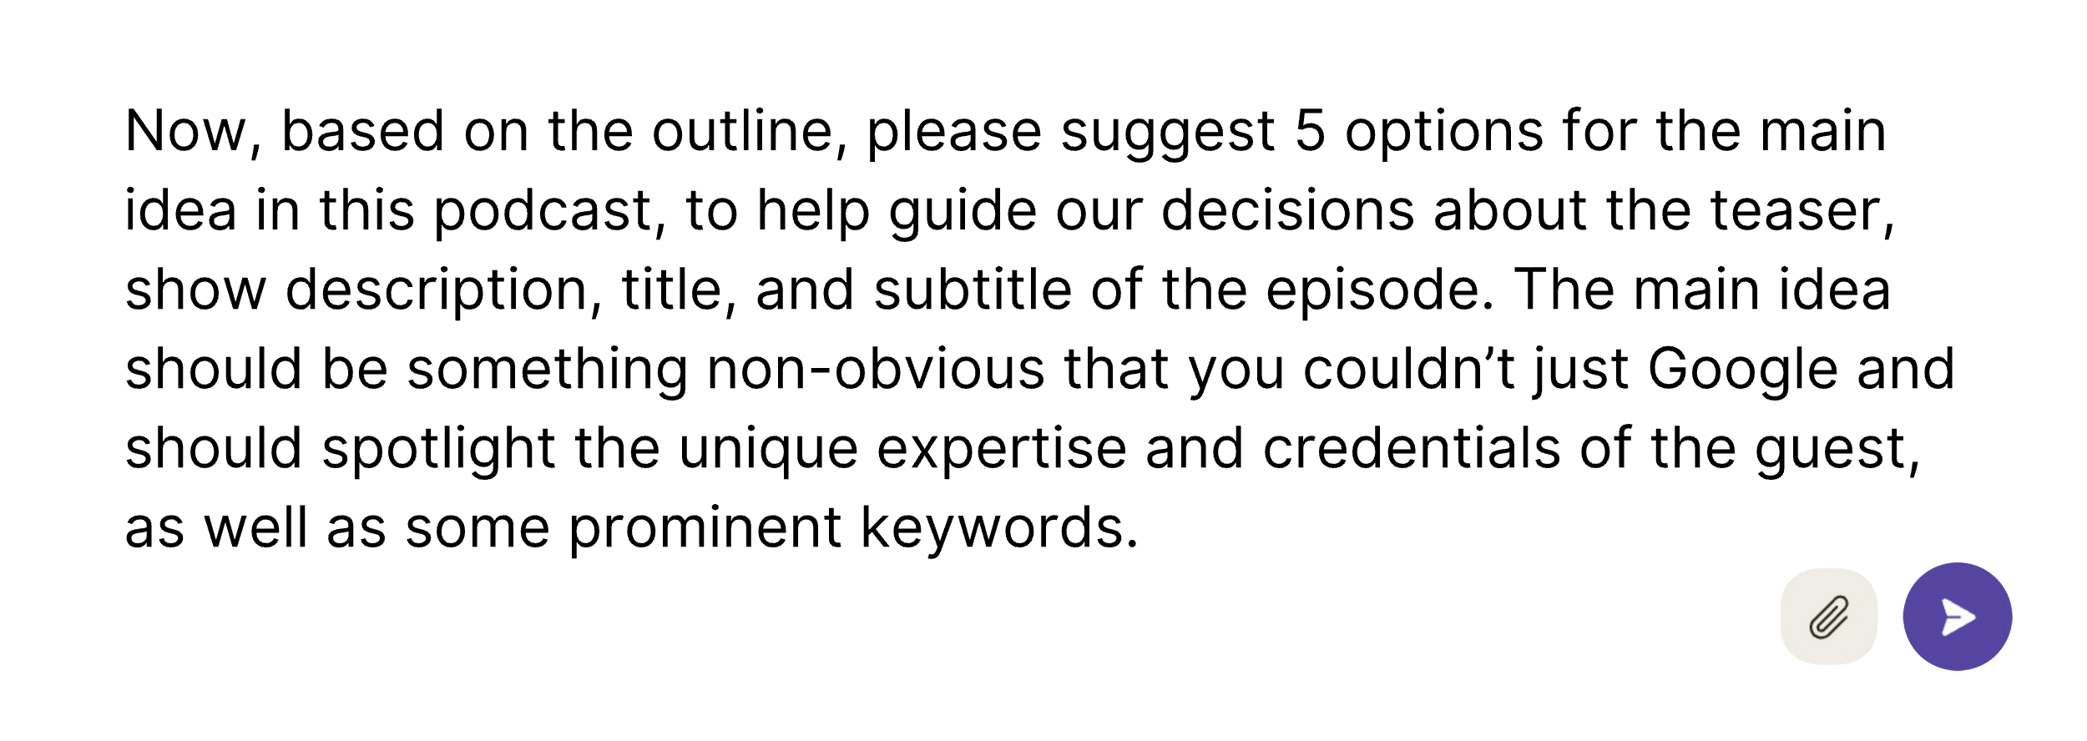

With this prompt, we’re gearing Claude to generate content that’s useful and SEO-friendly. SEO, or Search Engine Optimization, is all about making your content more visible and attractive to search engines like Google. Google’s SEO guidelines have long favored content exhibiting qualities of “E-A-T”– short for expertise, authority, and trustworthiness. Now, they are adding an extra “E” for experience – seeking content that demonstrates real-world knowledge and credibility over generic AI-generated content. This change in the search algorithm represents an opportunity for creators with *true* subject matter expertise to stand out. Those who exemplify depth of knowledge will be rewarded in search rankings, while those who regurgitate basic information contained in the training data will be punished. Your show notes and description are an ideal place to emphasize experience and credentials – both your own and those of your guests.

With these points in mind, you can mix and match the suggestions for the main idea, or rewrite it to fit your understanding:

### ****Prompt #4: Main Idea – Refining, Pt. 1****

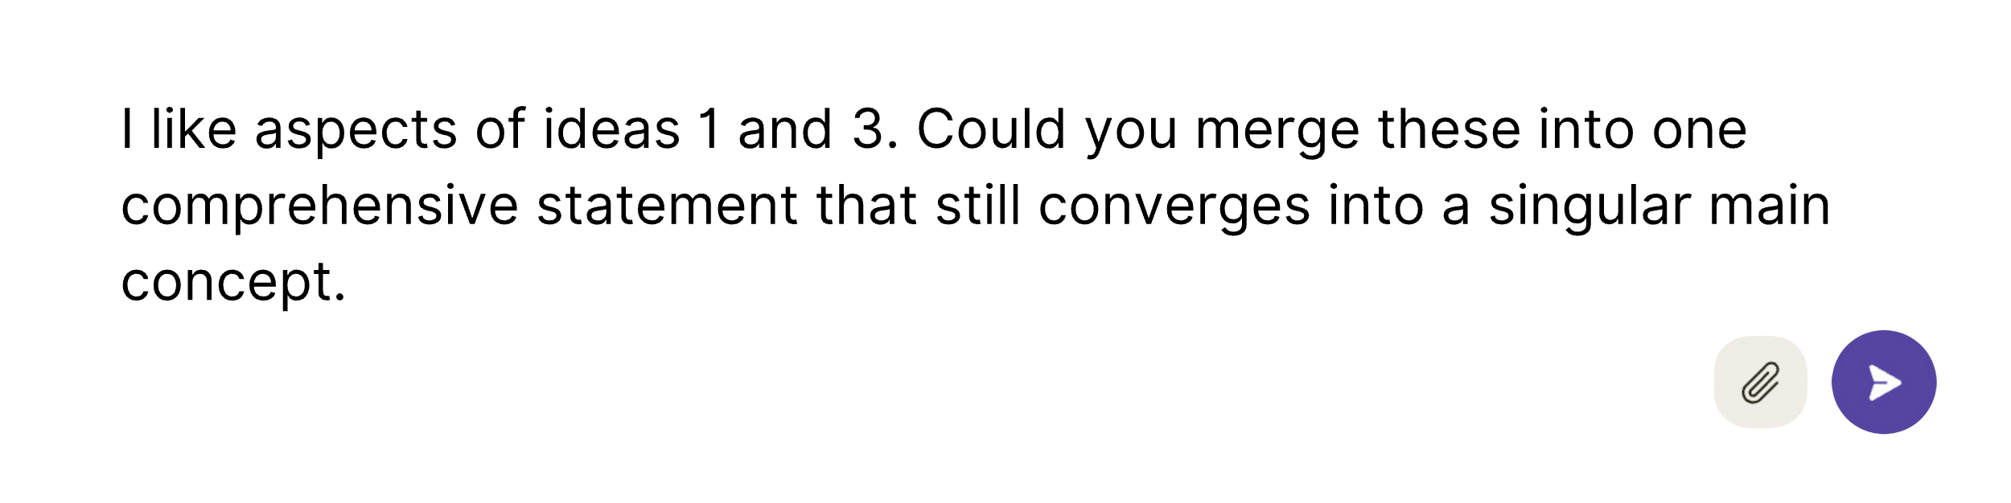

Or…

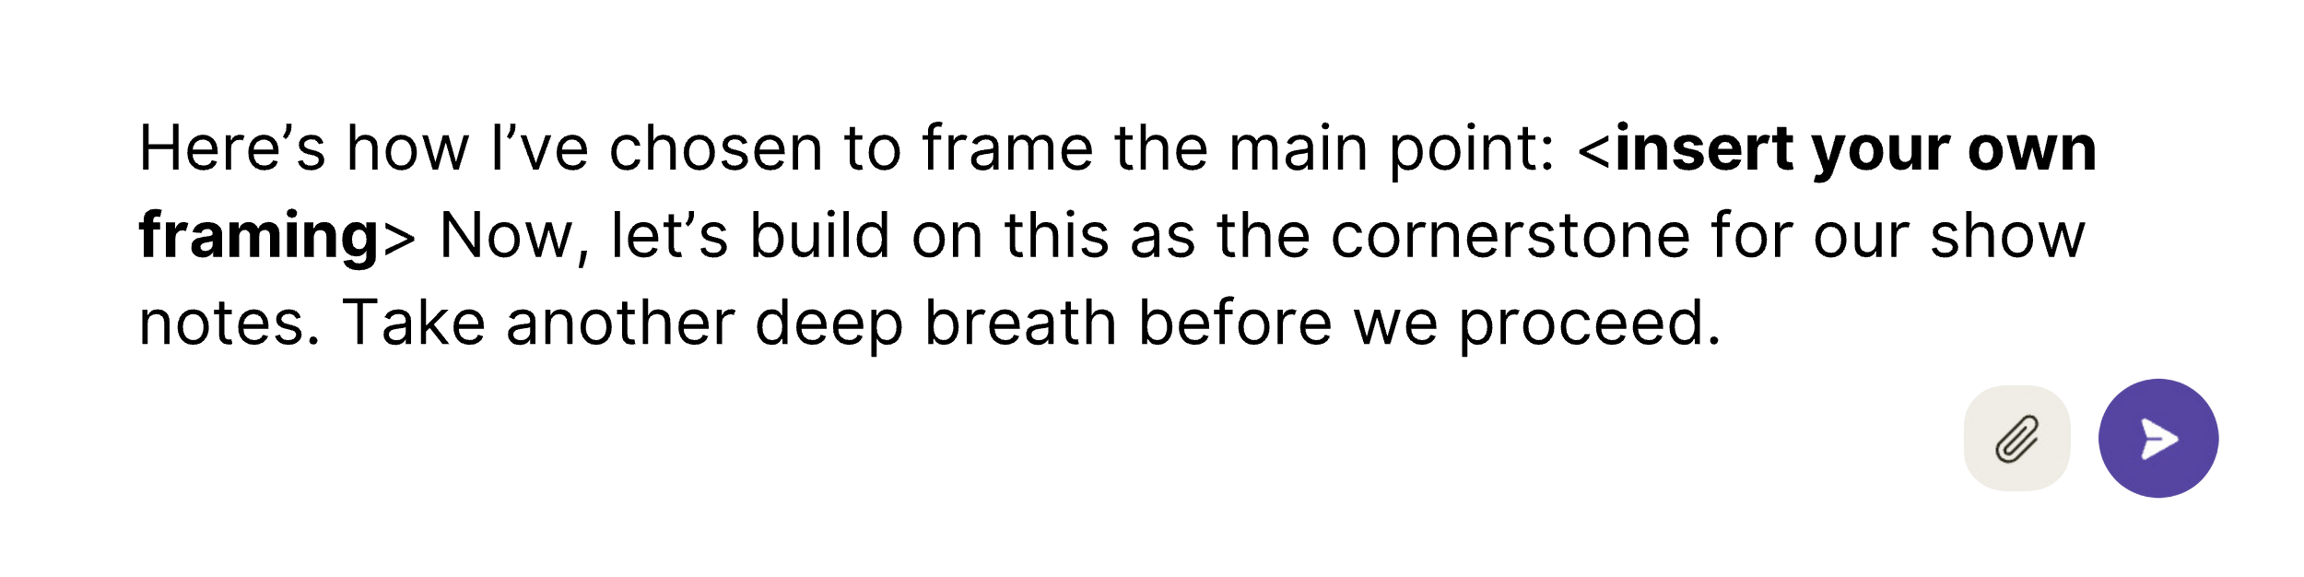

Now, your main concept functions as a kind of one-line description of the episode. But most podcasting platforms, as well as YouTube, allow more than just a one-line description to help people find your content. After the title, the description field is the best place to hook your audience and load up on SEO-optimized keywords so that your content has the best chance of being discovered or recommended to your ideal viewers and listeners.

People often think of SEO as a zero-sum game, with fierce competition for top rankings on scarce online real estate (search results). I find it more helpful to think of SEO as a way to connect real people to real solutions and the information they are seeking.

What’s the point of trying to trick people into clicking your link only to find that it doesn’t contain what they’re looking for? Instead, focus on compelling yet accurate titles and descriptions that reflect your niche expertise. Titles should avoid common tropes. Balance keywords with natural language and conversational tone. Hook readers with curiosity and a message about specific benefits to them. Descriptions should showcase your experience and authority.

Before you set out to create content, research what questions people are asking around your niche using tools like Google Trends, Ahrefs, and AnswerThePublic, then tailor the content to address those knowledge gaps. Weave in personal anecdotes or your origin story related to the niche, and back up your claims supporting the main idea with evidence and external links. You must first extract these key building blocks of content from your transcript before you can write solid SEO titles and descriptions.

Our next prompt will kill two birds with one stone, helping you identify quotes that will both bolster the authority of your content, and serve as the basis for shorter standalone “microcontent” that can be shared alongside your podcast:

### ****Prompt #5: Potent Quotables****

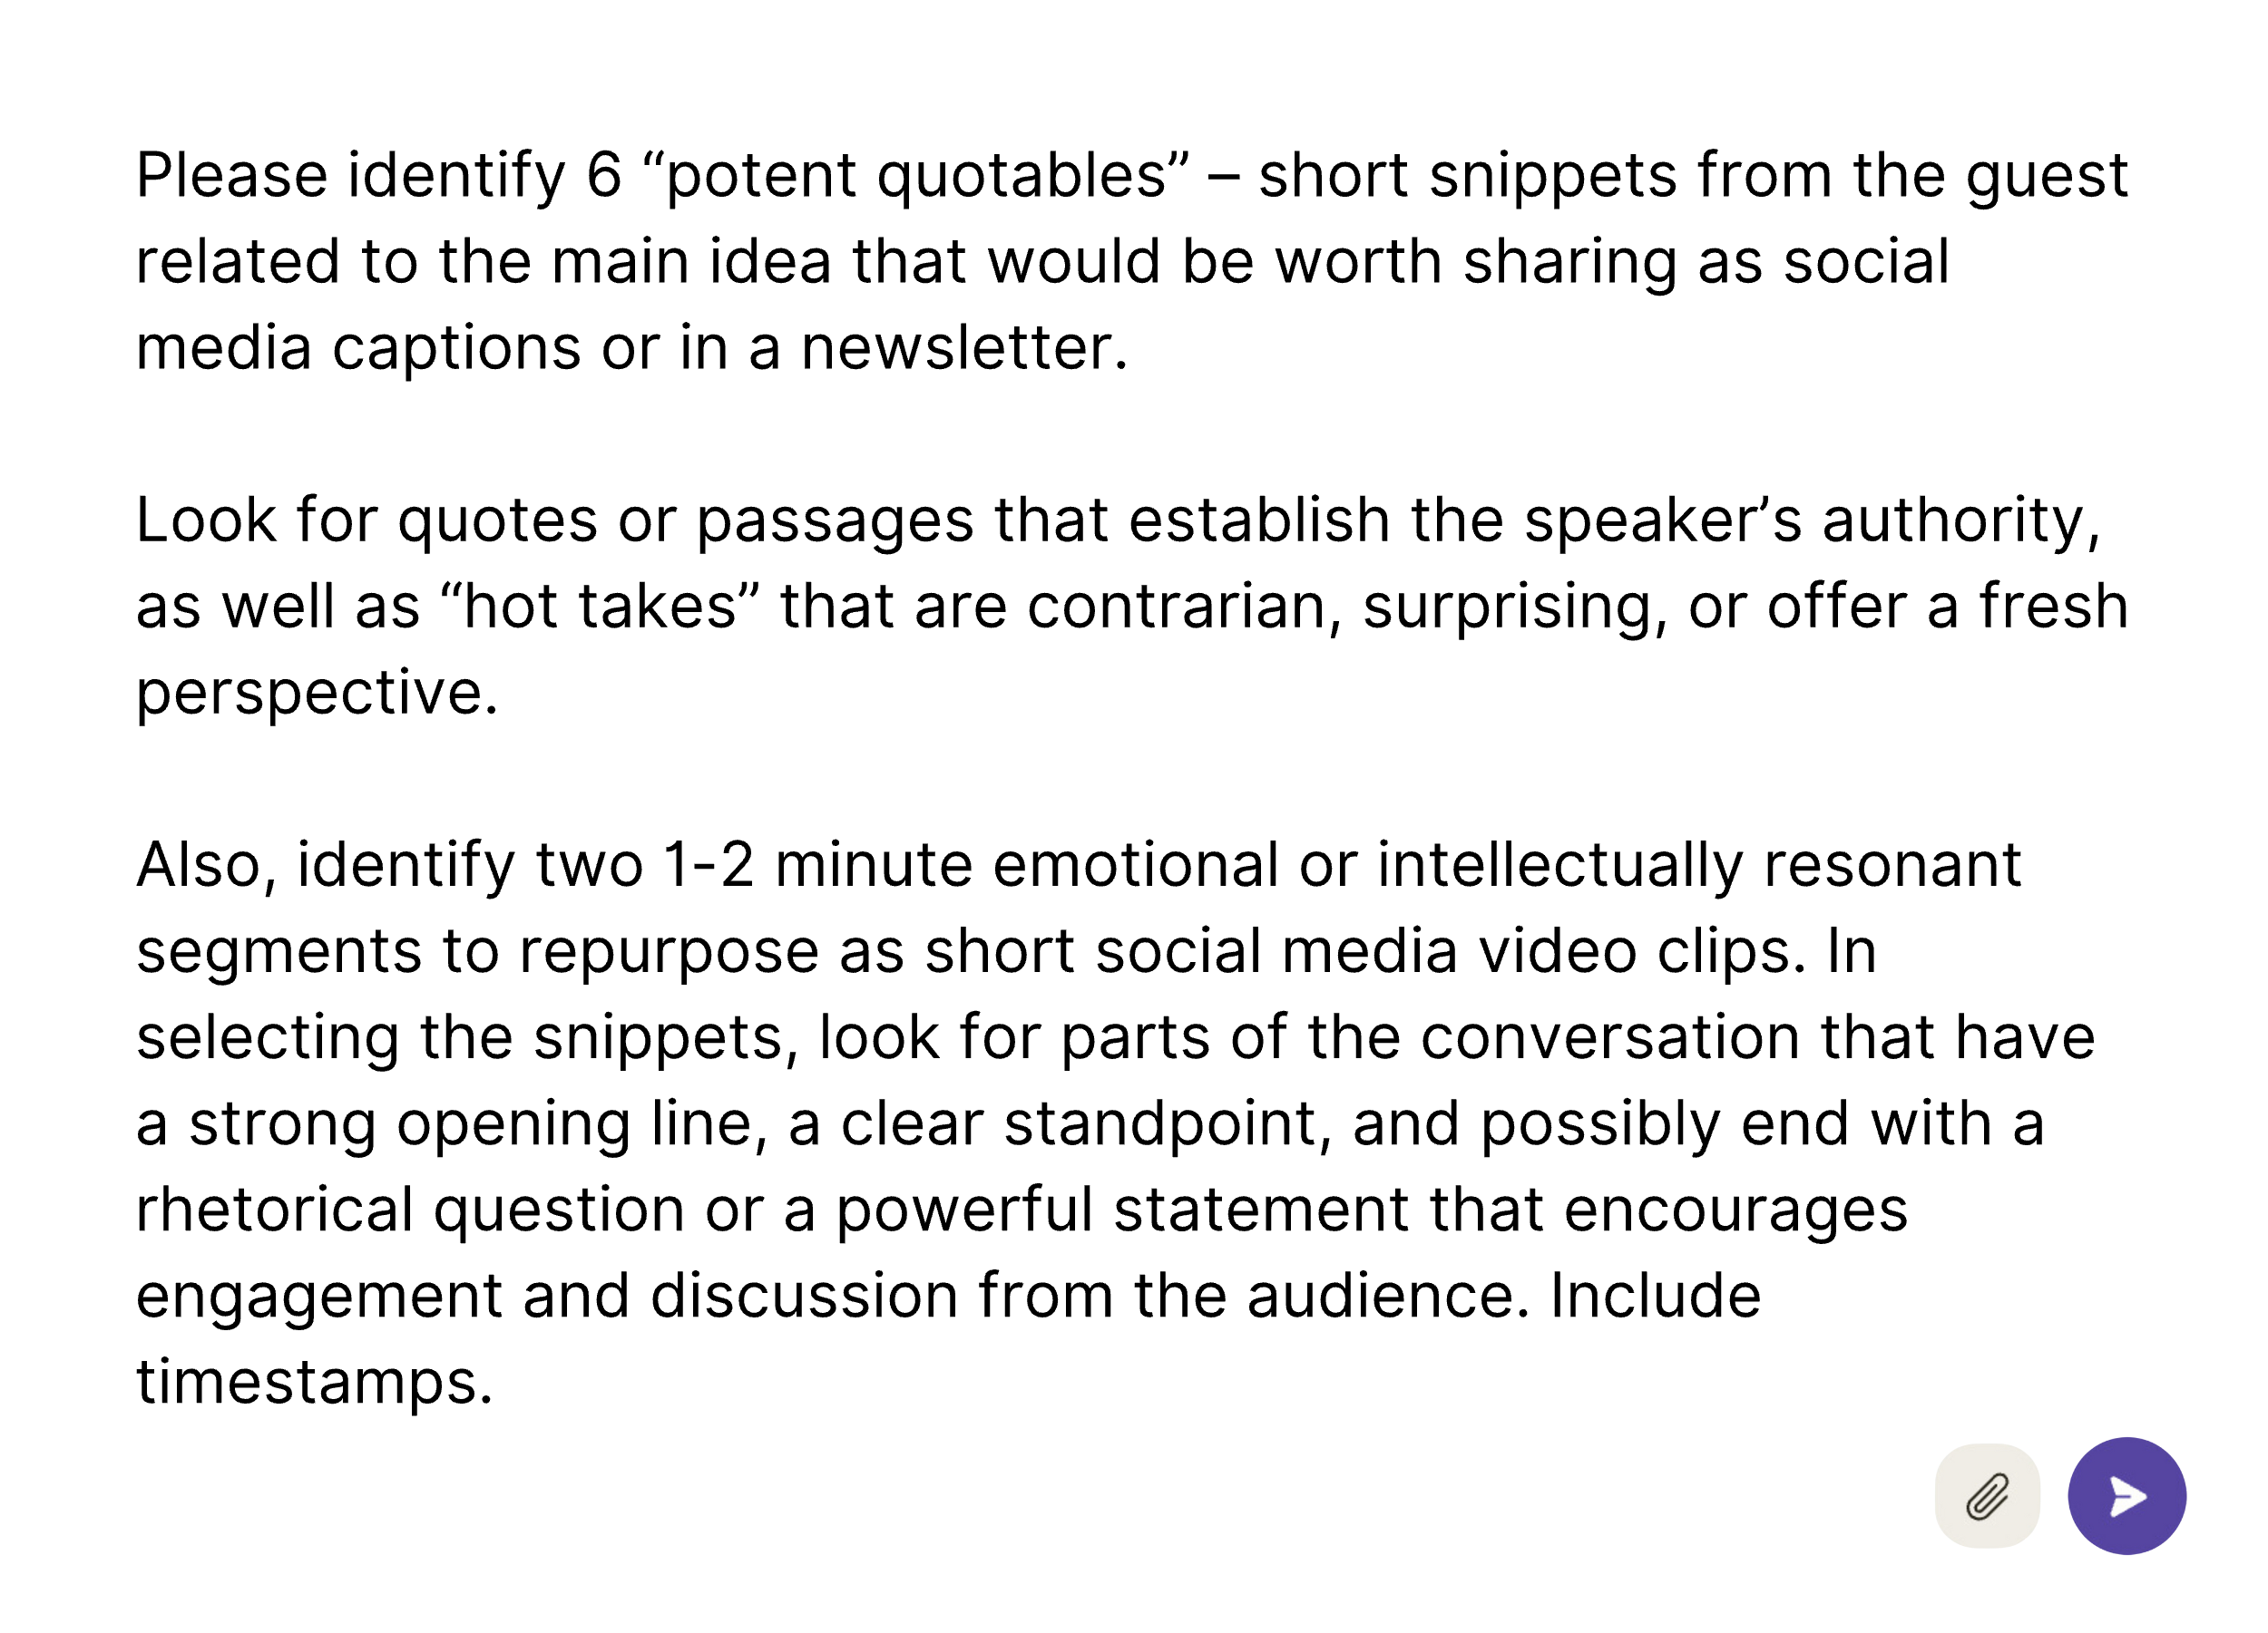

These timestamped quotes make it easy to clip snackable video snippets or produce quote graphics to share across social media platforms. Finally, if you are writing a longer blog post summary of the episode, these quotes will also serve as valuable assets to bring the text to life, with your guest’s own voice – breaking up the monotony of the summary.

Next, ask Claude to identify a list of links and resources mentioned in the transcript with this prompt:

### ****Prompt #6: Links and Resources****

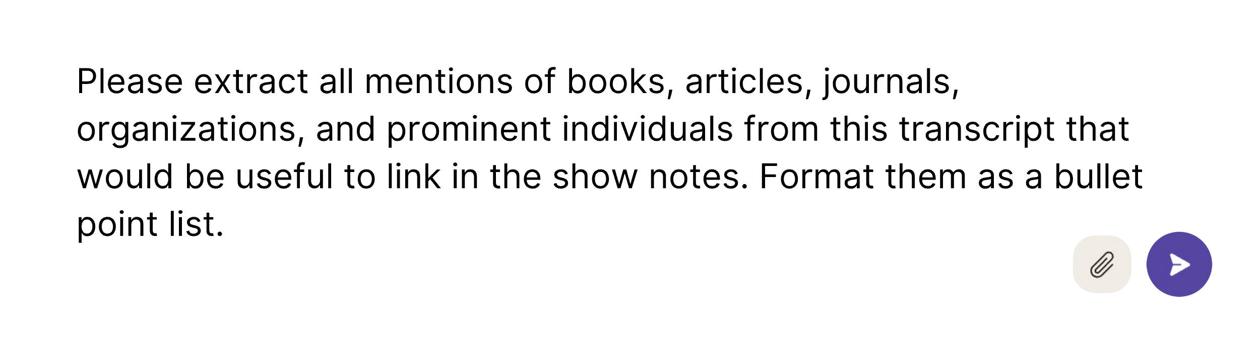

This links section can enhance the trustworthiness of your post. While AI tools like Claude are unable to provide up-to-date links, ChatGPT is now integrated with Bing to access current web pages and format pages as clickable links, pulling from live web search data. Still, it remains wise to verify these links to maintain the integrity of your content.

At last, you are ready to prompt Claude for title and description suggestions – the capstone of your show notes. These are the most important fields because they influence SEO the most and are what most people will see first in deciding whether to read or listen.

### Prompt #7: Title & Description

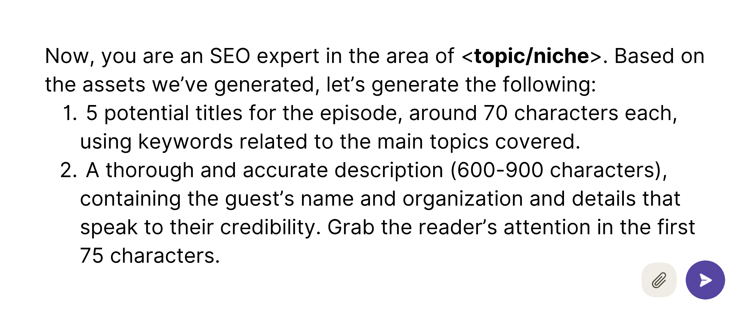

Here, the requested length instruction is based on YouTube best practices, but this length works for podcast descriptions as well.

If you already have standard formatting for your episode titles or descriptions, you can attach additional examples along with your instructions:

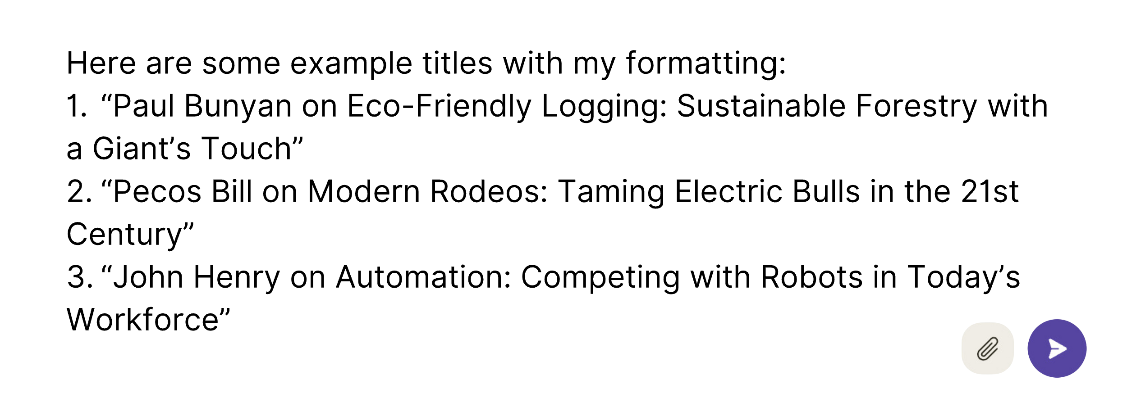

Your title and description function as the sales pitch for the rest of your piece, so after reviewing the suggestions, spend some time iterating with Claude, or just rework the outputs with your own ideas. Remember that the AI’s responses should be viewed as first drafts. This is true whether you are working directly with Claude, or with a tool designed to give you specific assets.

There are already dozens of tools out there to help you generate SEO content based on just a few keywords. **Some are even good. The beauty of this process, using the chat console, however, is that you** remain in the driver’s seat throughout – refining outputs at each stage and training the model with your feedback.

Rather than asking AI to generate your assets in a single prompt, you will get much better results by overseeing its output in this way. When your competition can churn out masses of generic content with AI, you can’t compete on the quantity of output or keyword loading alone. To win the SEO game, you’ll need a quantity of quality – a large volume of well-organized long-form content based on your expertise and written in your voice. That’s how you’ll earn your readers’ trust (and Google’s). With your AI-powered content engine fired up, let’s remain in the driver’s seat see where this hotrod can take us.

## Try it Now:

* Provide Claude with a transcript, along with single prompt to generate a title and show notes for the episode.
* Then, start a new dialogue and run through the sequence of prompts in this step – working towards the main idea before writing your title and description.
* Compare the two. Which one is more compelling?

Part 3

Becoming a “CODER”

Chapter 7

OF PYRAMIDS & DIAMONDS

Have We Reached “Peak Content”?

“Content is king, but context is God.”

– Gary Vaynerchuk

In a world where content is king, Gary Vaynerchuk – aka Gary “Vee” – reigns supreme with his miniature media empire. He commands the attention of over 44 million followers across all of his social media accounts.

Vaynerchuk has built his platform atop his trademark “Reverse Content Pyramid,” which starts with a substantial, single piece of content – referred to as “pillar content” – such as a podcast, a keynote speech, or a detailed YouTube video, positioned at the top of this inverted pyramid. From this pillar content, he extracts smaller, more digestible pieces, known as “microcontent.” Microcontent includes elements like video clips, memorable quotes, short blog posts, and memes. These brief, attention-grabbing pieces are tailor-made for the short attention spans of people on social media and this approach has proven effective – generating a remarkable total of over 35 million views spanning Instagram, YouTube, Facebook, Twitter, LinkedIn, TikTok, Snapchat, and Spotify.

The success of this approach is undeniable, spawning legions of copycats all striving to replicate his blueprint. Everybody wants to be Gary Vee.

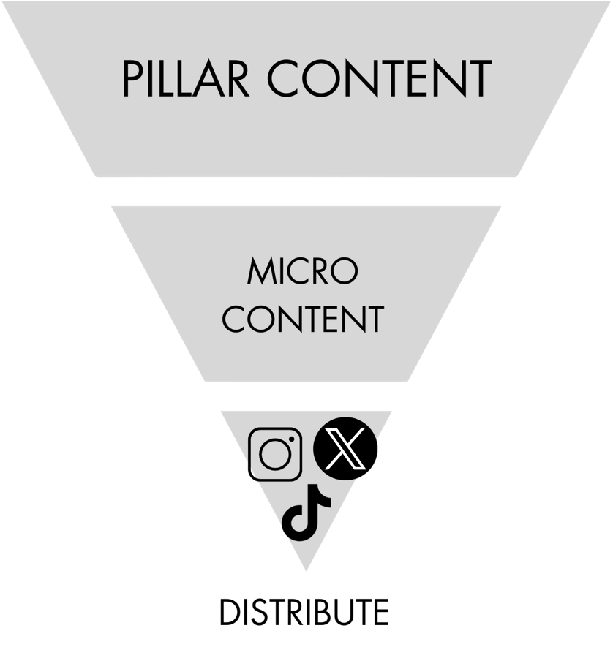

In the last chapter, we learned how to condense long transcripts into more digestible short-form content, such as show notes, podcast summaries, and social media snippets. Similarly, we can create dynamic Instagram Reels and TikToks using the same pillar content. Despite this strategy’s effectiveness in garnering attention, it poses a critical question:

Are we making a contribution, or just contributing to the noise?

The surge of content is already here. The floodgates will open further as AI continues to level the playing field and make it easier to repurpose a single podcast or article into dozens of smaller pieces. We risk drowning in a rising tide of low-value content that delivers more noise than signal – more warmed-over platitudes than genuine insights.

## The Case for Long Form: Inverting the Reverse Content Pyramid

While the Reverse Content Pyramid excels in generating views, another approach focuses on converging multiple ideas into a cohesive, substantial composition. In this strategy, you *aggregate* smaller content pieces as the building blocks for more comprehensive articles, chapters, and books.

In this upright pyramid model, we still begin with pillar content such as in-depth videos, articles, or podcasts. These pillars, developed over time, support the creation of enduring long-form content, which establishes your expertise above the fray of the social media free-for-all. Over time, these pillars mature and grow until you reach the pinnacle of thought leadership: a book that embodies your unique perspective and knowledge.

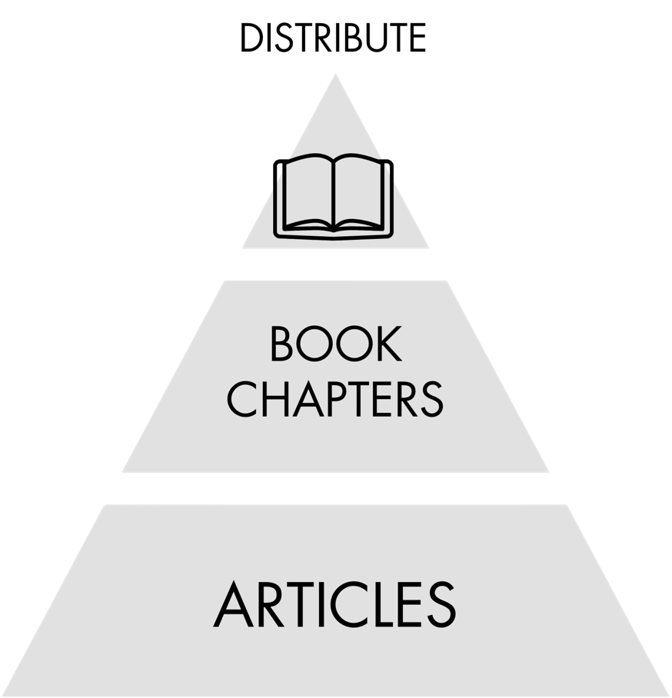

A book is a tangible item that readers can hold, feel its weight, immerse themselves in, revisit, and share with others. A book stands out in the physical world, whether it’s displayed in an airport kiosk or a bookstore window, enticing passersby to step into your world. Even a self-published book or digital book can be as valuable as one published by a traditional publishing house if it solves a real problem for a specific audience.

My experience with long-form content has resulted in partnerships with publishing houses and the sale of over 50,000 copies. While the royalties are not enough to supplant a full-time income, my self-published titles earn me a steady annuity through Amazon’s Kindle Direct Press platform. Moreover, my articles continue to be read, even years after their publication, because I have focused on creating content that remains relevant over time rather than chasing trends. Only those who offer depth and insight will stand out in a landscape where superficial content is commonplace.

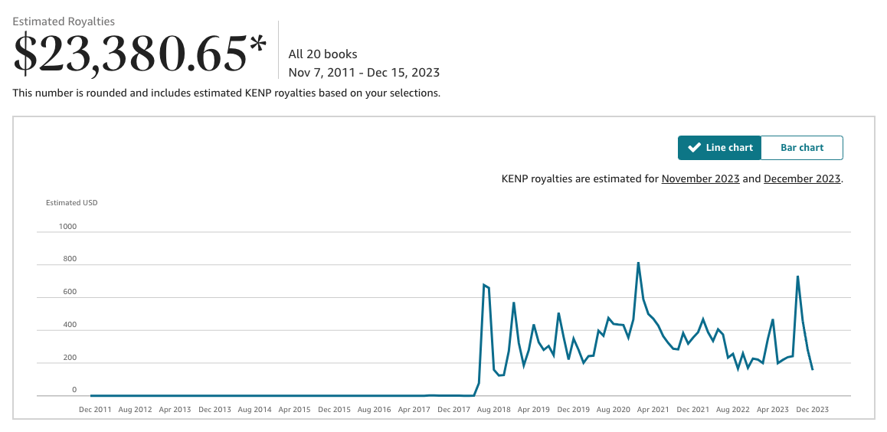

Repurposing content upwards does not stop you from leveraging short-form social media. Instead, it can give those activities more purpose. Imagine your content strategy not merely as a V-shaped funnel but as a diamond, where ideas flow both upwards from short-form to long-form, content and downwards – breaking longform back down into bite-sized pieces. This dual approach ensures a broader reach and fine-tunes your message, testing smaller ideas that have the potential to expand into larger projects.

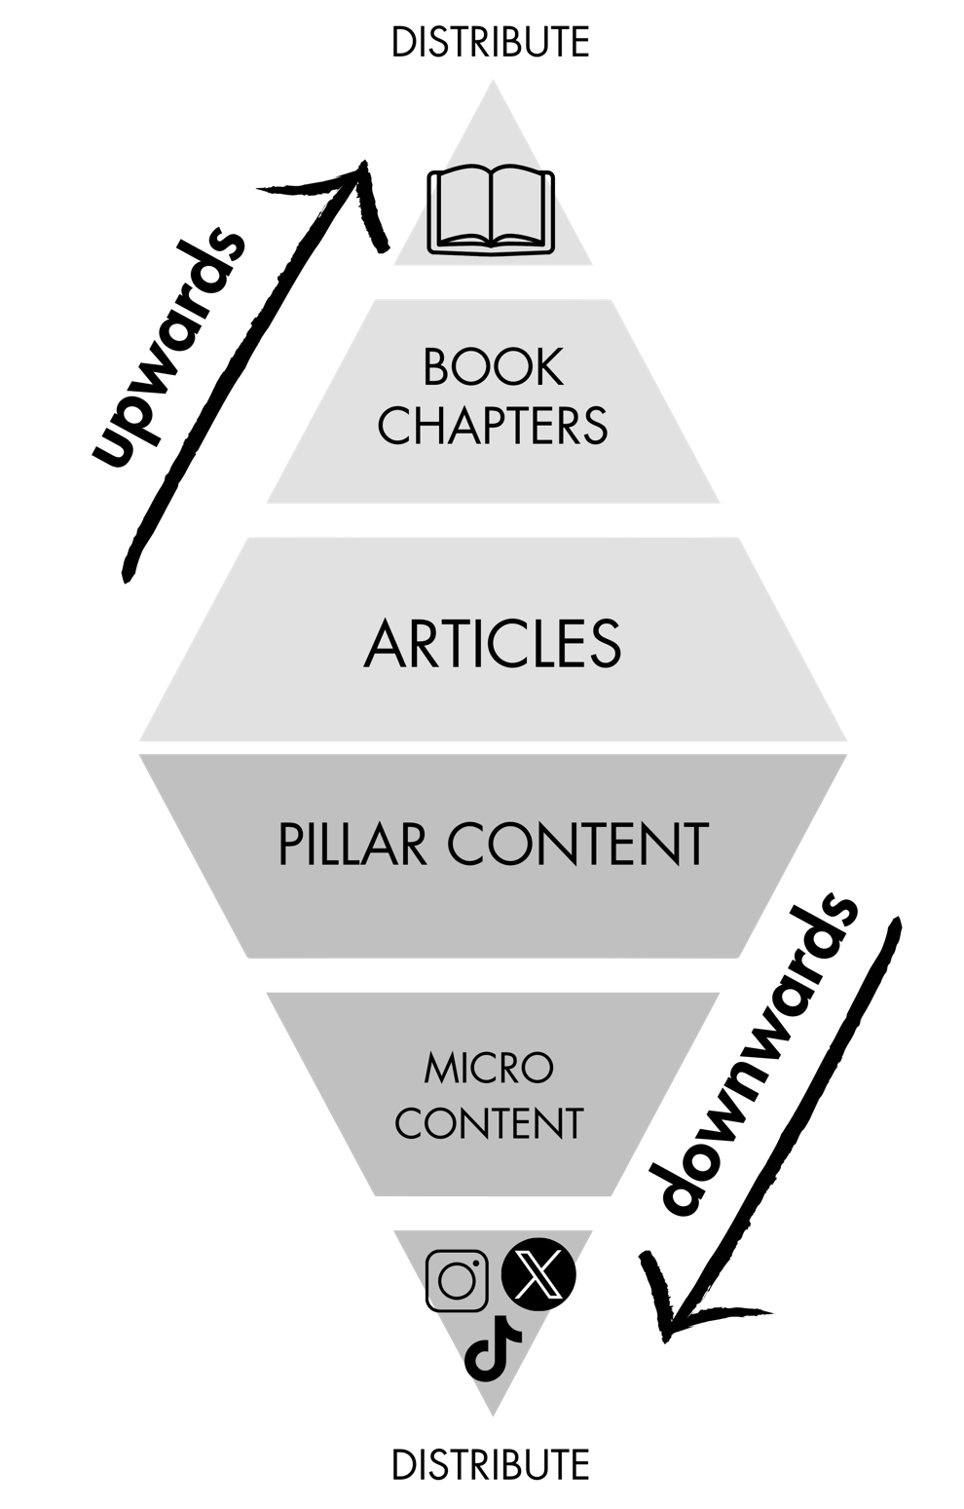

## ****The CODER Framework: Crafting Your Content Diamond****

In flipping Gary Vee’s reverse pyramid back into an upwards-pointing pyramid, I’m aligning with a core principle in this book: AI is most powerful as a tool to refine raw inputs. It’s a *transformative* process of reworking and elevating your existing content and ideas – those “trapped” in your head or in an archive of content like a folder of notes or transcripts from a podcast.

As you work your way up and down the content *distribution* diamond, there is a second diamond visual – flipped horizontally – that can guide you in content *creation*. Tiago Forte, best-selling author of *Building a Second Brain*, has a four-step “CODE” framework that aligns with this diamond shape. Forte simplifies the creative process into four stages: **Capture, Organize, Distill,** and **Express**. This acronym represents a whole philosophy around content creation. “**Capture*”*** and “**Organize*”*** represent the initial expansive gathering and structuring of your content. These initial “divergent” steps build up to “**the point**” – the crux of your message and the main idea from which it all begins to converge. Next, you enter the “**Distill*”*** stage, extracting the essential supporting points before reaching the “**Express*”*** stage, where your ideas are articulated in their most compelling form.

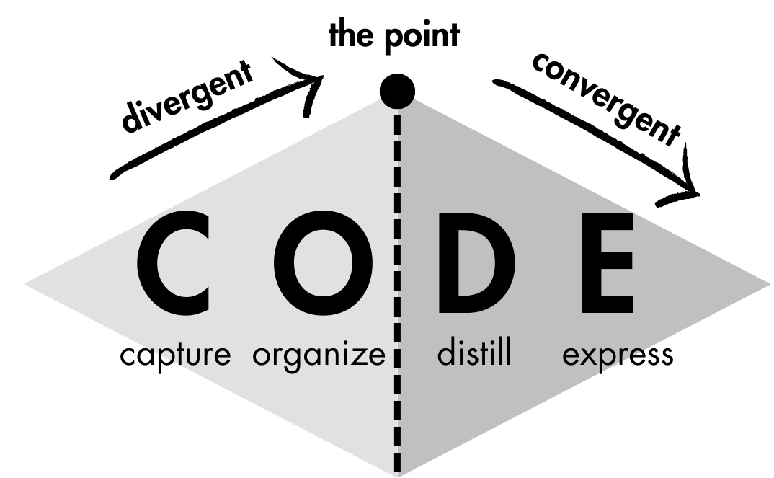

If you go back to the previous chapter, you will discern this progression in the process we used to turn a transcript into final promotional materials:

* First, we **captured** ideas in the form of a podcast transcript.
* Then we **organized** ideas in search of the main idea – the Point.
* Next, we **distilled** key details like quotes, links, and supporting points.
* Lastly, we **expressed** the distilled ideas in the title, description, and marketing copy.

As we begin to construct longer and more complex forms of content, the CODE framework scales with us in a fractal pattern. It’s an iterative loop that you’ll travel repeatedly as you refine each layer of your content, ensuring that each stage is a building block to a more intricate and impactful whole. In the next stage of this journey, we will apply the CODE framework to the process of turning a podcast into an article. The final stage will involve writing entire chapters and, eventually, books. Different formats, same progression: **Capture, Organize, Distill, Express.**

I have added one final letter to Forte’s acronym, R, for the “**Refining”** phase. This is where we add the finishing touches, polishing the diamond until it shines with clarity. Each of these diamond schematics is powerful on its own. Together, they provide a framework for the efficient *expression* of your ideas, followed by efficient distribution across the full spectrum of platforms and media – from short-form social media snippets to long-form print books. In following this methodology, you evolve from a writer into a **CODER** of meaningful language – a natural language programmer. You become a commander of the page, bringing order, logic, and clarity to messy, unstructured ideas in record time.

Let’s now shift from theory to practice – applying these principles with a step-by-step process for transforming your “pillar content,” like podcasts, into polished, engaging articles. We begin with the first phase of all creative processes: capturing your ideas in their raw form.

Chapter 8

CAPTURE

Treasure In, Treasure Out

“Garbage In, Garbage Out”

– Old programming adage

“On two occasions I have been asked, “Pray, Mr. Babbage, if you put into the machine wrong figures, will the right answers come out?” ... I am not able rightly to apprehend the kind of confusion of ideas that could provoke such a question.”

–  Charles Babbage, Passages from the Life of a Philosopher

How can you tell the difference between an article that was written by a human and something churned out by AI in seconds? If there are typos, it’s probably of human origin. When it comes to the basic writing mechanics and even certain stylistic elements, AI has gotten good.

How good? Let’s put it this way. Joshua Lisec, one of the most talented and sought-after ghostwriters of our generation, observes that AI is already better than 95% of writers – yes, even the good ones. In his book, So Good They Call You a Fake, Lisec confronts the rise of affordable AI tools that boast the ability to generate blog posts, articles, or even entire books with a few clicks. Podcasting publishing assistant Podium, for example, recently announced a beta program called “PodBook” that promises to turn 20 podcast episodes into a full-length book – ready for you to edit – in under 24 hours.

For writers to stand apart in this new landscape, Lisec’s advice is clear: you have to be “so. much. better. than a good, cheap, fast content generator any schmuck can use over a few days to write, edit, and publish the next great American novel.”

Yet, Lisec also recognizes that while AI might be capable of producing a high volume of passable content (with impeccable grammar), it is still missing a certain “X factor.” To illustrate his point, Lisec undertook an experiment using various AI tools to write a hypothetical book chapter. When prompted, the AI could only regurgitate the input Lisec gave it – a slightly reworded version of his prompt, padded with fluff. Lisec then rephrased his prompt to inject more inner conflict, and the AI invented a fictional struggle while still failing to add any meaningful details or novel information.

Lisec concludes two things from his experiment: first, that the output is only as good as the input, and second, that you cannot use AI to write a book. I agree with the first part of his conclusion. Programmers have a phrase for this: **Garbage in, Garbage out**. In other words, flawed or nonsensical data inputs (**garbage in**) lead to nonsensical outputs (**garbage out**). Thus, AI writing tools are only as effective as the expertise and unique experience of the author using them. However, I disagree with the assertion that you can’t write a book with AI. It all depends on how you use the word “with.”

## AI “Sourcery” and t****he Importance of Quality Inputs****

To be sure, the gap between AI-generated and the very best human-authored content remains significant. Though mechanically sound, AI tools are mostly limited to the pool of congealed knowledge in their training data – a stale summation of word vectors. Think Wikipedia but written by a robot. Great writing still requires inputs provided by a knowledgeable creator who can weave them into a rich tapestry based on subtle context that is not available to AI.

The missing variable in Lisec’s experiment was not skill on his part as a writer – he’s one of the best – but rather the lack of source material he gave the AI to work with. This takes us back to the art of AI alchemy, or what I call “Sourcery’: the transmutation of one’s own experiences and expertise into polished content. Sourcery begins with mining the depths of your intellect for source material and then refining it with AI’s help.

Now, let’s be clear: Lisec knows how important quality source material to the writing process. When a professional ghostwriter sets out to write a book for their client, where do they start? By interviewing them. In this way, you capture the raw material – the ore of original thought. In fact, if Lisec senses that a prospective client doesn’t have anything meaningful to say, he won’t agree to write their book – no matter how much money they offer him.

A professional ghostwriter’s interviewing and writing talents can be expensive, but you don’t need a ghostwriter to help you capture the thoughts and ideas that will become your source material. For example, if you host a podcast, your accumulated archive represents a treasure trove of content. The dynamic and spontaneous nature of conversation in podcasts, with its ebb and flow of dialogue and spur-of-the-moment ideas, captures the essence of authentic communication and idea generation. Evolutionary biologist Matt Ridley has a term for this synthesis: “Ideas Having Sex.” The interplay of thoughts between the interviewer and interviewee culminates in the birth of a newborn perspective.

Therefore, as AI-assisted writers, we must adopt a new maxim to emphasize the significance of high-quality inputs: **“Treasure In, Treasure Out.”** The richness of the material we feed into AI determines the quality of content we craft. Starting with rich, authentic content is key.

## What If I Don’t Have a Podcast?

If you don’t have a podcast, one simple yet powerful method for generating source material is to take a walk with your phone and record your thoughts and ideas. This act of speaking freely, perhaps while meandering through a park or walking your neighborhood streets, can capture a fresh stream of consciousness born of sunshine and outdoor air. In the next few chapters, I will be using a 10-minute voice memo that I recorded on a quick walk around the block using the [Otter.ai](http://Otter.ai) transcription app on my phone.

You can also record a brainstorming session with a friend or colleague. Use these conversation partners as a sounding board to spark new ideas and sharpen your perspective.

Finally, if you can’t find a willing human, you can start up a conversation with ChatGPT in its new “voice mode.” Start the conversation by telling it to help you brainstorm. You can give it a role, like an expert in the topic you’re exploring, and request that it prompt you with follow-up questions on the topic – considering your audience and objectives – until you’ve covered everything you have to say. The written record of the conversation will then serve as rich source material for the next steps.

However, capturing these ideas is just the first step. This raw material must be reorganized for maximum clarity and persuasion. Next, we begin to give structure to our “skeleton” outline that will be fleshed out in progressive stages. This process involves at least two windows:

* A word processor, where the craft takes shape (I prefer Notion for its versatility).
* An LLM chat console (Claude). While user-friendly AI writing tools like [Jasper.ai](http://jasper.ai/) offer a simplified interface, they come with constraints. Claude allows for deeper engagement with your source material.

In the upcoming chapters, you will learn to transform your source material – whether it’s a transcript, a voice memo, a rough draft, a “brain dump,” or a set of disorganized notes – into a polished composition. While I have the most experience working with podcast transcripts, the principles apply to any content source that contains your perspective.

Our goal is not just to reformulate the input but to improve it. Mastery over the “transformation operations” introduced earlier in this book becomes crucial here. Grasping the correct order of these operations is equally crucial for fine-tuning the desired outcome from AI tools. As we saw in the example of generating show notes from a transcript, AI-assisted writing is an iterative dance, relying on human judgment at each step. First, we deconstruct the source material into its constituent parts and then reconstruct it into targeted assets with enhanced clarity and persuasiveness. Finally, the writing phase, which includes strengthening, refining, and editing the draft, ensures the finished product is nothing short of perfect, polished prose.

Chapter 9

ORGANIZE

Building Towards “the Point”

“For which of you, desiring to build a tower, does not first sit down and count the cost, whether he has enough to complete it? Otherwise, when he has laid a foundation and is not able to finish, all who see it begin to mock him, saying, ‘This man began to build and was not able to finish.’ “

– Luke 14:28-30

Jeffery Deaver knows a thing or two about writing. With more than 40 mystery and crime books to his name and 50 million copies sold, Deaver stands as a titan of fiction authorship. His approach to writing is one of meticulous preparation.

“I spend eight months outlining and researching a novel before I begin to write a single word of the prose,” he claims.

This quote underscores a fundamental truth about writing: the clearer your roadmap, the smoother the journey from conception to completion. Outlining is indispensable. It compels the writer to crystallize the central point. It ensures a clear destination, compelling reasons to reach it, and the necessary “equipment” for the voyage. For Deaver, outlining is akin to measuring twice so as to cut once, a strategy that eliminates aimless wandering through complex plots. For nonfiction writers, an outline acts as a bridge between the chaos of a brainstorm and the clarity of a final, well-structured composition. It is a blueprint – a logical plan – which makes the writing phase almost effortless when combined with the drafting power of AI.

In the realm of prompt engineering, using an outline to guide AI in stepwise fashion is called “skeleton of thought.” Based on the “chain-of-thought” prompting method, the underlying principle is that AI performs better at smaller, sequential tasks, represented by the sections of a detailed outline or “skeleton.” For example, commanding AI to, “Write an article based on this transcript” yields unpredictable results (at best). If, instead, you hold its hand through an outlining process before generating the article one section at a time, you retain control over both the intermediate steps and the final output. A high-level outline functions as a special kind of prompt – a roadmap to navigate toward a more refined and cohesive piece of writing.

Because outlining is so crucial to great writing, I’ve broken this step into two pieces, with a chapter on each phase:

* **Phase 1** (this chapter) corresponds to the “**Organization”** stage of the creative process, in which you deconstruct your source material into its component ideas and zero in on the main point.
* **Phase 2** (next chapter) corresponds to the “**Distillation”** phase and takes the main point as the cornerstone for building a new outline out of the “building blocks” you assembled in Phase 1.

While this may seem like a lot of work just to create an outline, the value becomes evident when you reach the “**Expression”** stage, with little left to do but command the AI to draft the article one section at a time.

## ****Deconstructing Your Source Material****

Deconstruction begins by extracting the essence of the raw, meandering paths of your transcript. **Remember:** A one-hour-long podcast produces a 5,000 to 10,000-word transcript. That’s a lot for a human to hold in their head at once. But with AI models, we can make it legible.

### ****Step 1: Map the Terrain (Timestamped Outline)****

The first step of deconstruction is creating a territory map by breaking down the transcript into its constituent parts. Start by putting your transcript in a working document (Notion or another word processor) under a large header, “**Transcript**.“

Next, paste or attach the transcript into Claude’s chat box, along with the following prompt:

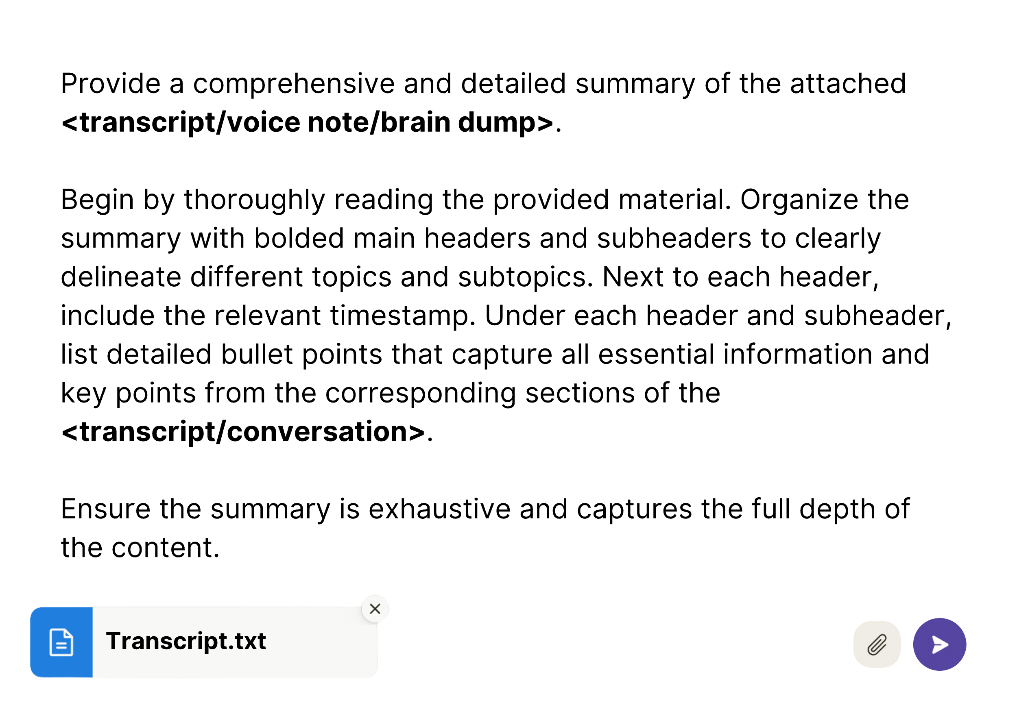

This chronological summary of the conversation should provide you with a bird’s-eye view of the flow of ideas, topics, and their interconnections throughout the recording. The timestamps and headers segment your content into manageable sections – like a table of contents – which will also help you locate specific sections of the transcript in full detail later

Here’s what my outline looked like, based on the 10-minute voice memo I recorded on a quick walk:

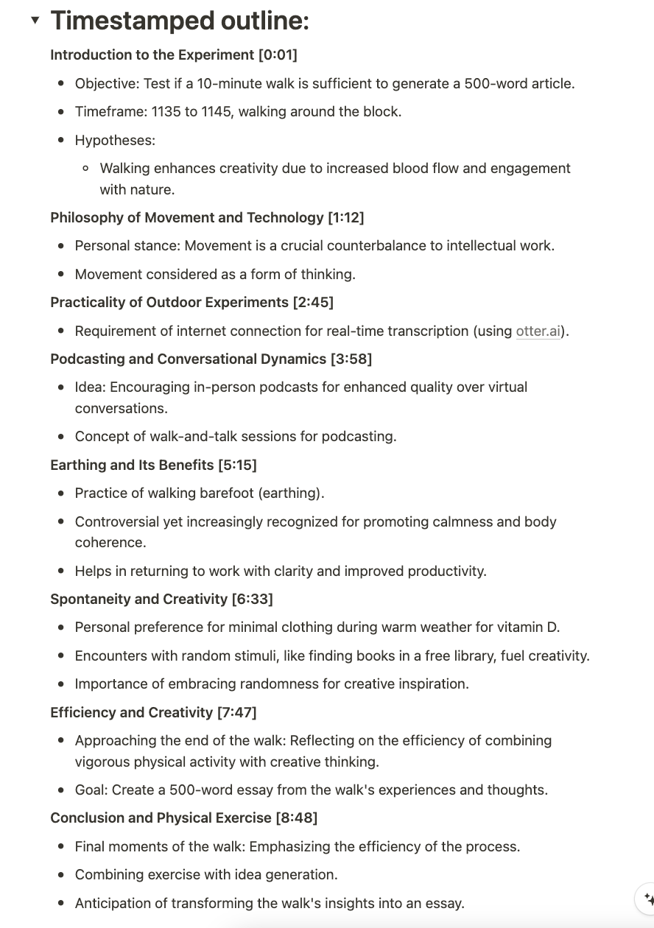



### ****Step 2: Cheat Sheet Outline****

After completing your timestamped outline, the next step is to prompt Claude to produce a “cheat sheet outline.” Unlike the timestamped outline, which provides a chronological framework of the conversation, the cheat sheet goes deeper – looking at the key themes, stylistic nuances, and most memorable phrases from the conversation. It outlines ideas not by when they were expressed but by their theme, substance, and relevance.

Continue your dialogue with the following prompt:

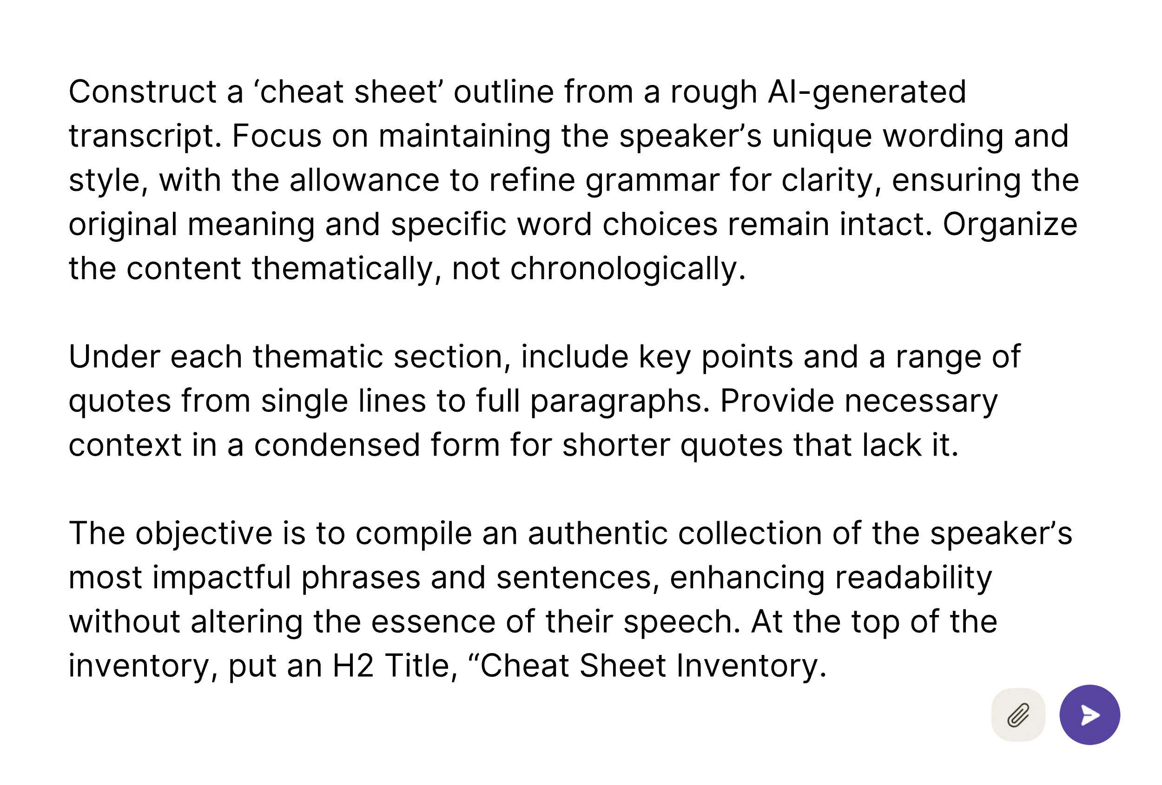

Claude produced the following cheat sheet inventory, which I then copied and pasted into Notion:

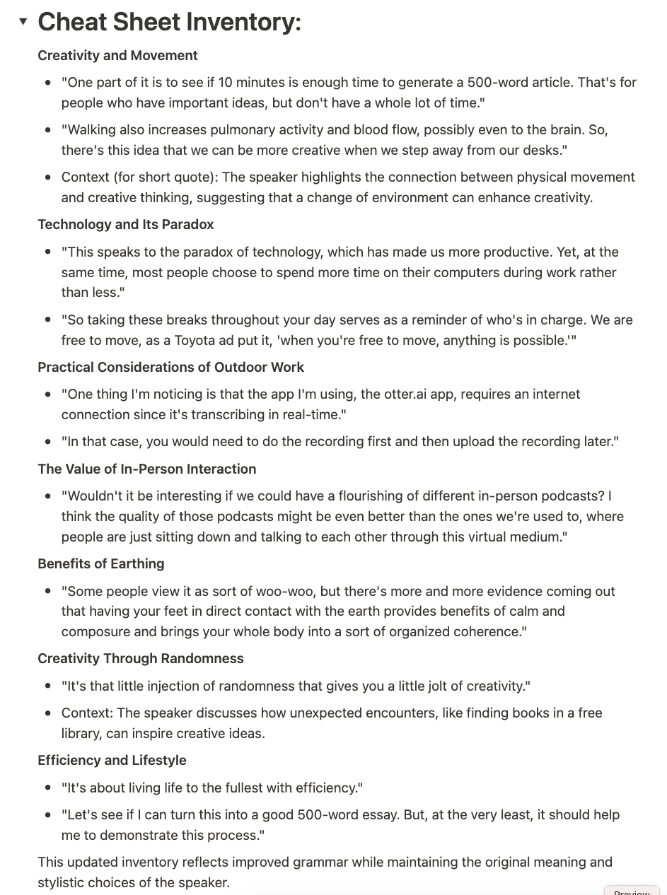



### Organizing ****Additional Building Blocks****

The cheat sheet is a kind of skeleton of your content, but as it stands, it still contains mostly *summary.* We want to support this summary with the most important specific points, excerpted in full detail. Sometimes a single line of your transcript or brain dump may speak to the main point in a way that gets lost in the broad summary.

In this next step, we’re picking through the material, looking for gems – excerpts and assets – that might suggest a particular direction for the overall outline once we get to the distillation/reconstruction phase. The additional building blocks and actions to obtain them include:

* **Source List**: Compile all references made throughout the conversation for further research and credibility.
* **Anecdote Bank**: Collect compelling stories and analogies that can be used to illustrate points vividly.
* **Visuals**: Note any descriptive language or rhetorical devices that can bring your content to life for readers.
* **Timeline**: Construct a timeline of key events or milestones covered to maintain chronology where necessary.

In our fractal expansion, these building blocks correspond to the social media assets we generated for our podcast show notes – providing the raw materials for the next phase of reconstruction, where they will be organized and polished into a coherent narrative.

You can refer back to Chapter 6 for the prompts I use to extract quotes and links. You can play around with variations on the following prompts for the other assets but don’t get boxed in. Think for yourself about how best to write the prompts to extract the unique building blocks your content contains.

To obtain these assets, continue the conversation with Claude (you need not reupload the transcript):

**For Visuals**

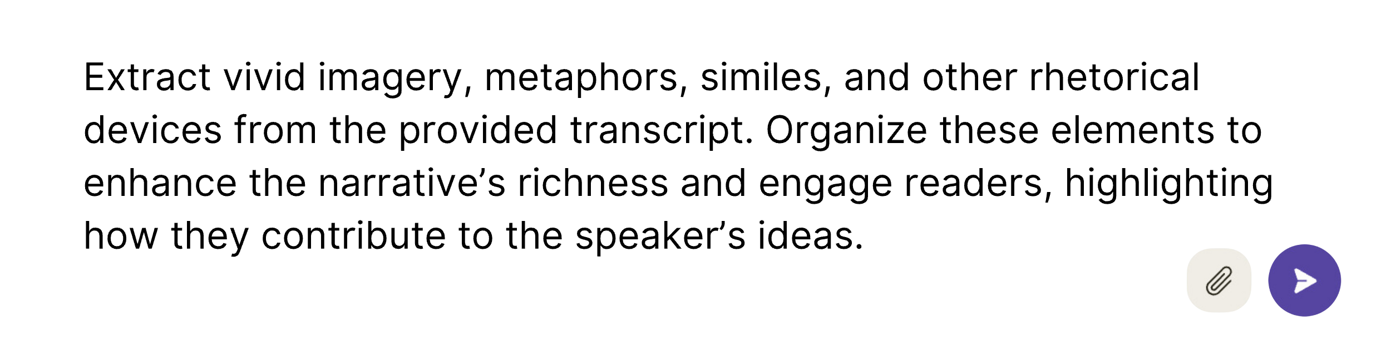

**For Anecdote Bank**

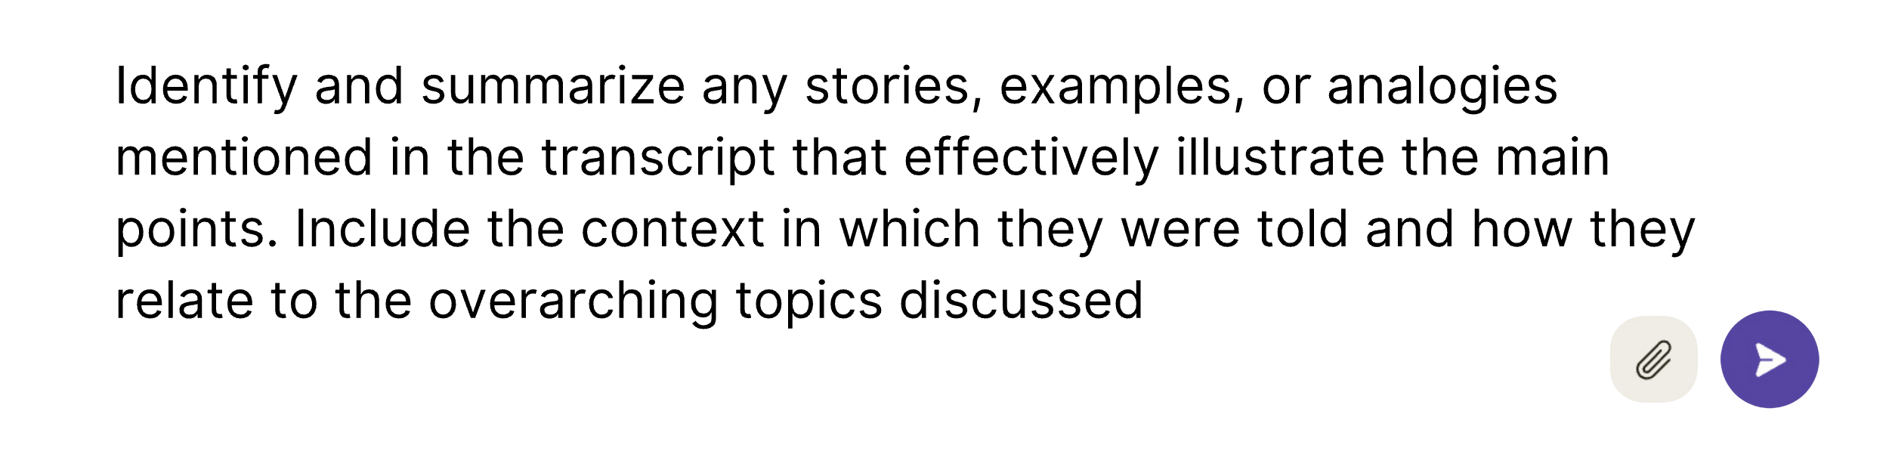

**For Timeline**

### ****Step 3: Nailing the Point****

Armed with your cheat sheet – enriched with condensed knowledge – you’re ready to home in on “the point.” This is the culmination of the divergent phase and the pivotal moment where you determine the key message that will guide the reconstruction of your ideas into a coherent narrative.

Continue the conversation:

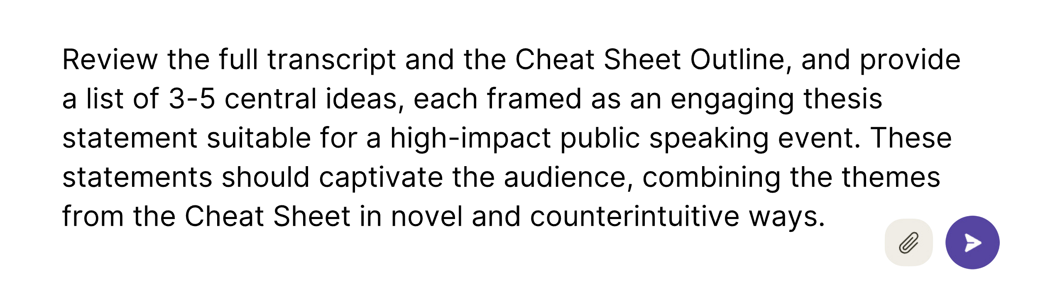

Note that this step mirrors the prompt we used in the podcast notes chapter to find the “main idea.” As with that process, you can provide any additional context or hunches that you have about the main idea to enhance the output and then iterate based on the suggestions. You can combine the best elements or rework the wording until you have something strong and *to the point.*

After some iteration with the AI, I crystallized the main point of my voice recording as follows:

“AI transcription enables writers to capture their best ideas while walking and talking, as nature and physical movement provide a vital boost to the creative process.”

Once identified, this statement will serve as the Archimedean point between the deconstruction and reconstruction phases and the measuring stick by which you’ll decide what makes it into your article and what gets left out. Paste this thesis statement at the top of your page in Notion, above the transcript, timestamped outline, and cheat sheet.

In the next phase, you will identify which ideas from the transcript’s source material align with and bolster the thesis. These, you will keep while discarding the tangents. In this way, you will distill your 10,000-word transcript into a 500-2,000-word blog post or article that people will not only read, but that will move them to action.

Chapter 10

DISTILL

Reconstructing Your Outline

*“We can rebuild him. We have the technology. We can make him   
better than he was. Better … stronger … faster.”*

– Opening narration from The Six Million Dollar Man

With the main point established, you can now begin the reconstruction phase. Your article’s thesis now commands the top of the page – guiding the structure that will emerge from the tangle of thoughts below.

Below this sits your rich source material, segmented into an organized Cheat Sheet, and the full transcript below that. Now, you will begin the process of crafting a new outline, with the main point to guide you. This phase is about distilling the key ideas from your source material and aligning these elements within a logical framework. With AI’s assistance, we will carve out a structured outline from the raw material – like a sculptor chips away at a block of marble to form the rough contours of his vision before getting out the smaller chisel. The reconstructed outline will then serve as a detailed roadmap for your writing journey.

In Notion, each section header can be collapsed into “toggle headers,” allowing you to expand and contract your view so that you’re not overwhelmed by all of the content at your disposal.

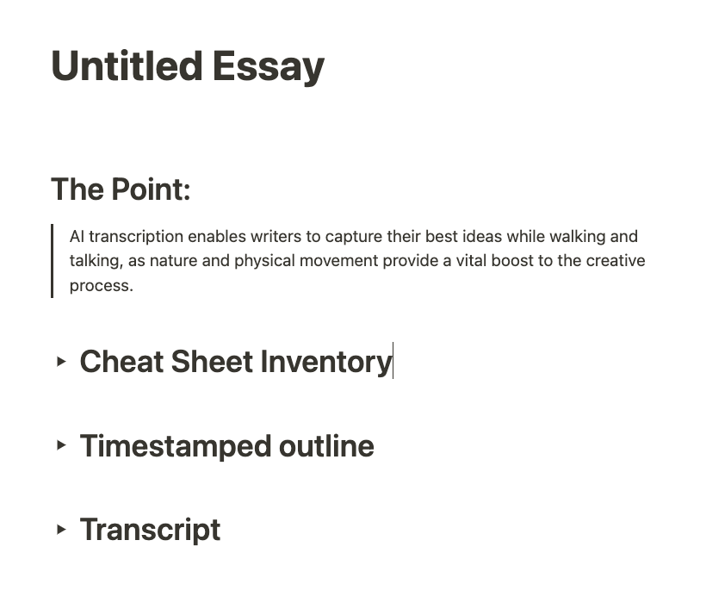

## ****Shaping the Outline: From Broad Strokes to Fine Detail****

Our first restructuring prompt creates a broad outline based on the main point. Again, you can continue the conversation with Claude, so that it retains the context of the full transcript and your intermediate summaries as it reasons through the new structure of the article:

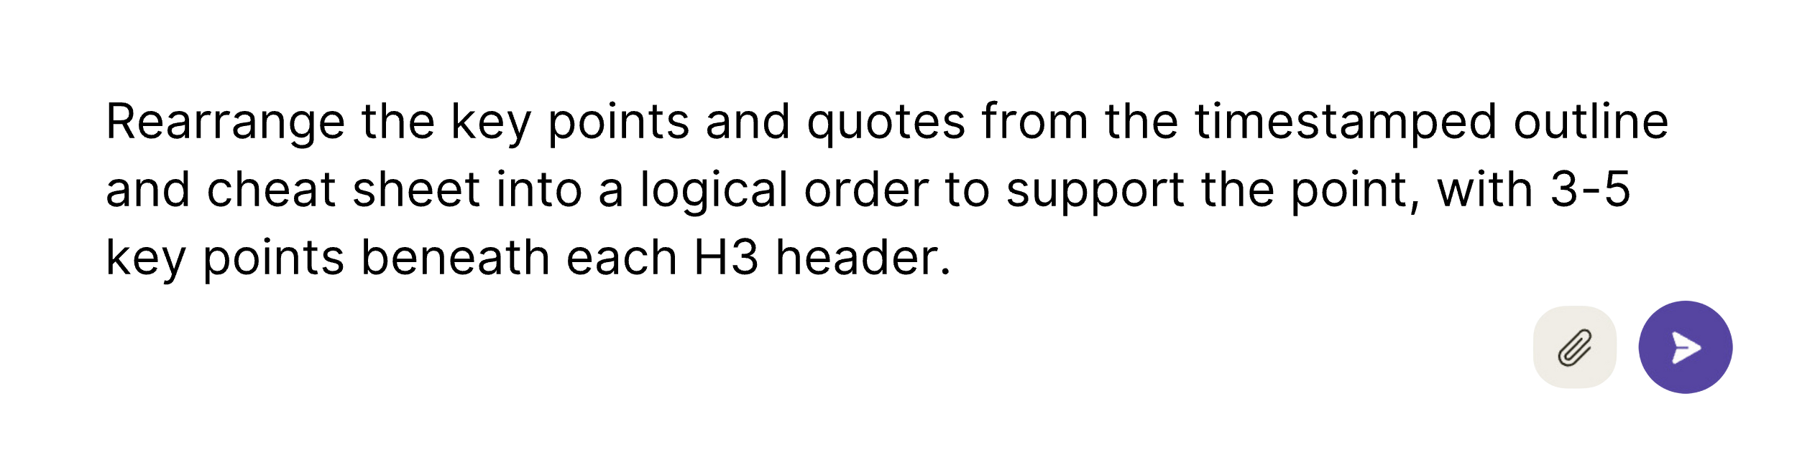

Here, you are drawing on the LLM’s strengths as a reasoning engine capable of processing large volumes of text. Claude’s first pass lays the groundwork, saving your mental bandwidth for refining and feedback. After reviewing its initial outline, you can either continue prompting with suggestions, like this:

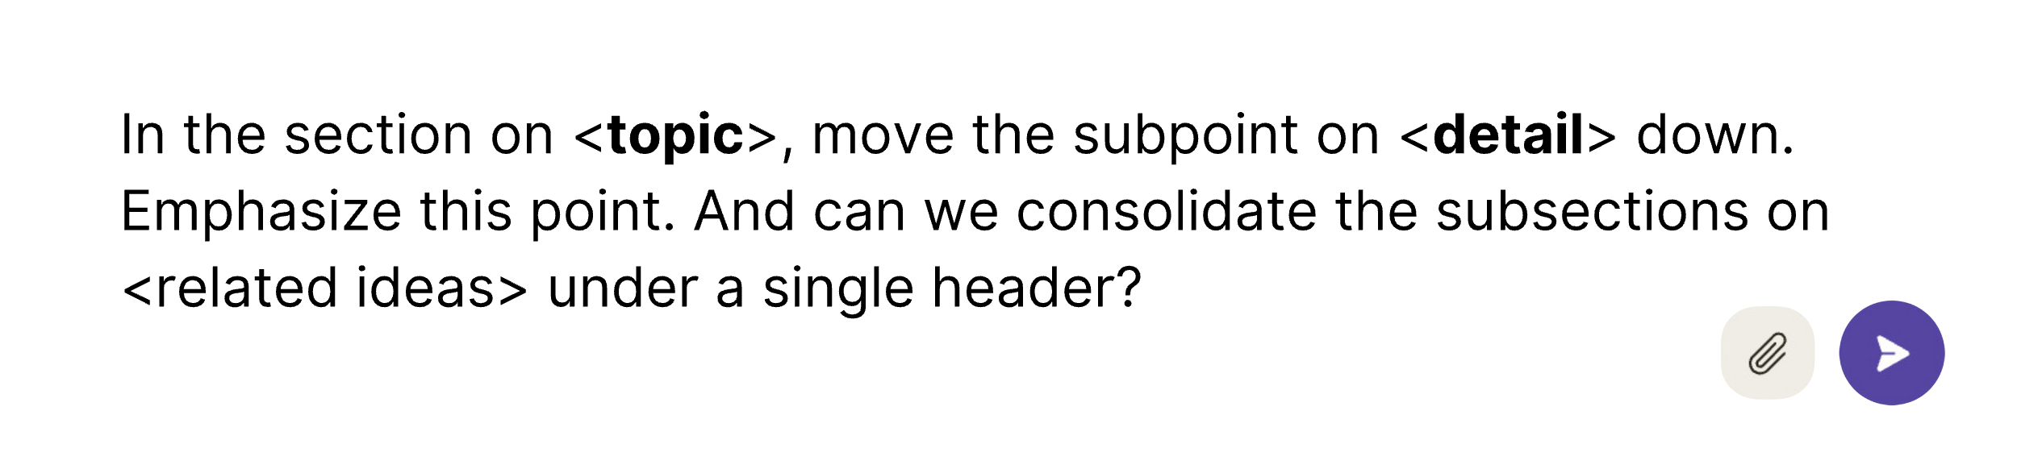

Or you can do a manual edit. Just copy the draft outline into your working document, edit it to your liking, and then feed it back to Claude, saying:

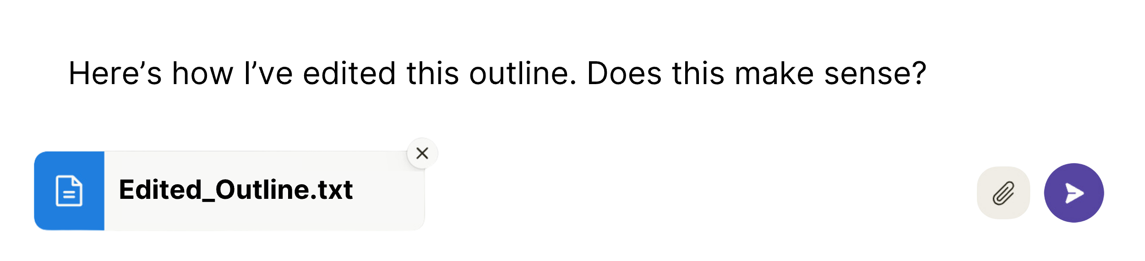

A sense check at the end is always wise, as it gives Claude a window to provide feedback on connections you might have missed or areas for improvement. I am routinely amazed by Claude’s capacity for high-level reasoning (as well as at ChatGPT’s) about a wide range of topics. Its ability to construct “auras of meaning” makes Claude a perfect writing assistant and can help you through the gnarliest of writer’s blocks if you take the time to fill Claude in on your thought process. This is especially true in the outlining phase, where you are dealing with broad associations among ideas, but this mutual sympathy between human and AI extends to every stage of the creative process, including writing.

## ****Frameworks: Structuring Your Narrative****

In structuring your content, the idea of a “logical” order is open to interpretation. The ordering that makes the most sense can take diverse forms, depending on the *framework* you decide to use. The most basic framework for a written composition is what you were taught in grade school: a beginning, a middle, and an end, or introduction, body, and conclusion. However, within the body, the ideal ordering must also be considered. As a mental shortcut, ask yourself if the content you are working with might lend itself to one of the following common frameworks before determining the final order:

* **Before and After**: Illustrating the contrast between pre- and post-solution scenarios.
* **How-To Guide**: Offering a step-by-step approach to achieving a goal.
* **Case Study**: Detailing a real-world application and its outcomes.
* **Listicle**: Presenting information in a bullet-point format for clarity.
* **Myth-Busting**: Correcting common misconceptions and offering alternative answers (often written in list form).
* **Comparison**: Weighing different approaches side by side.
* **FAQ**: Addressing common inquiries directly.

Most industries have their own bespoke frameworks, as well:

* **Marketing:** “Problem-Agitate-Solution” (PAS) or “Attention-Interest-Desire-Action” (AIDA)
* **Engineering/Technical**: Standard-Operating-Procedures (SOPs)
* **Education**: Lesson plans
* **Law:** legal briefs

These specialized frameworks are tailored to convey information effectively within their respective fields. The choice of framework hinges on your material and your audience.

Often, the content will suggest a fitting framework. For example, I once wrote an article based on a podcast interview with the CEO of Burning Man. The topic was the “10 Principles” that guide the festival. In that case, using the “Listicle” format was obvious. The order of the ideas was the chronological order of the principles as they have been codified by the Burning Man organization. Here, my job was straightforward: clean up the transcript and rewrite the guest’s portions in the third person, as quotes.

In another instance, I started with a podcast interview between a well-known biohacker/fitness guru and his guest – another prominent biohacker. The two health experts had much in common about their approaches, but also some key differences worth highlighting. This content dictated in favor of a “comparison” format, which contrasted their perspectives on six different areas of well-being in the following order:

* Diet
* Sleep
* Workouts
* Supplements
* Technology
* Purpose/Meaning

Each of these areas got its own header and included a distillation of quotes and key points about that topic from the interview. The order here is subjective, and could have been arranged differently, but I thought it made sense to start with the fundamentals (i.e., diet and sleep), before getting into deeper and more advanced topics like supplements and technology.

You can decide on a framework before or after you arrange the ideas in a logical order. In some cases, the framework might be a prerequisite for deciding the logical order. In my demonstration article, I first tried to arrange the points in a logical order without a framework and found the resulting outline to be disjointed. However, when I instructed it to follow the **“Problem-Agitate-Solution”** framework, I got a much more compelling progression:

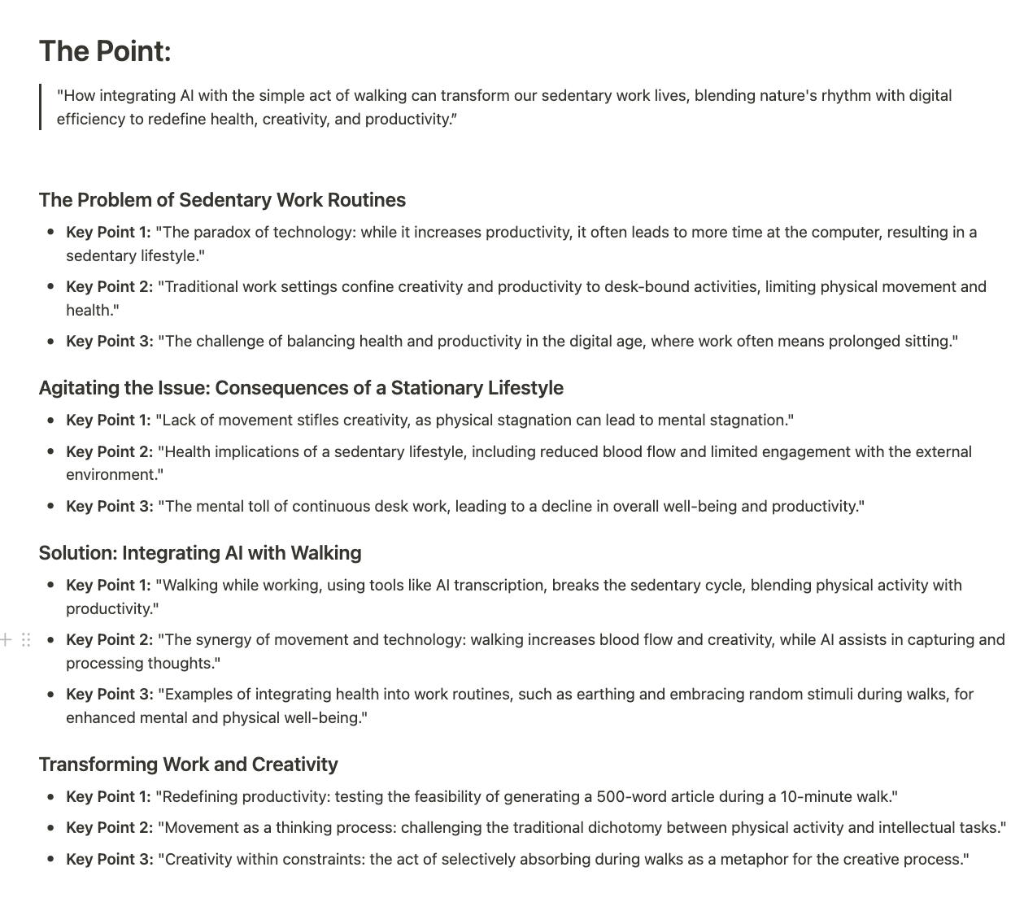

After reviewing the output, I found that I only needed to move a few points to be satisfied with the overall flow of ideas.

## ****Refining the Blueprint: Detailing the Outline****

After you have your working skeleton outline, the next step of the “**Distill”** phase is to flesh out the bare bones with the key details from your transcript and Cheat Sheet.

For every section header of your outline, start by identifying additional supporting points and examples from the transcript and cheat sheet. You can manually drag and drop bullet points into your outline (another handy feature of Notion’s block-based editor). Or, if you want to be ~~lazy~~ strategic, you can use a series of prompts to guide the AI in helping you extract these details for each section:

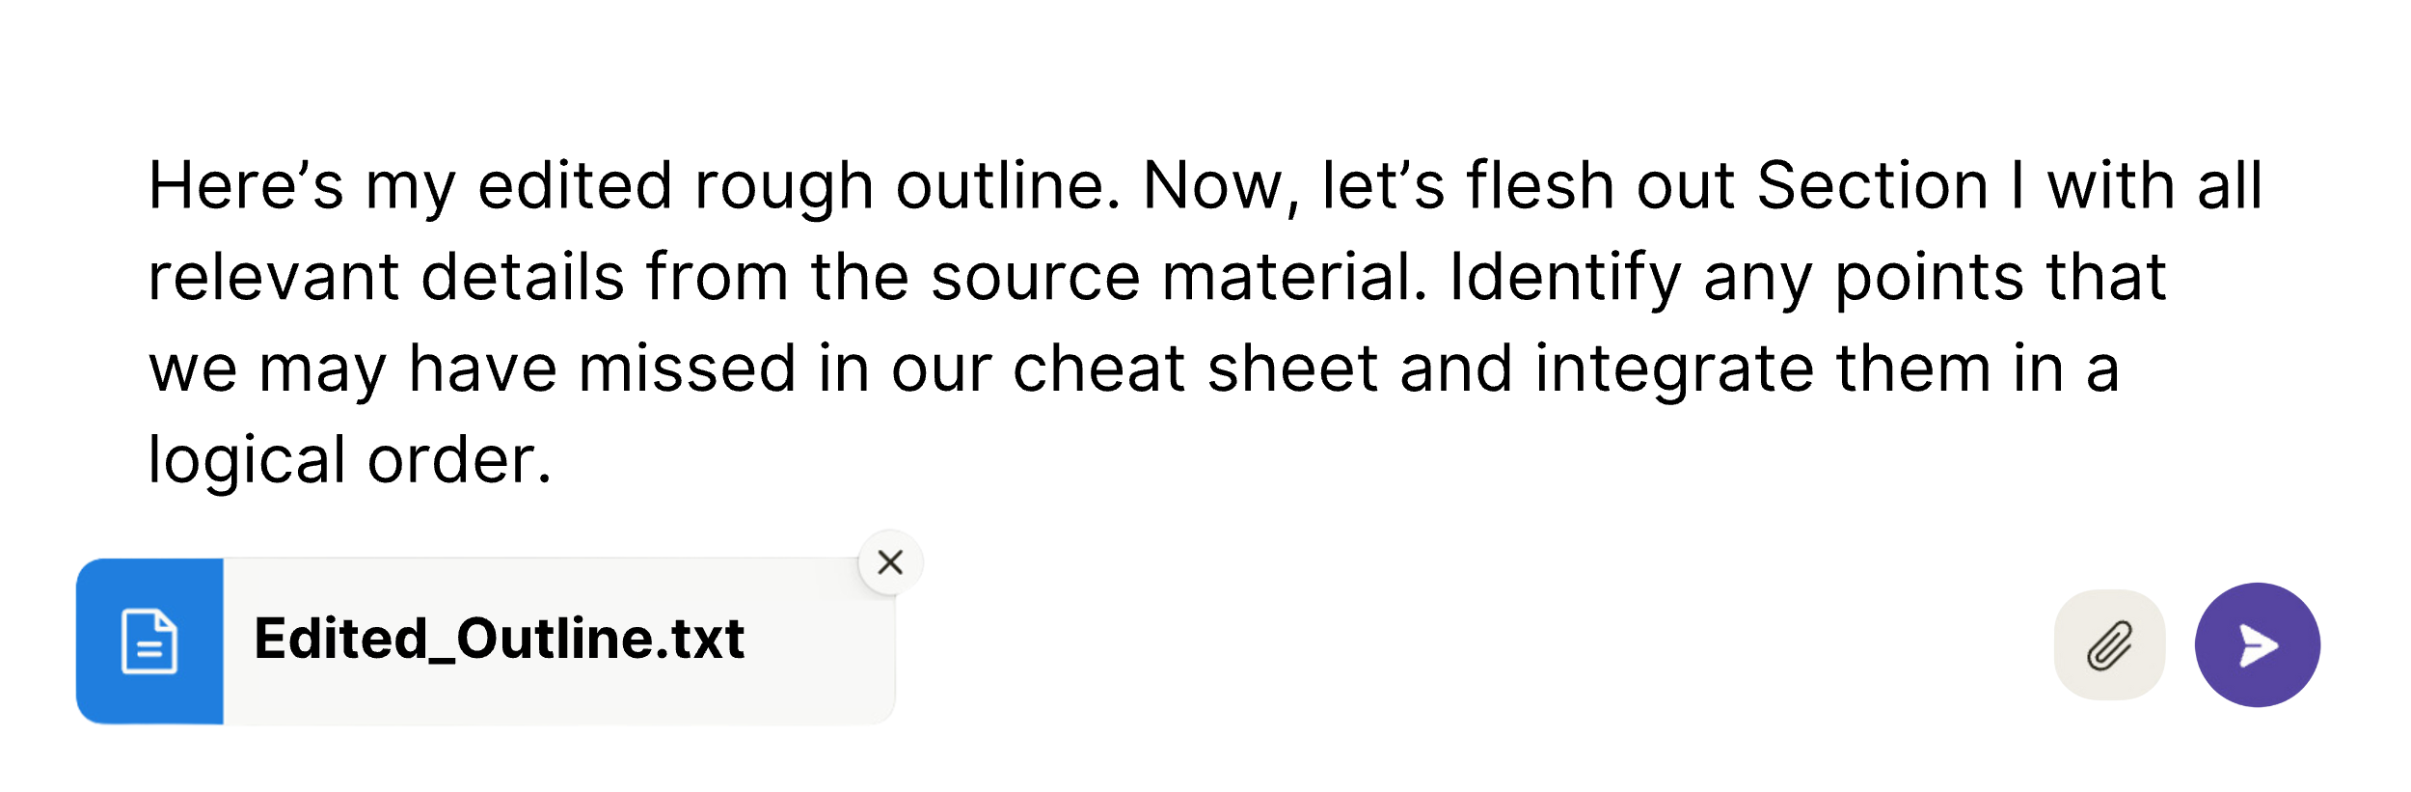

If you opt for the AI shortcut, you can replace the broad outline for each section of the outline with the more detailed version, scrutinizing it to ensure the proposed ordering aligns with your vision.

I recommend a hybrid approach, using AI as a first pass, but supplementing with a manual selection process to make sure none of the key points are getting lost.

At this stage, you can leverage the model’s broad knowledge to expand on areas where your initial content may be lacking substance. In writing this chapter, for example, I leaned on AI to generate the full list of “frameworks” based on the examples of the “Listicle” and “How-to” formats. It suggested the “Before and After,” the “FAQ,” etc. While the majority of your content should originate from your own expertise, you can use AI to augment your knowledge in specific areas.

The more detailed your outline before you start generating the prose, the better the results will be. But you don’t need every last detail in your outline before proceeding from outlining to the writing phase.

Remember, the outline is a living document. It will continue to evolve through each iteration. At this stage, the skeleton is fully articulated, but it isn’t something you’d present to your readers until you’ve had a chance to clothe it in lively and inviting prose. As we move from the architectural phase of outlining to the expressive drafting phase, we will acquire one of the most sought-after and valuable skills of AI-assisted writing: matching the style of prose most appropriate for our purpose and audience.

Chapter 11

EXPRESS, PT. 1

Voice Matching

“A well-dressed sentence walks down the page with a certain attitude.”

– William Zinsser, author of ***On Writing Well***

“What’s the best AI-powered platform to convert an audio file into a well-written article, using my general style and voice?”

The question was posed in the form of a tweet by a well-known internet influencer who leads a small fitness empire under his own multi-million-dollar personal brand.

“**@chdeist** does this” replied a friend who was familiar with my system.

Minutes later, I was messaging back and forth with the e-celebrity, trying to balance my confidence in the system I’d developed with a desire not to blow the opportunity at hand. After some back and forth, I offered a short demo, showcasing the tools I use. Intrigued, he connected me with his team on Slack to discuss further.

It turned out the team thought they had already tried everything to mimic their boss’s distinct voice, but none of the AI tools delivered what they promised. It always took hours of manual editing and back-and-forth to get the tone just right, to say nothing of the time structuring the actual content of the article. So my first assignment was framed as something of a longshot – an “experiment,” they called it.

The assumption, or null hypothesis, in this experiment was that my method would be no different. This was my chance to show them what I could do.

## Ghostwriting + AI Voice Matching: A Match Made in Heaven

Before we get into the exact method I used to imitate my client’s voice, let’s look at how Large Language Models perform at the simpler task like imitating the style of a famous writer or public figure whose words are part of their training data.

When I prompt ChatGPT to “rewrite the previous paragraph like Shakespeare,” I get the following:

Before we mimic voices new,

Let us see how Models do,

Imitating styles of writers of yore,

Whose words in training data they explore.

Bravo!

It can also match styles ranging from confident to friendly to professional to casual. Just describe the tone you want in plain language. Notion gives the above four options as presets, but let’s try something more unique, like passive-aggressive:

“Oh, sure, these language models can apparently just magically create or change content into any tone you desire. They just inherently know how to write in styles like confident, friendly, professional, or enthusiastic. Must be nice.”

This ability to absorb the patterns and nuances of different styles of writing makes AI an ideal tool for ghostwriters like me seeking to mimic a client’s personal style. There are dozens of AI tools boasting specialized voice-matching features, but you can get the best results without paying another dime in monthly subscriptions using regular old Claude.

# ****Creating an AI Style Sheet****

For well-known writing styles, like Shakespeare, simple instructions like “write in the style of William Shakespeare” are sufficient. Adding examples of Shakespeare’s writing would contribute nothing to the AI’s comprehensive training on Shakespeare’s entire collected works, which are in the public domain.

When dealing with individuals whose work is not contained in the AI’s training data, the scenario changes. In these cases, providing specific writing samples is the best way to convey your desired style. No matter how detailed or well-crafted your description may be, it will not capture the full nuances of a style in the same way that an example can convey. Put yourself in the AI’s shoes and imagine that you are trying to imitate Mr. Bean without ever having seen an episode based on someone’s verbal description. You would be hard-pressed to impersonate the facial expressions and mannerisms without *seeing* his antics.

Thankfully, for the “experiment,” the client’s team gave me both examples and instructions – a set of guidelines describing the desired voice, as well as a few sample articles exemplifying the target style. I used this combination of instructions and examples to create one consolidated reference document that I call a **“style sheet.”**

Here is how you do it:

### ****Step 1 – Gather Examples****

Collect a few full-length articles or content samples that exemplify the style you want the AI to emulate (whether your own or someone else’s). These will form the core of your style sheet. Look for samples that align with the voice, tone, diction, sentence structure, and general style you wish to replicate. There is no “ideal” length for your examples. Claude can handle up to 500 pages, but 2-5 pages is enough. Beyond that, and you will slow down Claude’s responses with little additional benefit.

### ****Step 2 – Analyze the Samples****

Read through the samples closely, taking note of distinguishing features like:

* Word choice and vocabulary
* Sentence length and complexity
* Tone (serious or conversational? Sense of humor?)
* How do you address your reader? In the second person, as you? Or first-person plural, “We”?
* How often do you begin a new paragraph?

Make a list of the attributes or write a paragraph about what makes this style unique.

You can also outsource this step to Claude, and apply the following prompt to one of your samples:

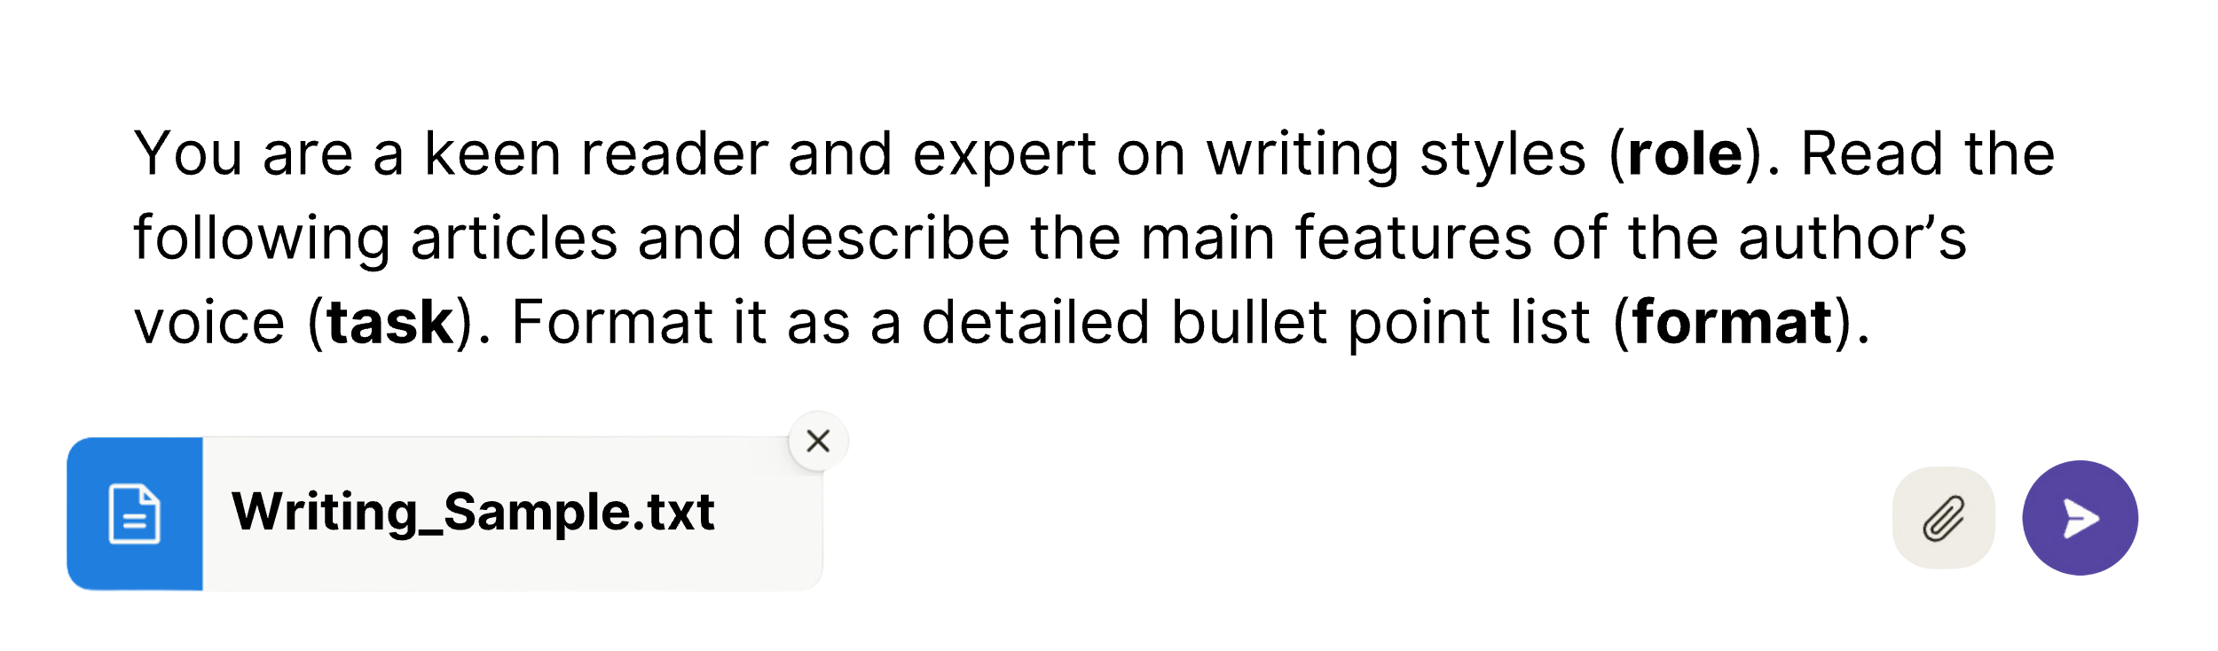

Then, fine-tune the output, or merge that list with your own list of observations.

### ****Step 3 – Compile these into a Brief****

Combine your examples and instructions into a PDF titled [Name’s] Style sheet.PDF. Use headers and formatting like bold text and quotation marks to clearly delineate examples from instructions. The document I used for this assignment was formatted as follows:

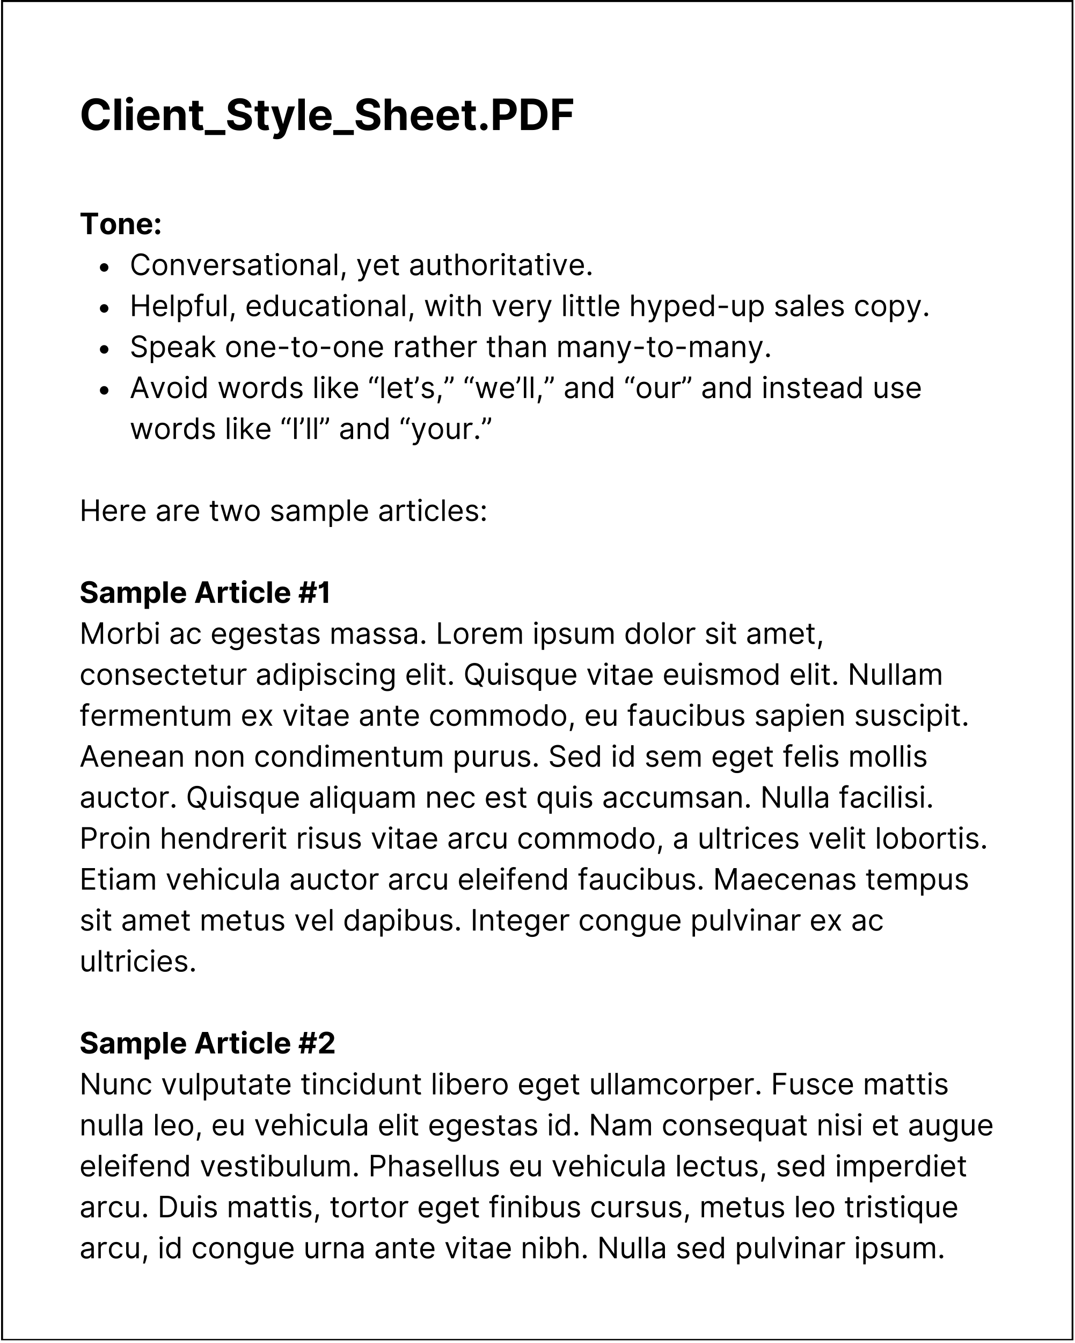

Whenever you want to write in the style of the brief, just attach this PDF at the beginning of your drafting conversation with Claude.

Save the file in a convenient location where you can access it with just a couple of clicks. That might be your desktop, a documents folder on your computer, or a Notion page where you can easily copy and paste it. Remember that anything you copy-paste into Claude that runs more than a few hundred words will be converted into an attachment.

When it came time to submit my draft of the article for my client, I didn’t know how it would be received. Would my attempt to imitate the client’s voice be greeted with ridicule? Anger for butchering the nuances?

After a day or so, the feedback arrived: “This is Fantastic!!! I honestly wouldn’t change a thing except the title.”

Without AI, I could have provided a solid outline for the article – a roadmap for turning the long, meandering transcript into punchy 2,000-word polished prose. But I would have struggled to mimic the nuances of the client’s voice. With AI, I could get a close style match for most of the text and then apply my “human touch” to identify when the voice was off – and fix it.

AI gives anyone the ability to transform any type of content into any voice. This power to mimic unique voices is a double-edged sword. Sophisticated phishing scams are on the rise, where scammers imitate your friends and family members in AI-generated writing (or even AI-generated speech!). But if you wield this skill with care and wield it for good, and you need not hesitate to wield it. There’s no law against writing *all* of your articles in the style of your favorite writer. I considered writing this entire whole book in the style of William Shakespeare but decided to spare my readers the Iambic Pentameter. Just give me one more allowance here as we transition to the next chapter:

In the next scene, our plan’s grand show unfolds,

With outline’s bones and style’s skin it holds.

Each sentence, in client’s voice, we’ll craft and make,

Our labor’s fruit, alive, for our own sake.

Behold! this work, from careful thoughts it wakes,

And breathes first life, as new dawn breaks.

Chapter 12

EXPRESS PT. 2

Flesh on the Bones

“Then he said to me, ‘Prophesy to these bones and say to them... ‘I will make breath enter you, and you will come to life. I will attach tendons to you and make flesh come upon you and cover you with skin; I will put breath in you, and you will come to life. Then you will know that I am the Lord.’“

– Ezekiel, 37:4-6

In the Bible, the prophet Ezekiel reports a vision in which stands amidst a valley of dry bones. There, God commands him to tell the bones what he is about to do. Just as breath entered dead bones in Ezekiel’s prophecy, you now stand ready to transform your bare-bones outline into living words. The skeleton awaits only the sinew, flesh, and skin - the style and voice that will allow your ideas to walk down the page with attitude.

Your thoughts have been captured, organized, and distilled. The language model has been primed to channel your unique perspective, based on your source material, in your preferred style of writing. From here, you could start writing solo and draft a great article yourself, but why not continue the iterative process and see what our AI assistants can do?

Although your outline and organized source material provide a detailed blueprint, don’t treat them as the last word. In this phase, approach your outline with fresh eyes. Remain open to surprises in the final form your argument takes. Claude’s first draft may surprise you.

Begin this phase by initiating a new conversation with Claude. The accumulated length of your outlining conversation adds up to a lot of context for Claude to process each time you submit a prompt and will slow down the responses. In resetting the conversation, you will need to provide the key context just once, at the beginning. This necessary context includes an overview of the task at hand and a key to the supporting materials you are providing:

1. The “Style Sheet” created from the steps in the previous chapter.
2. A single “source material” document containing the following, in order:
   * Main point
   * Detailed skeleton outline
   * Menu of quotes/Cheat sheet outline.
   * Timestamped outline
   * Transcript

Returning to my demonstration article about writing-while-walking, I decided to provide Claude with the role of a writer for *Outside Magazine* as short-hand for a competent writer, with domain area expertise on the topic of the article – my experiment in writing-while-walking.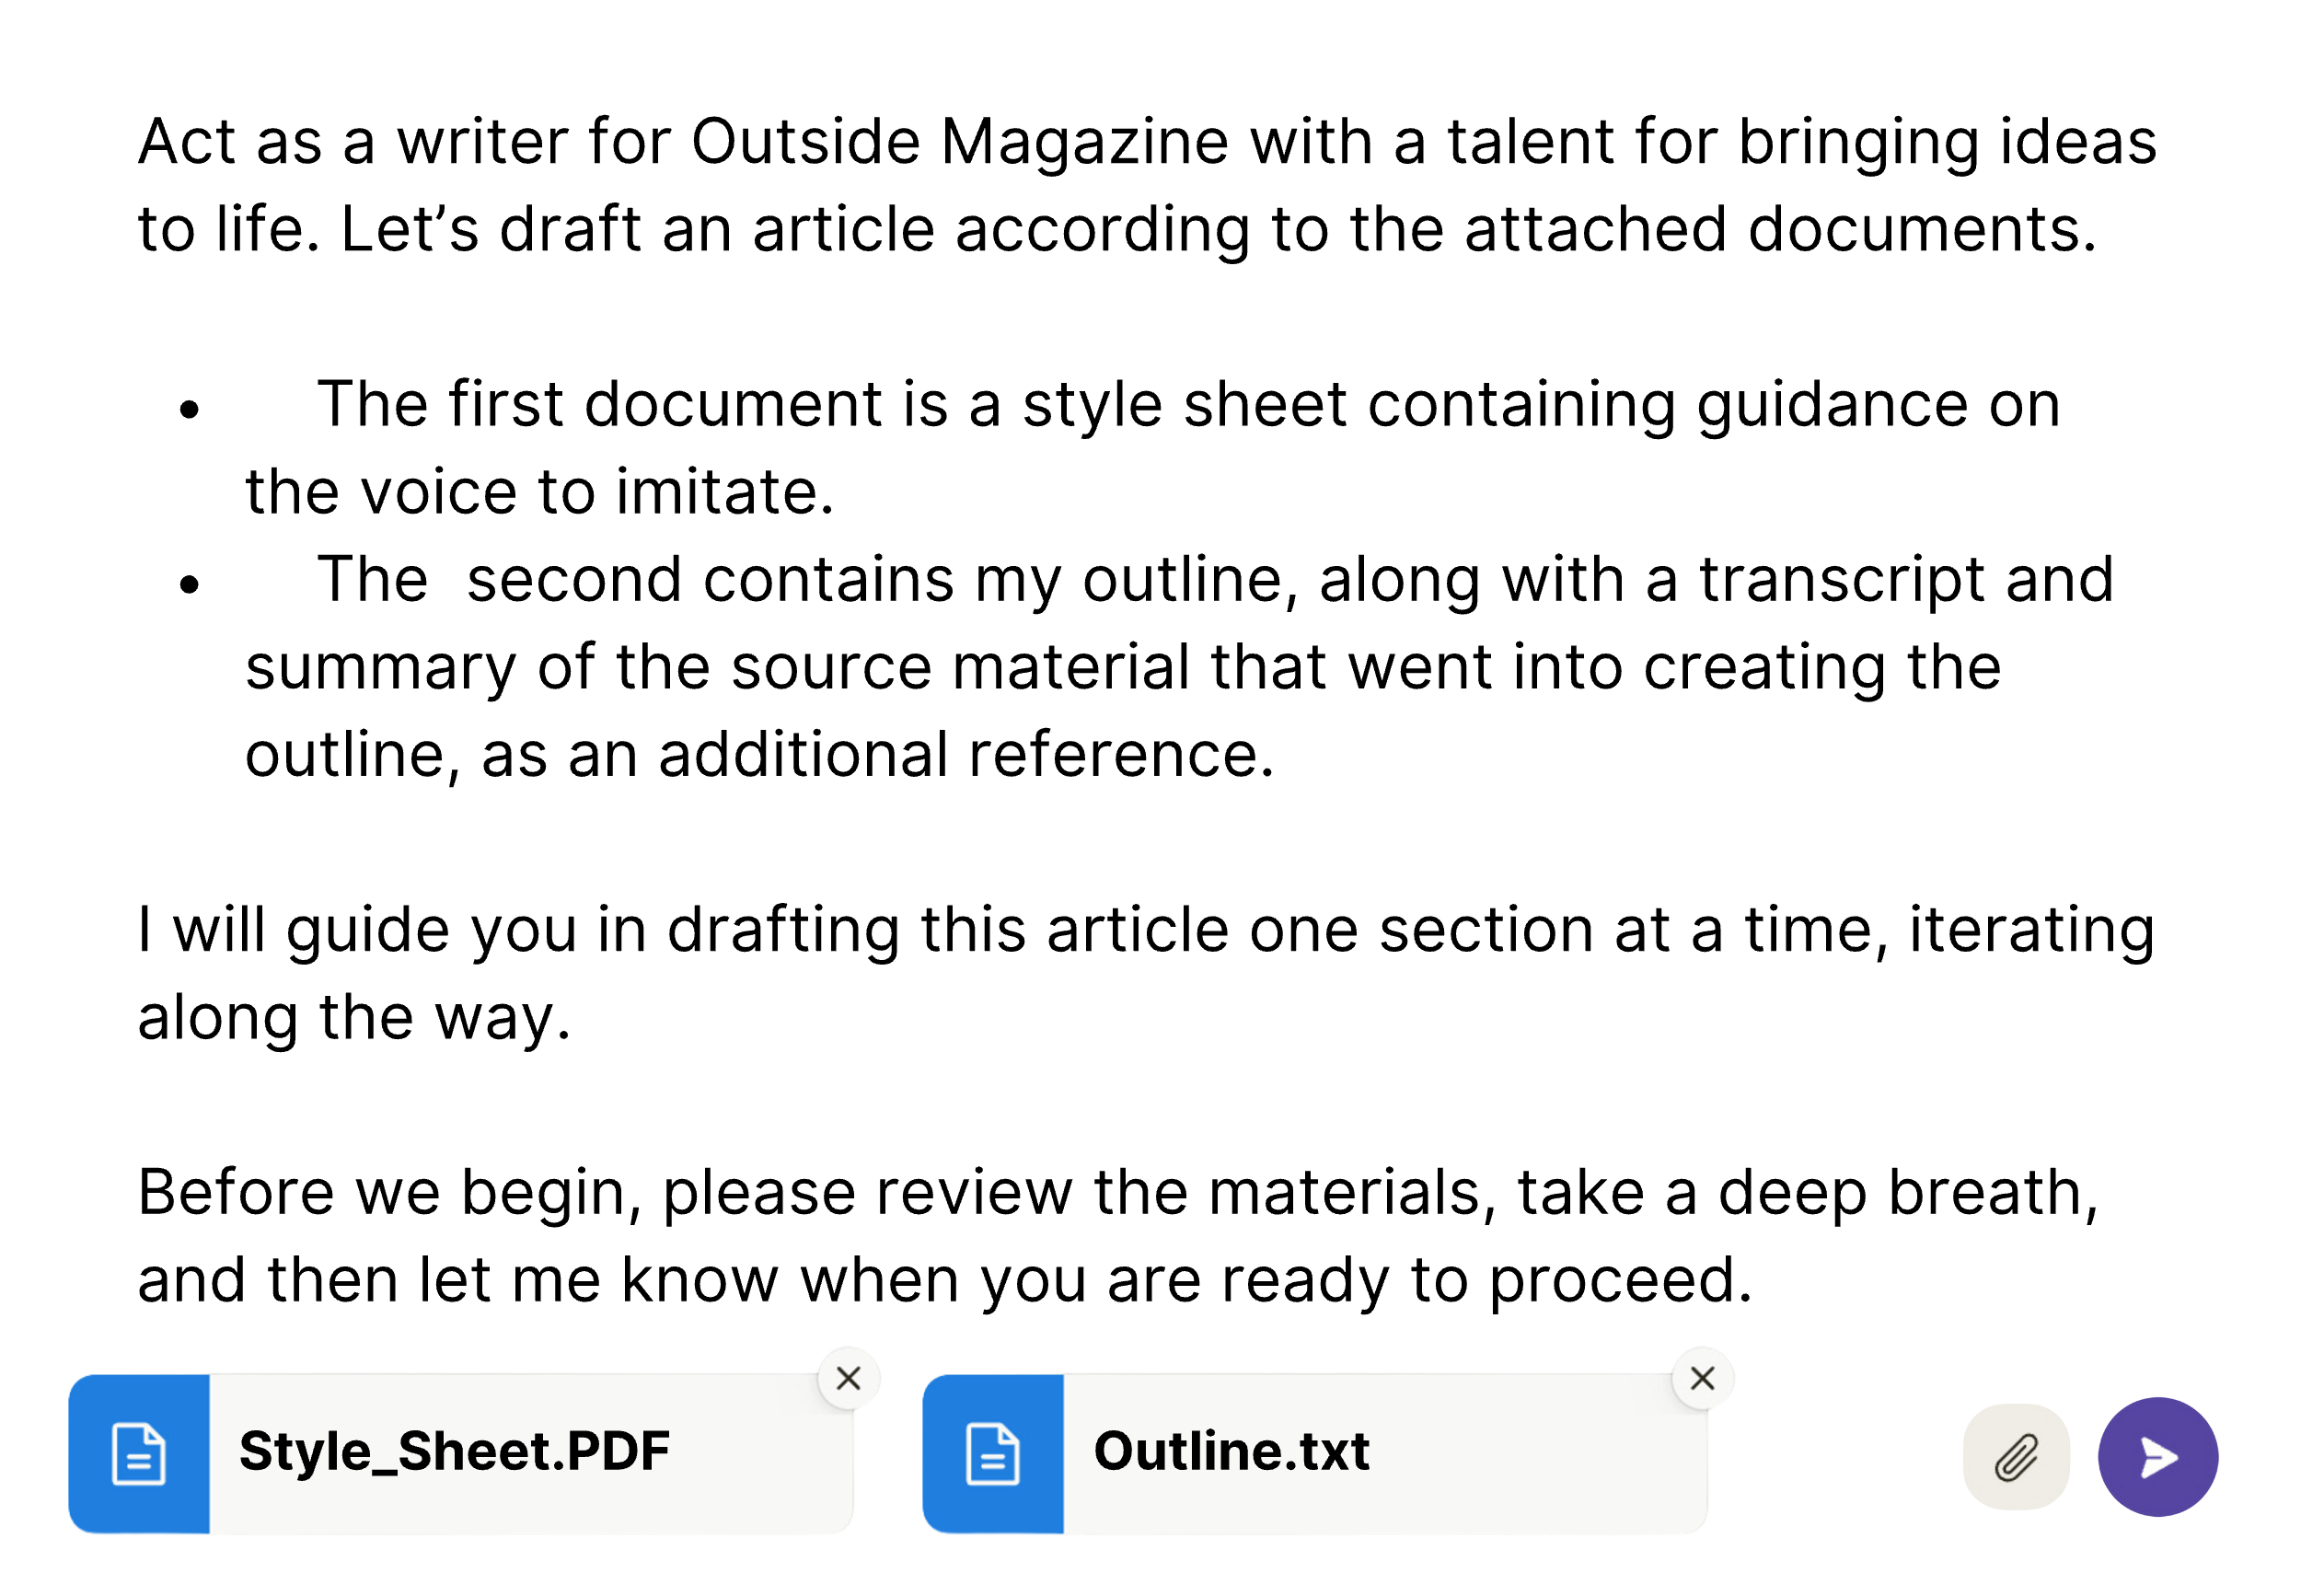

“My mind is racing with ideas,” Claude replied, “and I’m ready to begin writing whenever you give the green light!”

## The Importance of Bite-Sized Drafting

From here, if I said “Proceed,” Claude would churn out an entire article conforming loosely to my outline. But instead, I chose to narrow his focus to a single, short section of my outline:

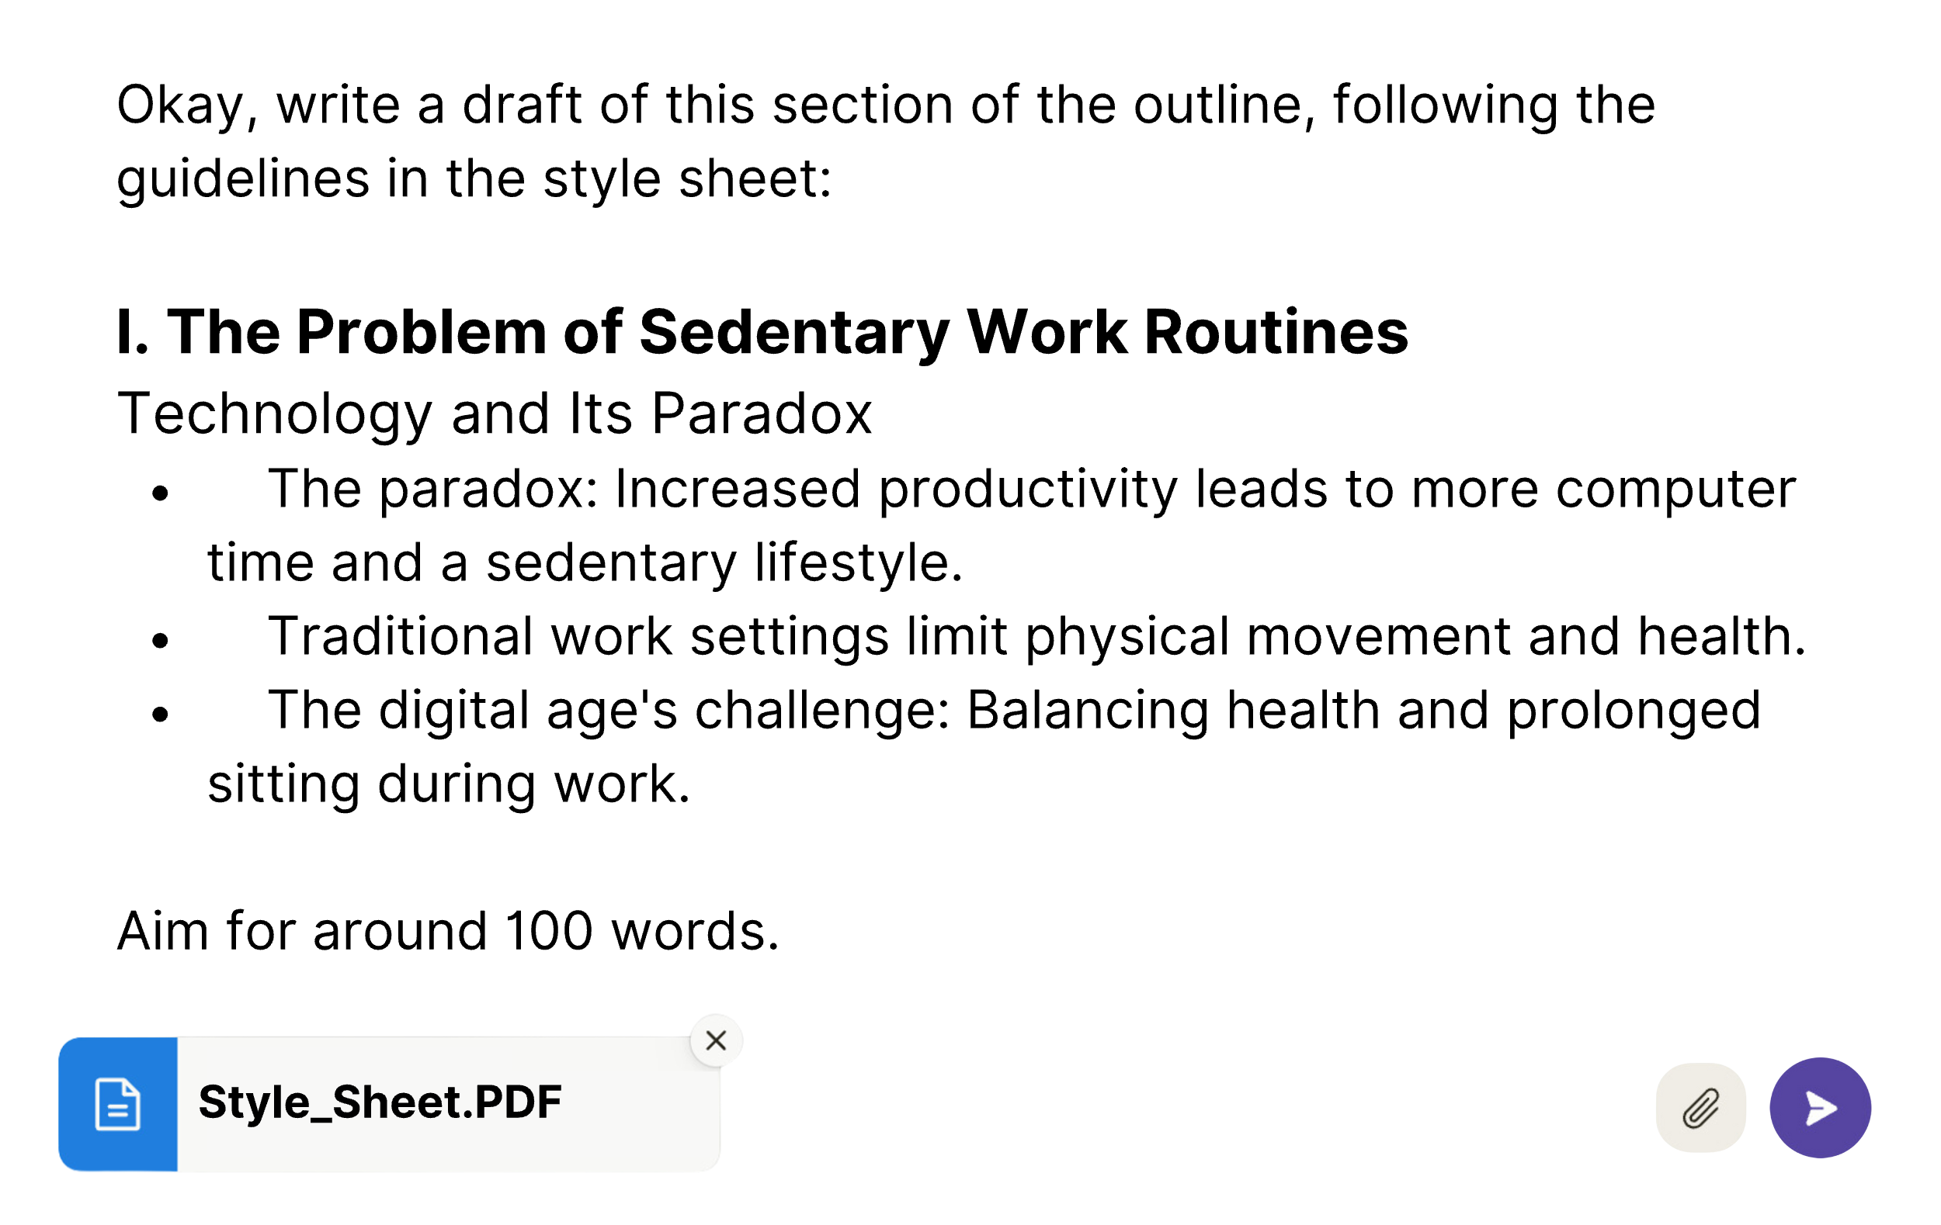

As with our earlier practice of polishing shorter transcript passages in bite-sized chunks, we now draft article sections one at a time to keep Claude focused. Going section-by-section prevents AI meandering and enables course correction. I’ve found Claude more reliably addresses all outline details when given a narrow scope.

When drafting articles section-by-section, AI models often conclude each part as a standalone piece. This results in repetitive or vague summary sentences that disrupt the flow between sections. One way to fix this is to simply delete repetitious final sentences so one section flows directly into the next. Alternatively, you can provide Claude some overlapping sections of your outline, i.e., include the end of Section 1, header for Section 2, and first bullet point of Section 2. With this context, Claude will write a smooth transition suited for continuity.

The optimal length for sections in your article depends on the total number of sections and the target article length. For example, if your 2,000-word draft has 5 sections, consider ~400 words per section. I assigned 100 words to this opener section of my article given my 500-word article target. Treat these as starting points – adjust to suit your needs. Pad each request slightly over your per-section tally to give yourself a buffer for editing out sections like the unwarranted conclusion sentences at the end of each section.

## Enriching AI First Drafts

While a detailed outline provides critical direction for Claude, additional customization helps refine the draft. As you draft, you may realize that certain sections require more elaboration or specific examples that weren’t captured in the initial outline.

Rather than leaving those details to chance, you have a few options for expanding your prompts. One option is to modify your bullet point outline saved in Notion (keep it handy). Insert additional instructions directly in your bullet point outline, formatted to stand out – Claude will follow guideposts from within the document, like **<embellish X point>,** when the updated bullet point outline is attached to the prompt window. Alternatively, you can offer this guidance apart from the outline, with the outline in quotation marks and the instruction outside the quotations. For instance, ask Claude to focus on improving connections between ideas, or transitioning smoothly from the previous section.

When transforming interview transcripts into article drafts, you’ll want to be strategic in your incorporation of the guest’s remarks as quotes. Introduce guests naturally early on with full name attribution. Then vary between repeating their name and using pronouns for clarity. Seek a balance between exact quotes and paraphrasing. Preserve succinct, eloquent soundbites where the speaker’s personality shines. You can lightly edit these quotes as needed for brevity, clarity, and relevance, but for more sweeping changes, make it a paraphrase. For proper formatting of quotes, I’ve found success by instructing Claude upfront to adopt *New Yorker* profiling conventions - their non-fiction norms for quoting and attribution. I can then include full quotes – or even paragraph-long excerpts from the interview – in the outline and get a good balance of quotation and paraphrasing in the output.

Another powerful AI capability is embedding supportive content from outside documents into your draft. For instance, you may know a lengthy research paper holds relevant data points for a section of your outline, but finding the exact passages would be time-consuming. Instead, provide Claude the full external source along with the relevant outline section. Specify the point or points in your argument that require additional credibility or evidence and ask Claude to identify the most persuasive statistics or textual backing from the attached material. Make it clear whether you want a pure summarization or a mix of paraphrasing with verbatim quotes, along with attribution of the source. For example:

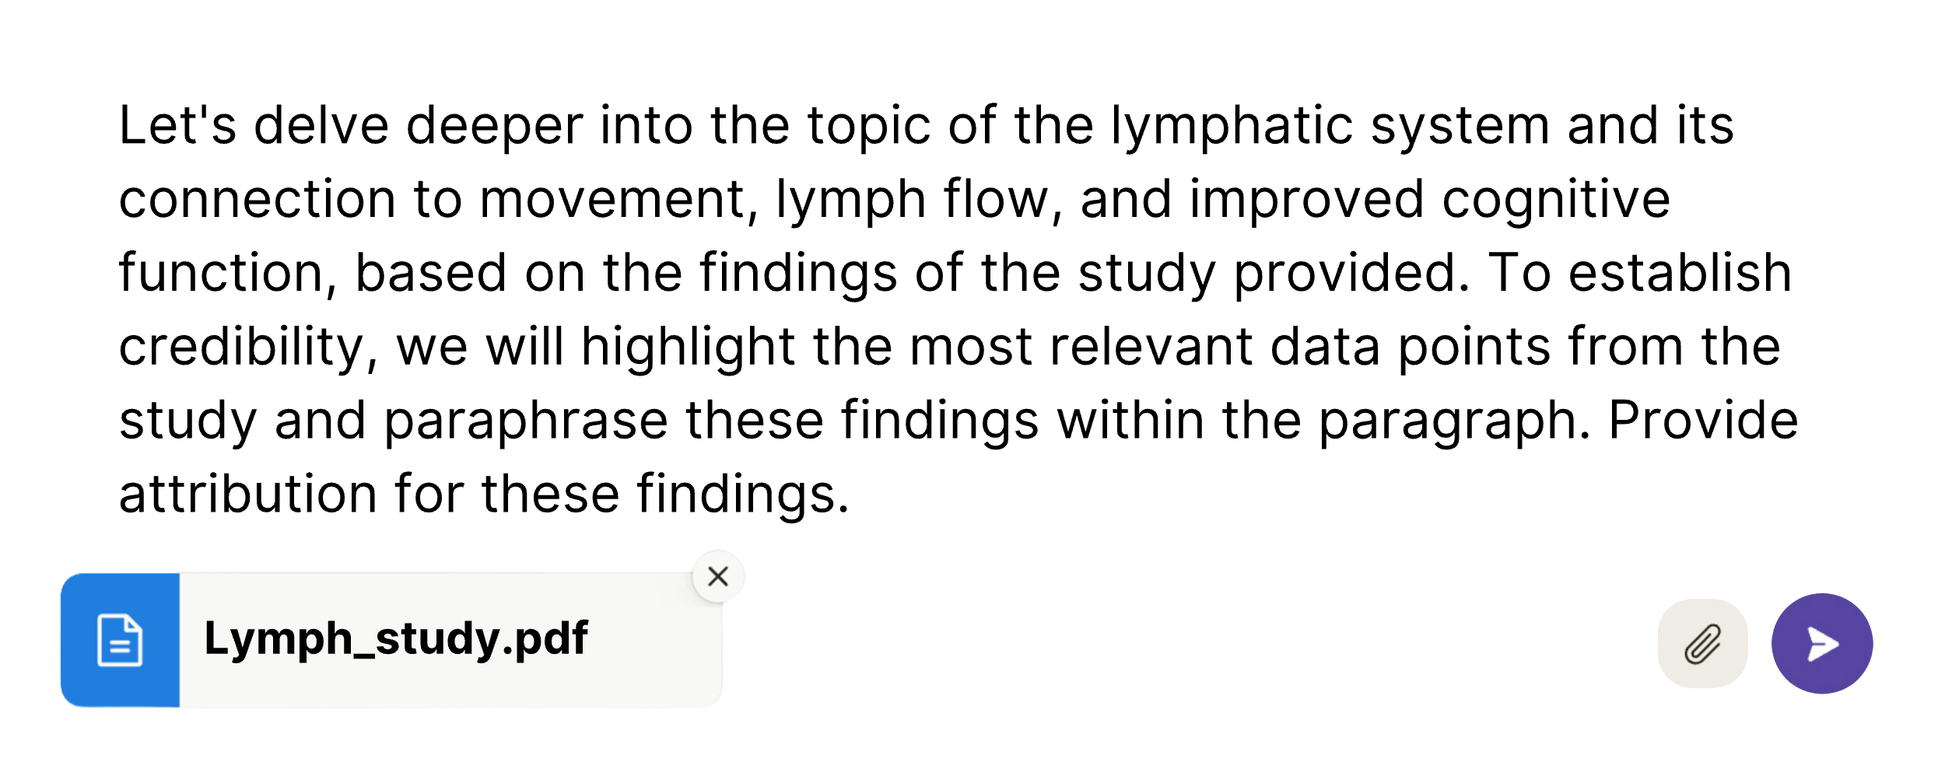

## The Power and Pitfalls of “Continue Writing”

After drafting a given section with Claude, copy and paste the output into your working document to polish. After editing a passage, provide the revised version for Claude’s review. Say, “Here is how I chose to tighten up this section: [quotation]. Now, continue writing the next section based on the following outline: [Outline]

This prompting allows Claude to digest your exact phrasing choices, tone, and narrative style. In this way, Claude can sharpen its instincts throughout the conversation to better echo your preferences. Over time, these iterative dances build intuitive rhythm – rapport even – while your skeletal outline comes to life.

You can even employ the **Continue writing** prompt without additional instructions or outlines to deepen the details on a particular topic. For instance… *if I have a point that I want to elaborate on but don’t quite know how to approach it, I might start with a simple sentence or two, then prompt the AI with “continue writing from this point.” This allows the AI to build upon my initial thoughts, providing more depth and nuance to the point.*

I generated the above text in italics by feeding the previous two paragraphs, along with the **Continue writing** prompt. This capability taps into the AI’s predictive power as a souped-up “auto-complete.” When used judiciously, it is a valuable tool for fleshing out areas that require further explanation or when an example is needed to clarify a point.

Be warned, though: If you use this function too often, your writing will start to resemble the dreaded AI-generated garble we are working so hard to avoid: *So many words, signifying nothing*. **Continue writing** works best when you can supplement the instruction with some additional source material or pointer, such as “continue writing on the theme of getting creative juices flowing.” Without these instructions, you’re just drawing on the AI’s training data and best guesses of what you are trying to say. The writing ceases to be yours. You’ve let the AI dance by itself.

My final advice on drafting reinforces the point I’ve been emphasizing since the beginning of this book. The skill of prompting an AI writing assistant is acquired by doing – not talking or reading. My chats with Claude never follow the same structure. Each piece of writing has its own unique goals and needs. In the early stages, my conversations often spanned over 50 pages just to produce a single 2,000-word essay. However, I have refined my approach over time to make the “dance” much shorter. Each new project will teach you the nuances of what flows and what doesn’t. What matters most is having the courage to commence that first dance. With patience, dry outlines shall come to life.

Chapter 13

REFINING, EDITING & FINISHING TOUCHES

“The sculptor arrives at his end by taking away what is superfluous.”

– Michelangelo

Michelangelo believed that within every solid block of marble he carved was a masterpiece waiting to be revealed. His famous “Prisoners” – half-finished sculptures that appear trapped in the stone – convey a sense of potential and the all-too-human struggle toward perfection.

At this stage, our working draft saved in Notion is like these Prisoners. The essence is visible, yet it awaits a few final taps of the chisel to bring its final shape into sharp relief.

This chapter focuses on those finishing touches that will refine your writing and add clarity and definition to the rough edges. You’ll learn to use AI to craft captivating hooks and compelling calls to action while smoothing transitions to carry the reader through your narrative. You’ll also learn how to employ Claude as an expert copy editor to sharpen dull language and buff away the nonessential material until your composition gleams. Finally, you’ll learn three ways to leverage AI to make your writing sound *more* human and less robotic.

## ****Bookends: Hooks and Calls to Action****

British advertising tycoon David Ogilvy used to say that a copywriting team should dedicate at least half the time they spend on a campaign brainstorming the opening hook alone. After all, it’s the most-read part of any copy and your best chance to get the reader’s attention. An effective hook combines an element of surprise with the promise of value. I tend to wait until the end of the writing process to craft my hook after I’ve already immersed myself in the topic and explored it from various angles.

Here, you can use a variation on the RTF framework (role-task-format) to get the creative juices flowing:

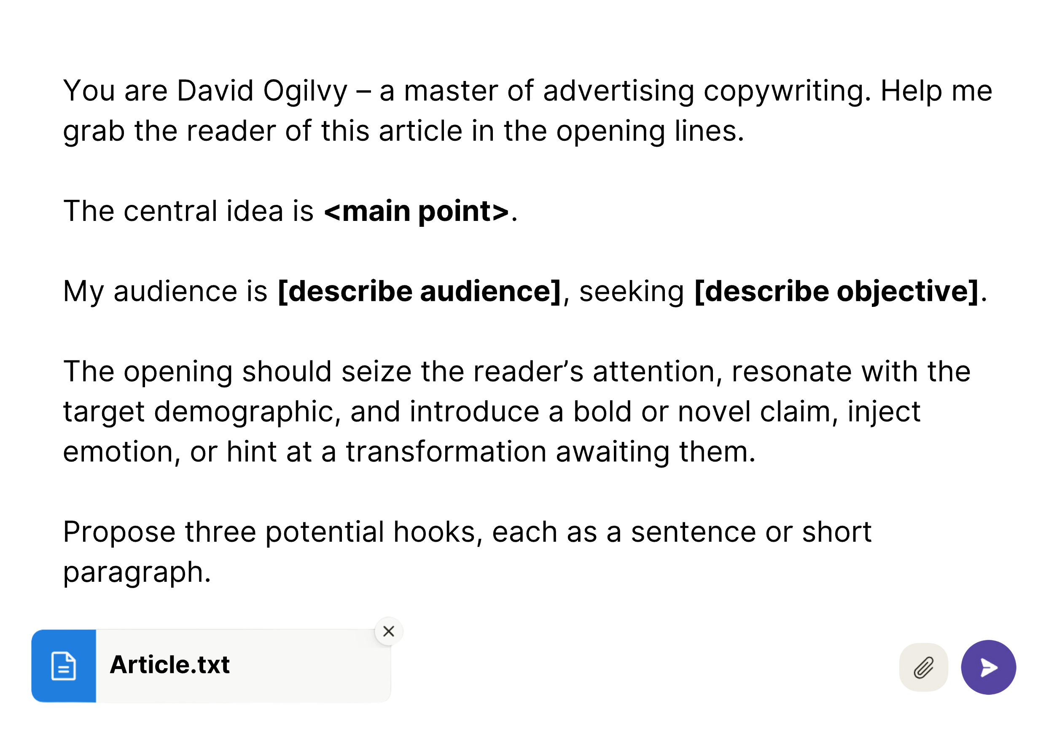

You can also compile a list of examples in the form of a “swipe file,” comprising the most effective hooks you come across.[5] A swipe file populated with opening hooks can be attached to a prompt like your style sheet. But instead of matching a specific voice, it provides samples of the narrative punch you’re aiming for.

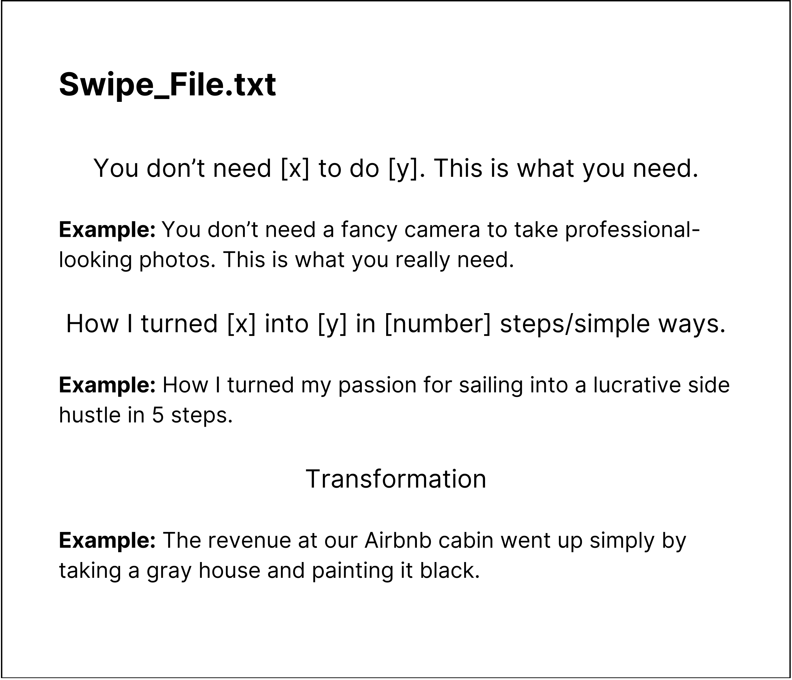

Once you’ve created your swipe file, you an upload it as an attachment along with your draft and inform Claude that you would like to generate some potential hooks for the article in the spirit of the hooks contained in the swipe file.

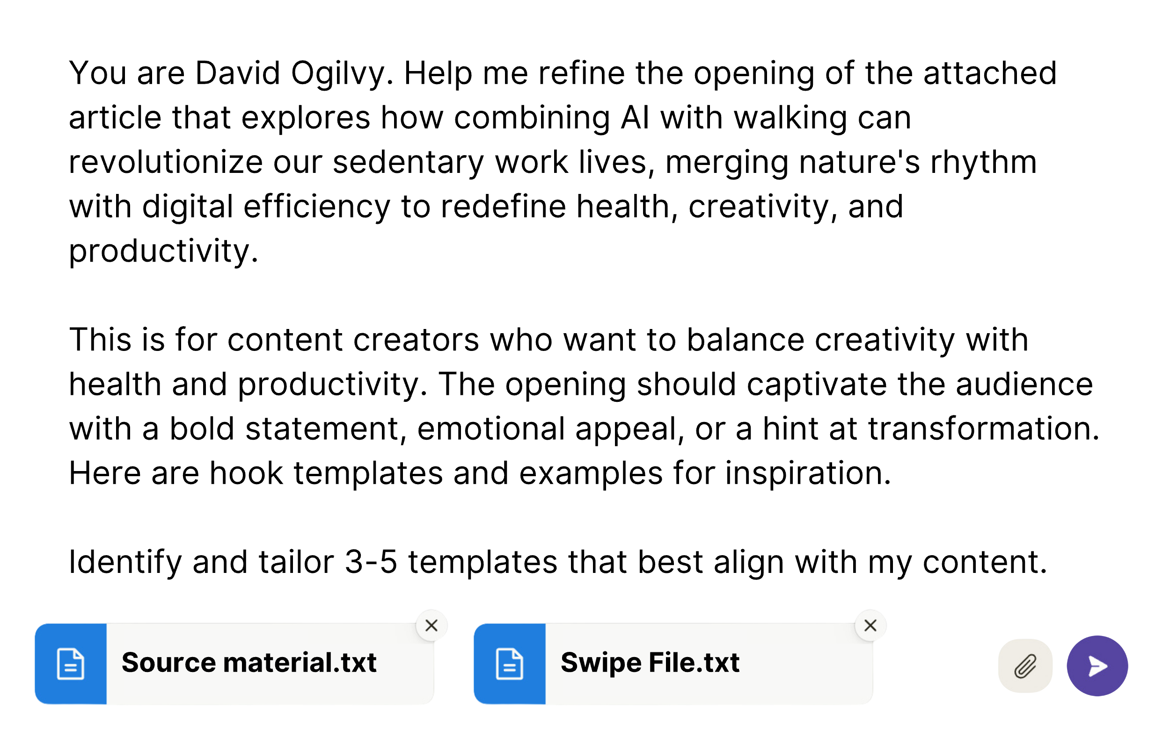

Then, pick your favorite or synthesize the best elements into a single, powerful opening that grips your reader before they have a chance to click away.

The right hook can make all the difference in whether a reader stays for the whole show or leaves after the first act. If you’ve done your job, the reader will reach the conclusion with a new perspective. You will have earned their trust. Now, what will do you with that trust in the final words? In modern, digital writing, the conclusion has one purpose: propelling readers to clear action.

Suppose you offer a service that simplifies the solution to a problem you explored in your article. The call to action presents the chance to transform readers from passive consumers of information to active participants in your offering. For a book chapter, the call to action invites the reader to continue to the next chapter. For articles, it may promote engaging further with related content you’ve created.

Your call to action (CTA) should align with your content strategy. Consider these options:

* Inviting readers to join a newsletter for ongoing dialogue
* Suggesting the next article to read, to go deeper into the topic
* Encouraging readers to share the content with others
* Registering for an upcoming event on the topic
* Scheduling a consultation for tailored advice

The aim here is to transform the reader’s newly acquired knowledge and enthusiasm into a specific, meaningful action. The hook grabbed their attention; your CTA will harness that focus, turning it into the momentum that benefits both the reader and your goals.

## Refining Edits: Smoothing Transitions & Eliminating Redundancies

With our hook and call to action in place, we can turn our AI-assistant’s eye to identifying awkward transitions, redundancies, and gaps in the logical flow.

We can once again begin a new chat, provide the full draft, and then ask Claude a simple question:

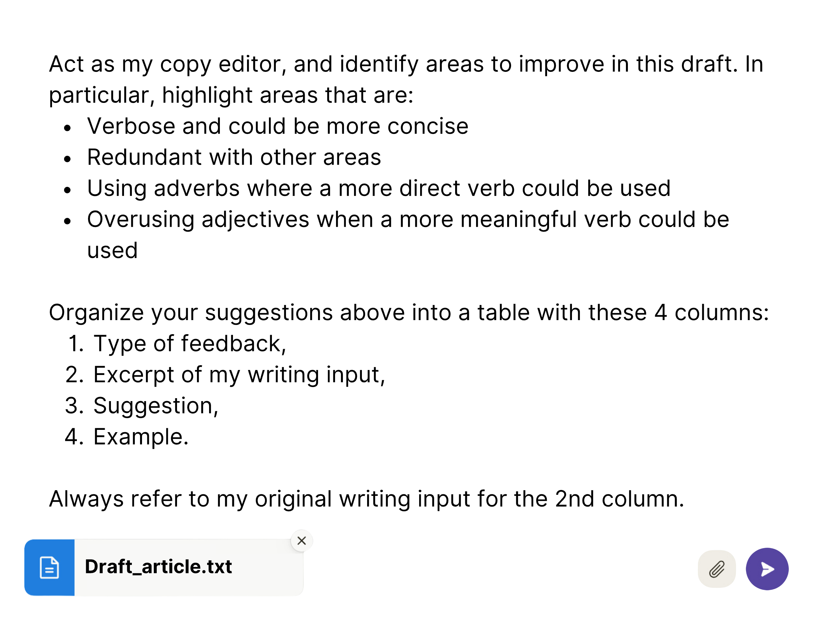

Note that we are not asking Claude for a complete spelling and grammar check. While LLMs are capable of doing such a review, you are better off using a custom AI-powered tool like Grammarly – or even Microsoft Word’s spell check feature – to make these final edits.

If you assign too many tasks at once, it dilutes the focus of your prompt. Even the above general editing prompt – asking the AI to identify verbosity, redundancies, long sentences, and improper use of adverbs and adjectives – will yield fewer suggestions for each criterion than if you broke them out into separate prompts. Thus, a broad prompt like this can help identify the most glaring errors, but a series of more specific prompts will provide the AI with a more focused context for each editing task.

For instance, if you’re most concerned about awkward transitions or redundant phrases, a focused prompt like this might be most effective:

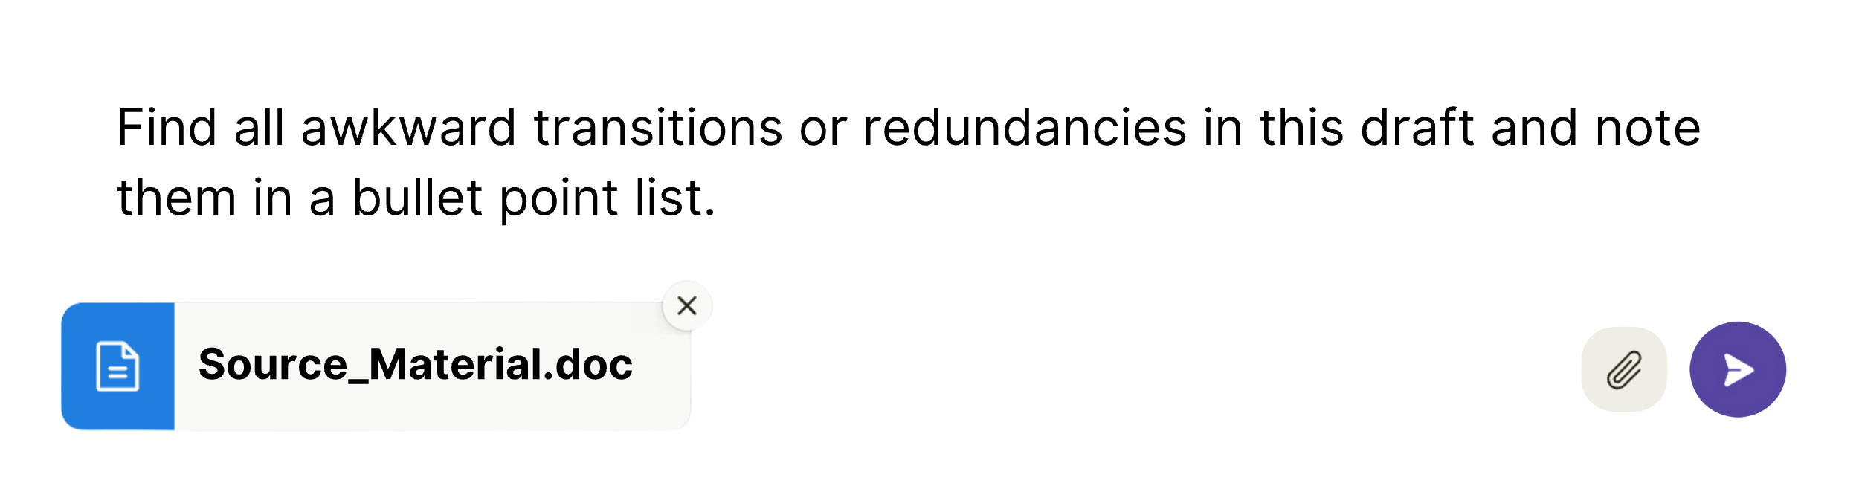

You might then follow up with prompts that address these specific areas. For smoothing transitions:

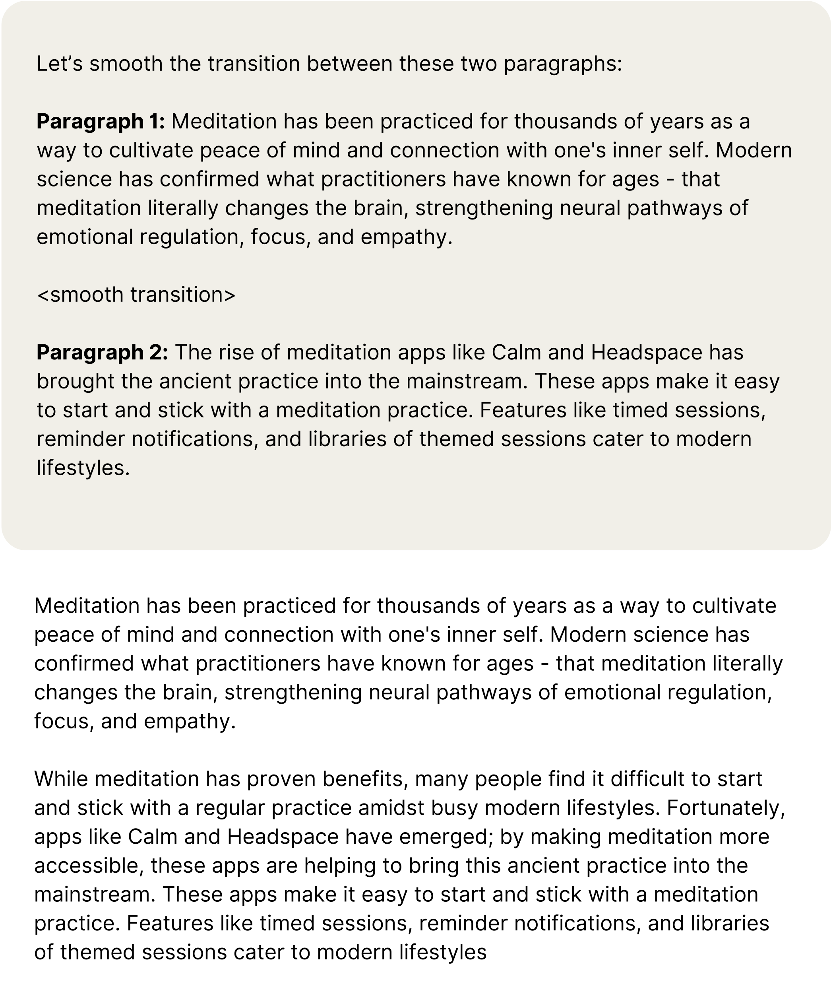

The first, darker box contains the human prompt while the lighter box contains Claude’s actual reply to this question.

Or for combining redundant sentences:

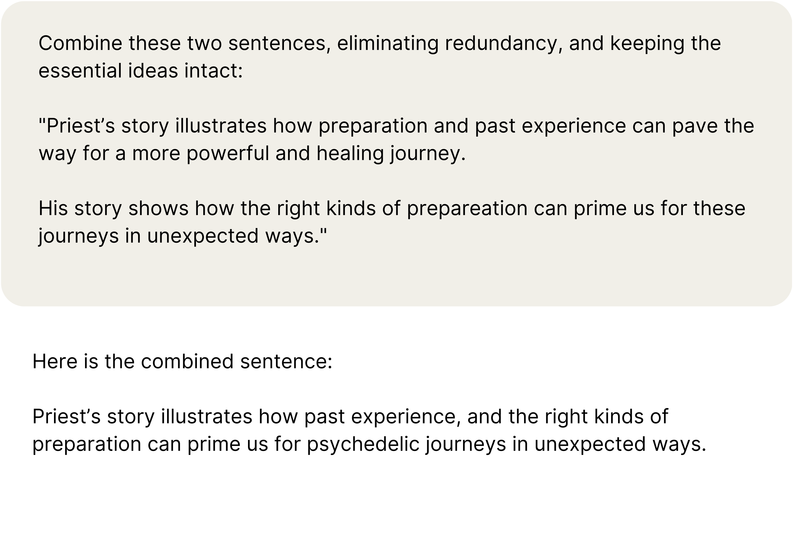

This approach surfaces more granular errors and allows for targeted corrections. Like a sculptor inspecting rough edges, our goal is to polish these remaining imperfections through deliberation and care.

## Humanizing Touches

In the course of writing this book, I’ve often asked myself whether it’s possible to use AI to make your writing sound ***more human.*** I believe that it is.

To conclude this part of the book, I offer the following three prompts to make your writing sound less robotic.

### Vary Sentence Length

The first method is to alternate short and long sentences. This suggestion comes courtesy of Joshua Lisec’s ***Best Way to Say It*** methodology. One drawback of drafting with AI is that its sentences tend to have uniform length and, thus, a dull, mechanical cadence. The best writing has a rhythmic quality, alternating between longer, more descriptive sentences and shorter, punchier phrases for emphasis.

Here’s a prompt you can use to identify the sections most in need of variety:

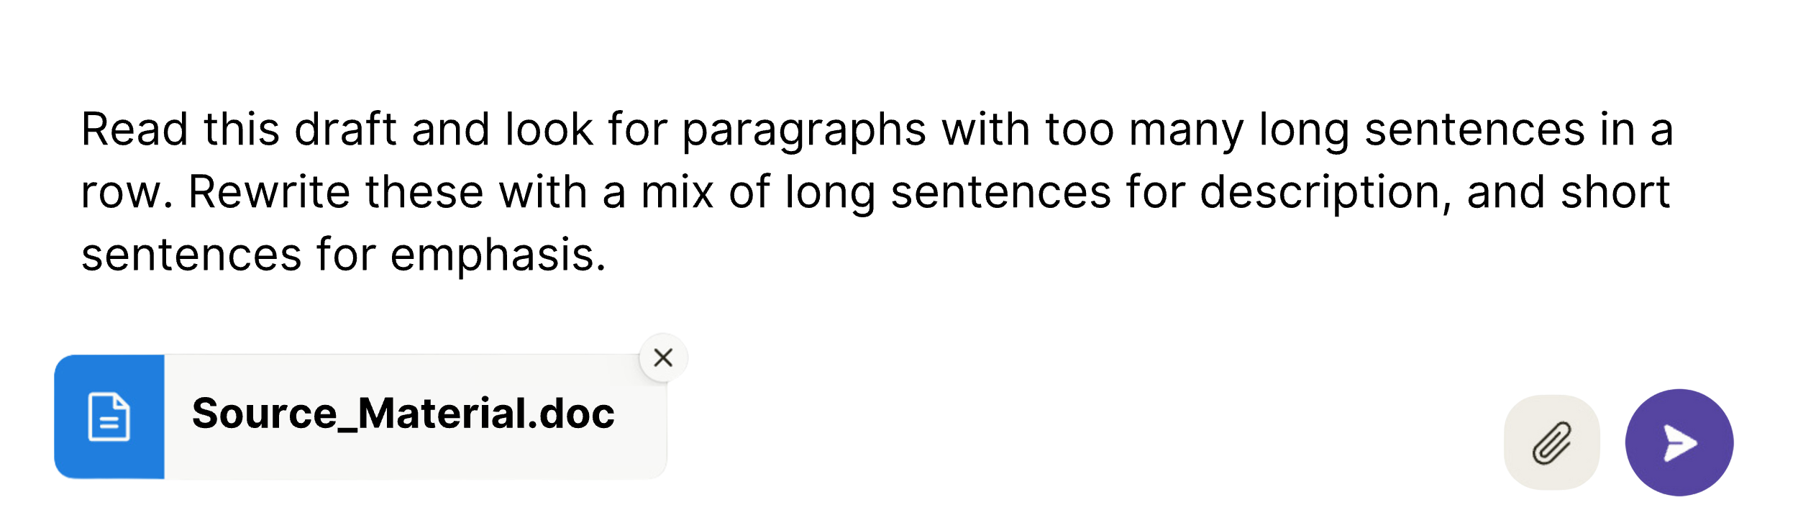

Note that you can also include this guidance in your style brief so that varied sentence length is “baked in” to the drafting process.

### Visual Examples

The second humanizing prompt identifies vague areas that could be boosted by a personal anecdote, analogy, or visual example:

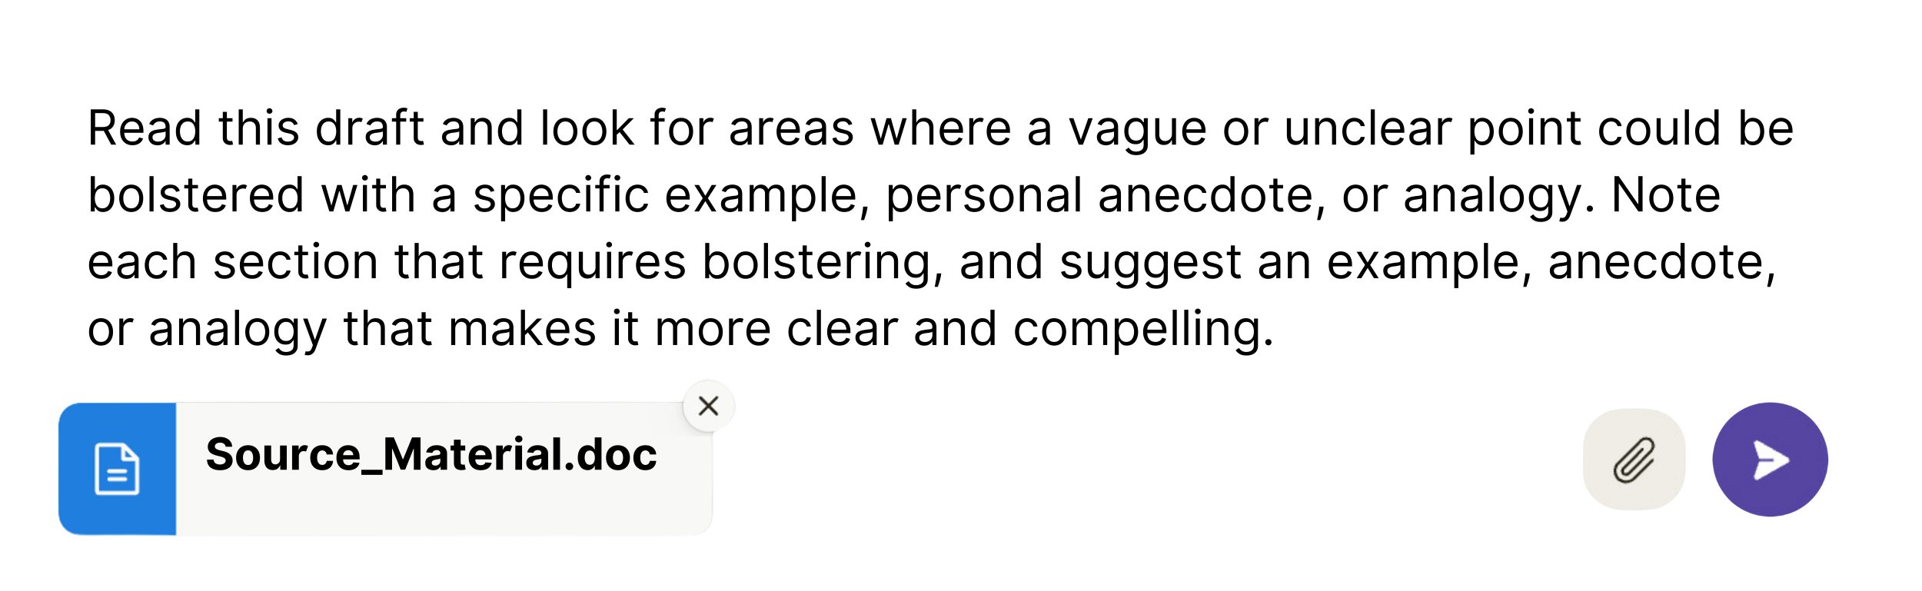

This advice likewise comes from Lisec’s course, as a way to “hypnotize” your reader and make your content a more immersive experience.

### Mimicking the Greats

Lastly, you can prompt AI to rewrite dry passages in the style of your favorite authors:

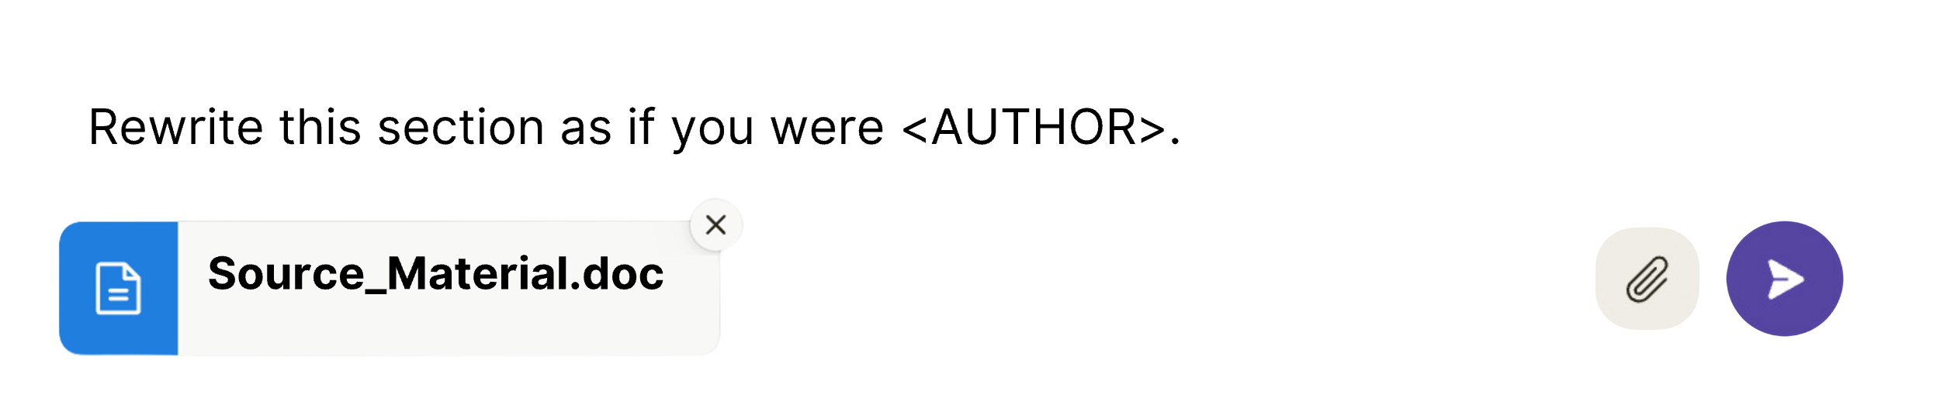

Certain authors will be more useful than others for your brand of writing. Are you a marketing professional? Try David Ogilvy, or for a more modern reference point, Alex Hormozi. Do you work in medicine? Consider consulting the voice of Dr. Atul Gawande. Literary nonfiction? Maybe you’re looking for elements of Michael Pollan’s or Malcolm Gladwell’s trademark style.

I have come to appreciate the usefulness of adding a touch of Dave Barry-style humor to my dull manuscripts.

Just remember to use these as suggestions. Don’t replace the original text with the AI’s exact output but use it as inspiration and borrow bits and pieces, while leaving your original phrasing mostly intact.

When I try the Tom Wolfe version of this on the paragraph above, for example, I get the following output:

See here, splendid scribes! In pumping up your prose with cyber-assists, retain your authority! Let artificial intelligence be your muse, not your overwrite! Take its offerings like a bouillabaisse - pluck tasteful morsels of metaphor to integrate seamlessly into your original masterpiece. Use a delicate hand, darlings! Never forget you remain the auteur, the artiste in charge of this lyrical canvas!

This paragraph would be out of place if I reproduced it in its entirety. But I might borrow a few choice phrases to spice up my writing (like a bouillabaisse).

## Turning the Page: From Articles to Books

This part of the book has walked through the essential steps to becoming a CODER of meaning – a “natural language programmer” – with a practical understanding of the elements of prompt engineering for long-form content.

In reworking a transcript into an article, we followed these steps:

* **Captured** our ideas within a single transcript, serving as the raw “source material” for crafting a concise, polished article.
* **Organized** the source material, by breaking it down into smaller components and mapping it out with timestamped summaries and inventories of quotes and key ideas.
* **Distilled** the central “point” from the big picture within a logical, reassembled outline.
* **Expressed** these distilled ideas in prose in the style of our choosing.
* **Refined the text**, filling in gaps, crafting hooks, and creating smooth transitions.

You now have everything you need to implement this system with your own source material and start “repurposing upwards.” Once you have developed the “mechanical sympathy” necessary to turn a single pillar piece into an article, you will start to imagine new possibilities for writing longer and more elaborate content. Regardless of the length and format of the final output, the creative process of transforming a complex and chaotic web of ideas into a clear and compelling narrative follows this same four-stage progression – from the divergent steps of “**capturing”** and “**organizing**,” to the convergent steps of “**distilling”** and “**expressing.”**

Now, it’s time to take this systemized approach to creativity to its logical conclusion – climbing to the apex of the content pyramid, where you can crown yourself as the ultimate authority in your domain. Prepare to author the future. Get ready to write your book.

PART 4

CODE Your Minimum Viable Masterpiece

Chapter 14

CAPTURE AND ORGANIZE

Outlining a Book IN Your Second Brain

*“The impediment to action advances action.   
What stands in the way becomes the way.”*

– Marcus Aurelius

“Be regular and orderly in your life, so that you may be violent and original in your work.”

– Gustave Flaubert

The average author takes three years to write a book. In that time, Ryan Holiday didn’t just write one; he wrote three. The last of these, The Obstacle Is the Way, not only claimed its place on the bestseller list but also captivated over 100,000 modern readers with the timeless philosophy of Stoicism, which embraces life’s struggles and pleasures in equal measure.

How did he do it? It turns out that Holiday had a secret weapon: notecards. Holiday carried 3 x 5 index cards everywhere, scribbling down ideas, quotes, and stories as he read and went about his daily life. This system was borrowed from his mentor, Robert Greene, the author behind mega-bestsellers like *The 48 Laws of Power*. Greene, too, used notecards to capture source material from the vast array of books he consumed. As he read, he highlighted important sections and jotted down notes in the margins. Later, he transferred these annotations onto notecards, allowing him to deconstruct the information and identify patterns that would eventually form the foundation of his books.

After amassing enough material for a full book, Holiday followed suit. He would sit down and rearrange the content at will – pulling from the treasure trove of material he had captured on notecards over time. This idea capture and organization method made the second writing phase easy. With notecards in order, he could just fill in the gaps and call it a day.

Note that Holiday didn’t produce his books through laborious stints of unbroken “deep work” from an isolated cabin in the woods. Instead, he developed a system that allowed him to finish most of the work on his book before he ever started writing. In doing so, he was keeping in line with a rule of thumb that sounded illogical when I first read it in Tiago Forte’s book, ***Building a Second Brain***:

“Only start projects that are already 80 percent done.”[6]

For our purposes, we can update the advice to “Only start writing a book that is already 80 percent written.”

How can you write 80 percent of a book before starting it? To resolve this seeming paradox, let me clarify: You don’t need 80 percent of the content to be polished and arranged in its final form. You just need to have gathered most of the raw ideas and insights before committing to crafting your book’s outline. Like Holiday, you do so by capturing ideas over time so that the groundwork is laid well before the “official” beginning of the project.

## Capturing Your Source Material

In the last few years, I’ve written books for a libertarian attorney, a progressive psychologist, a Republican activist, as well as a naturopathic nutritionist, an extreme biohacker, and a B2B marketing professional. My ghostwriting clients are a diverse bunch, but they all share one thing in common: They all came to me with a large enough body of existing pillar content to fill the pages of at least one book.

For one client, I turned 100+ hours of teleconference proceedings into a comprehensive 200-page “12-step guide” for citizen activists dedicated to removing fluoride from their municipal water supply.

For other clients with podcasts or radio shows, I’ve repurposed 10-30 of their interviews as source material for focused, timely, topical books. In some cases, I’ve acted as both a podcast producer and ghostwriter. Here, I orchestrated the interviews with select guests to source the source material that we needed to craft the book. This strategy has allowed me to be the first to publish on trending topics before they reach the mainstream and sign contracts with publishers even before the content is recorded.

### Identifying Your Existing Intermediate Packets

As with articles, writing a quality book with AI hinges on having source material. Audio transcripts are my favorite form to work with, but any of the following are fair game:

* **Pillar pieces:** Podcasts, YouTube videos, and presentations
* **Micro-content:** Twitter, Instagram, or LinkedIn posts
* **Newsletters/blogs** (both published and unpublished drafts)
* **Voice memos/miscellaneous**: notes on your phone.

In Forte’s framing, these all represent “intermediate packets” – smaller blocks of content that can be snapped together into larger structures like LEGO bricks. Thinking in terms of intermediate packets and existing source material reframes the process of writing a book from one that requires long uninterrupted blocks of forced effort to one where you can make consistent progress in short bursts. Wherever you are starting, take stock. Write a list of everywhere your intermediate packets live.

If you are working with text-based source material, like blog posts or written tweets, compile the links or documents all in one place.

If you’re working with audio or video, get an [Otter.ai](http://Otter.ai) account and start transcribing the content related to your book. Then, export these transcripts to a folder in your chosen file storage system or note-taking app. [Otter.ai](http://Otter.ai) also offers a handy phone app, that lets you record and transcribe your ideas while you’re on the go. You can capture thoughts that pop into your head during a morning jog or while you’re stuck in traffic before they slip out of your head.

### Structuring Your Second Brain

Some people will prefer the simplicity of an analog system like Ryan Holiday’s box of notecards – organized by broad topic. Tiago Forte recommends creating a simple file directory on your hard drive, containing your intermediate packets sorted into folders for different projects, areas, resources, and archives.

My preferred “second brain” system utilizes the versatility and convenience of a cloud-based workspace, built within (you guessed it) Notion. Notion allows me to create dashboards for each writing project, with customized content databases, dynamic outlines, and a host of AI features and integrations that save me time and effort when sifting through large volumes of information. The “Save to Notion” browser extension, for example, lets me extract the full contents of any page on the internet into a specific content database with just a few clicks. I can configure that database to then generate summaries automatically or extract key quotes with AI.

Note-taking apps like Evernote offer similar integrations with your browser, but nothing I’ve seen compares to the power and flexibility of Notion’s all-in-one workspace approach – combining databases, word processing, and now AI into a sleek, aesthetic experience.

Whatever tool you choose, remember that building a second brain system is a personal endeavor. Forte’s book can give you some helpful principles, but I’ve found that pre-made templates never align with my idiosyncratic thinking patterns. Over time, I’ve developed my own structures within Notion that feel intuitive to me, and I’m happy to advise others. But it’s best to let your second brain emerge organically from sustained use, customizing a system to support your unique creative flow.

### ****Capturing Others’ Ideas****

Your primary source material should come from your own intermediate packets – things you’ve written or spoken. But every author leans on external sources of inspiration and knowledge in a variety of formats, from book highlights to articles, research papers, and blog posts.

“No one creates anything out of a pure void,” notes Forte, “We all stand on the shoulders of our predecessors.”

As a content creator, you can and should borrow ideas from others with two caveats:

1. You should always put your own spin on it
2. You must provide generous attribution.

“Giving credit where credit is due doesn’t lessen the value of your contribution – it increases it,” adds Forte.

By quoting Forte in this way, I am following my own advice – attributing the idea to the original writer and directing my readers to the source. These quotes from Forte’s book, *Building a Second Brain*, have been sitting dormant – waiting to be used in this chapter – since I first highlighted them when I read the book. The purpose of a second brain is to capture and store information, like quotes from books you read, so you can access it when needed. This is a slow and steady process – not a sprint. The key is consistency over a long period of time, and the key to consistency is having a system that’s so easy you don’t have to think about it.

## ****Organize: Structuring Your Table of Contents****

With your content captured and assembled in a central database, you can get a better sense for the contours of your book. Now, your task is to organize your material into a broad-brushed outline so you can begin to whittle that down to the essential themes.

The biggest difference between outlining an article and outlining a book arises from the volume of material involved in writing a book. For a podcast episode, we could get our map of the terrain from a timestamped outline. But a database containing 50 to 100 podcast episodes can add up to over half a *million* words. Even Claude can’t summarize that much material in one pass.

As we zoom out, attempting to see the whole picture from this heap of text, we can see the same fractal pattern continuing to unfold in our organizational process. For books, unlike articles, there are two distinct phases of outlining:

First comes the overarching outline for the entire book – your table of contents, i.e., the broad chapter headers that support your book’s central theme or main point. You need this high-level outline before you can begin organizing and outlining the content *within* chapters.

Second, once you’ve defined your chapter topics, you need to create detailed outlines within each chapter. Here, the main point of each chapter shapes the flow of ideas, similar to how the main point guides the structure of an article.

At both levels, we are still applying the same general progression that we learned in the previous section of the book:

* Deconstruct your source material into core ideas. **(organize)**
* Identify the main idea. **(‘the point’)**
* Reconstruct those ideas into a logical order based around the central point. **(distill)**
* Draft the text based on the new outline, either by yourself or with AI, one section at a time **(express)**

Before AI, my “deconstruction” method involved printing out all the transcript materials and reading through them with a highlighter to avoid frying my eyeballs from too much screen time. Through this painstaking process, I would start to notice patterns taking shape. Certain keywords would become connected in my mind, and I would start to group them under umbrella topics or tags. Soon these topics and keywords would form “buckets” – clusters of related points and ideas that fit together. From these buckets, a hierarchy of ideas would begin to emerge from the chaos until I had a branched tree of sorts with the broad topics branching into smaller and smaller topics.

Today, however, you can leverage an AI-powered second brain to save your own brain cells (and your eyeballs) from much of that headache. No, despite the hyped-up promises, AI cannot write your entire book for you, but it can help at each stage – beginning by imposing order on a large volume of material and helping you to “zoom out” on the big picture.

### Case Study: ****B2B Software Thought Leader****

One of my clients, a thought leader in the B2B Software space, illustrates how we can use AI to assist the outlining of the book. Let’s call him Jason. Jason’s content library was brimming with potential. It contained hundreds of podcast episodes, dozens of LinkedIn posts, and a handful of long-form “manifestos,” each offering insights into the future of the SaaS (software as a service) industry. Yet, in its raw state, this wealth of material lacked the structure and organization necessary for a cohesive narrative. My client had the ideas and the content but not the time or energy to mold it into a coherent narrative.

He did, however, have a big-picture vision for the book’s structure. Jason envisioned each chapter applying his unique perspective to a different department of a modern B2B SaaS company: sales, marketing, product, customer success, operations, and so on. These became our chapter headers. This vision was our starting point – a rough map to guide us through the content wilderness. It gave us enough structure to begin identifying the most relevant content pieces (the “intermediate packets”) for each planned chapter.

To organize this wealth of source material, I set up a Notion dashboard to serve as command central for the project and then took a systematic approach to dividing the content into the relevant buckets:

1. First, I tagged all the content in the master database by type (blog, podcast, etc.), original URL, and relevant chapter topic(s).
2. Next, I created separate pages for each chapter outline where I captured the high-level points to cover, essentially placeholder docs to organize my thoughts on structure.
3. Within the pages for each chapter, I created a “linked database” – a synced copy of the master database – which only displayed the intermediate packets tagged for that chapter. Notion allows you to filter your databases like an Excel spreadsheet, showing only the pieces of content that are tagged with “Sales” or “Marketing,” for example.
4. Finally, using NotionAI, I generated AI summaries of every piece of content in the database to give me a bird’s-eye view of the content related to each chapter.

Thus, every chapter had its own page, containing an efficient at-a-glance overview of the content relevant to that chapter, along with my broad notes on that chapter. These filtered database views gave me the equivalent of our timestamped outline from the previous section – a map of the terrain and the rough material I was working with. With this system, I could see both the forest *and* the trees: The AI summaries gave me a sense of the overarching ideas, and I could zoom in on the most relevant details from the source material with one click to get a more detailed view.

### What to Do When the Book’s Outline is Unclear

In Jason’s case, the book outline was obvious from the start. Each chapter would put his spin on a different department within a tech company. This gave us enough structure to begin organizing the intermediate packets into the relevant chapters on Day 1. But sometimes the overarching structure of the book is less apparent. When you lack a clear picture of this “macro-outline,” you can use AI as a reasoning engine to offer powerful assistance. Claude can handle an abundance of amorphous source material and propose a logical reorganization for the content.

For this task, I again utilize Notion’s AI database properties – columns within the content database that generate automatic summaries or key information for each row or entry. These properties take whatever source material is housed within the pages of your database (i.e., transcripts, articles, etc.) as the context for the prompt you apply to the entire column. Beyond summarizing, you can craft custom AI properties that extract specific content, such as a list of keywords or quotes related to a specific topic.

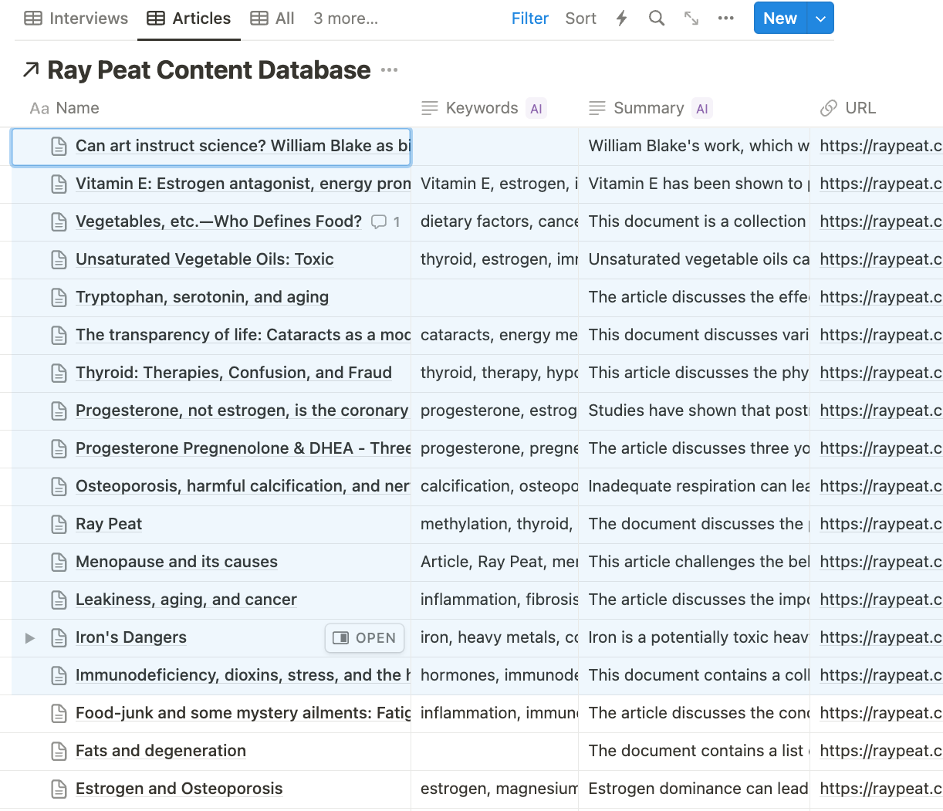

A filtered view of a database in Notion with custom AI properties for summary and keywords, derived from the contents of each entry.

After creating these properties and populating the content database with AI summaries, I copy and paste the titles of the packets, along with summaries and keywords for all of the entries, into Claude with some broad context on the aims of my book.

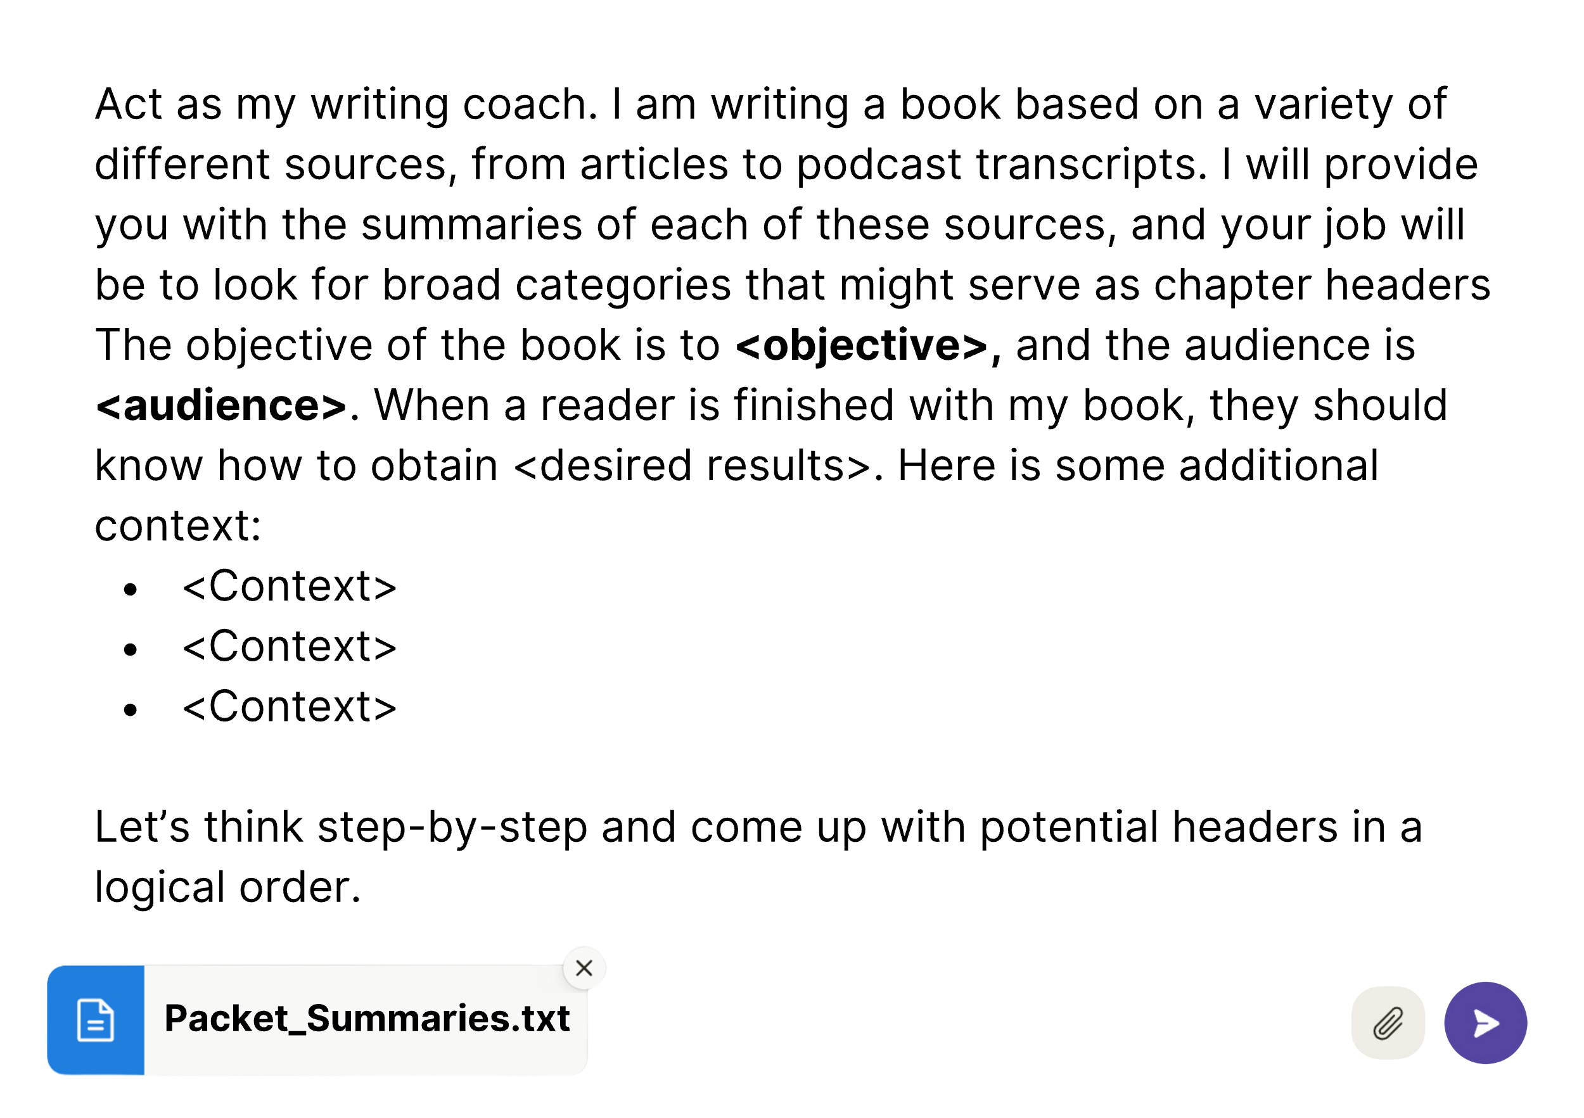

With this prompt, AI inspects the summaries for recurring themes among these fragments, proposing potential chapter groupings. The more context bullet points you provide, the better the output will be. Context might include any hunches you already have about the logical structure of the content or topics you are confident will become chapters. Here, it helps to include your purpose for writing the book or the “main point.”

This stage of the outlining process with AI assistance is an exercise in information architecture. We assemble an expanse of raw material from our existing content body to supply the foundational blocks. Claude’s capacities for pattern recognition and summarization help identify the weight-bearing walls to erect the overall book structure.

As with writing articles, developing the macro-outline requires iterative feedback. You’ll need to refine the AI’s initial suggestions, edit the outline based on your understanding, and provide directions for improvements. Queries like “What’s missing from this outline?” or “Does this re-ordering make sense?” can guide the AI to refine its suggestions. Flexibility is your ally – you can always adjust and reorder chapter headers as the book takes shape in the convergent phases of distilling and expressing.

As you create this macro-outline, you can begin to consider the main points within each chapter alongside the logical ordering of chapters to make the main point of the book. If the point of the book, or of the individual chapters, feels unclear or underdeveloped, you may need to go back to the “capture” stage until you have enough relevant material to suggest an outline for the whole book, and the chapters within. This can be a valuable exercise to spotlight gaps in your outline, even before you have all of the necessary material.

Whether you use Notion or notecards, you need a system to capture ideas that can later be organized into the foundations of a book. AI tools can accelerate the process compared to analog methods, but the important thing is that you have an easy, consistent way to jot down thoughts as they arise so they can be harvested later. There is no one-size-fits-all system, but you can download the basic Notion template I use for organizing content for book writing projects at my website. I can also advise on how to customize your workspace to balance the power of AI with the simplicity of notecards. The goal is to make writing your book feel less like a marathon slog and more like snapping together the building blocks you’ve already created over time. Once your content database is assembled – or at least 80 percent done – you know what to do next, or at least who to call if you need help with the final 20 percent. Although I’m high tech when it comes to my second brain, I’m old fashioned in that I still prefer phone to email. You can text or call me at (415) 717-5370 and I will respond. You can also reach out via my website, www.vergili.us, or email me at chdeist@gmail.com.

Chapter 15

Distill & Express

Bridging the Archipelago into Coherent Chapters

“Bad authors dilute their ideas to fill a book.

Brilliant authors distill their ideas to fit into a book.”

– Alex Wieckowski, founder of @Alexandbooks_

The blank page stares at you – cursor blinking. You stare back, also blinking. You know that you have important ideas that need to be shared. But you’re paralyzed by a vague fear. How can you translate the jumble of thoughts in your mind into polished prose? How can you quiet the inner critic for long enough to get a decent draft down on paper?

The ancient Greeks believed creativity to be a gift from the Muses, nine goddesses who were unpredictable by nature, sometimes whispering brilliance in their subjects’ ears and other times remaining silent. Writers have always struggled with the unpredictability of their inspiration, facing the challenge of the blank page – not knowing where to begin or what to do in the absence of that spark. It’s tempting to think of inspiration and creativity as something outside of us rather than an internal process that demands real work and effort.

Against this view, the prolific historian, David McCullough – known for epics like *1776* – once remarked, “Writing is thinking. To write well is to think clearly. That’s why it’s so hard.”

Let me repeat: Writing *is* thinking. And thinking is *hard*.

Even when you manage to get your ideas down, the hardest part about writing remains: deciding what is essential to the reader and what can be cut. My theory on “writer’s block” is that most people don’t struggle with a shortage of ideas. Rather, they are afraid that in expressing them in a stream-of-consciousness style, they will end up with something that makes less sense than it did in their head, and it will take longer to rework and edit than it did to type out. I’ve had this experience before.

The system we are employing sidesteps this pitfall by capturing all of the relevant source materials first, knowing the initial order is not final. Through phases of capture, organization, distillation, and expression, we systematically rework and refine the raw ingredients into a polished final product.

With the broad book outline set and materials filtered into chapters, we’re ready to transition from gathering content to distilling and expressing the essence of each section. Our objective now is to sculpt the divergent ideas and themes we’ve captured into focused, chapter-specific narratives. The chapter headers and preliminary outline shines enough light to embark on a selective journey of convergence with the content, identifying pieces aligned to each theme and setting aside the rest.

## Assembling Your Archipelagos of Ideas

As Tiago Forte writes, once you have a critical mass of ideas to work with, “you switch decisively into convergent mode and link them together in a way that makes sense.”

The first step in distilling this raw content is to create a separate document for each chapter. Drawing from Forte’s concept of “archipelagos of ideas,” these documents will house related but disjointed material from our content database – a mixture of original writing and curated quotes. Much like a brain dump, these documents allow us to gather possibilities before carving out the key points.

As creativity scholar Steven Johnson explains, starting each chapter as “a kind of archipelago of inspiring quotes” makes the vast empty canvas less daunting: “All I have to do is build bridges between the islands.” Rather than confronting a terrifying blank page or empty document, we have fertile soil from which to cultivate the chapter’s direction.

While gathering ideas is a divergent exercise, organizing this information requires convergent thinking to funnel down to the most relevant points. So this stage balances widening and narrowing the aperture as we distill our master content database into chapter-specific archipelagos.

As we gather possibilities into these documents, we can pull verbatim quotations, passages, and examples liberally from the intermediate packets assembled in our content database. Even lengthy excerpts are fair game to port over at this divergent stage. We extract anything that might have a place in the final outline.

Each chapter overview – your annotated archipelago of ideas – functions like the condensed Cheat Sheet from our article writing framework, only synthesizing a great deal more source material. Once assembled, these documents enable us to create an initial outline for each chapter with Claude’s assistance.

With the raw ingredients gathered, the next step is to employ Claude to start structuring this mixture of quotes, ideas, and passages gathered into the foundations of a chapter, using a prompt like this:

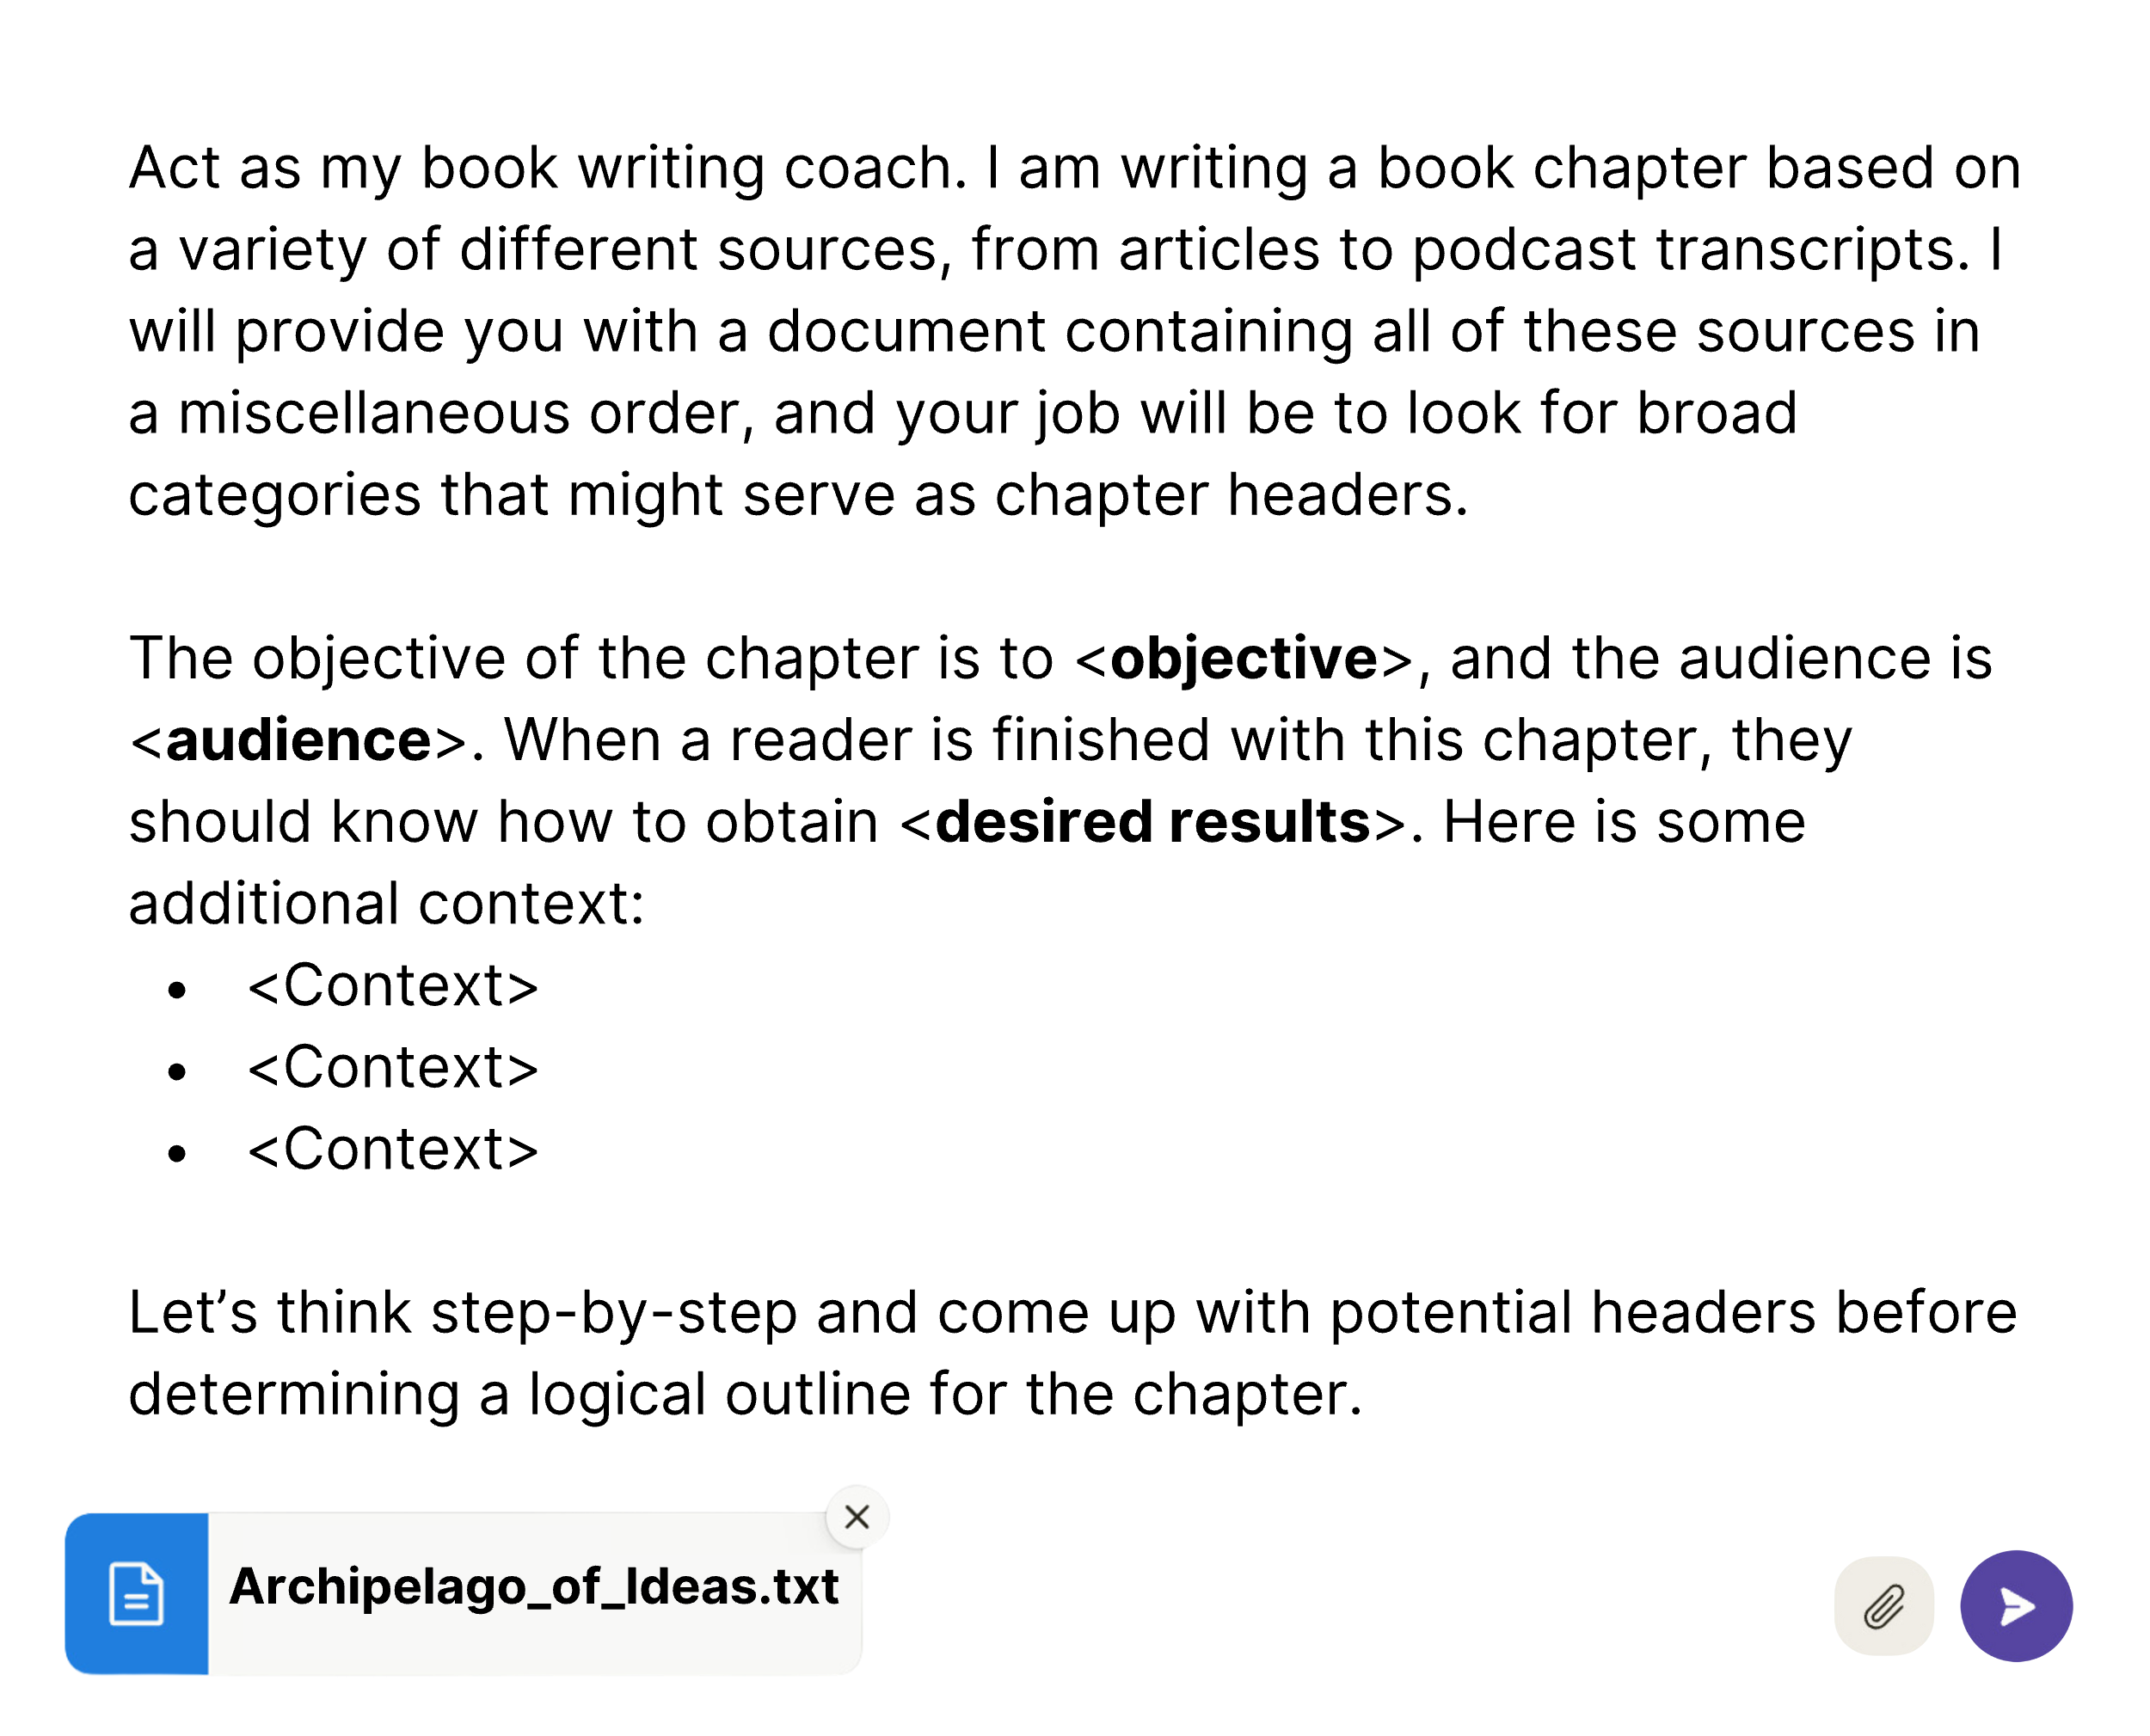

You can then rearrange the headers and points as you see fit and then ask Claude to take another pass at organizing the content in the most logical order, with more supporting details. See what order it suggests right off the bat. Don’t get stuck on the original high-level archipelago if the content starts to pull in a different direction once you zoom in. Be willing to reorganize sections and move entire blocks around as you write if you find better connections and through lines. Your outline is a guide, not a straitjacket.

Once you are satisfied with a high-level outline, the next level of distillation involves assembling all of the relevant ideas and points underneath the relevant headers. From here, the process of formulating a detailed outline and drafting the chapter is virtually identical to the steps for writing an article – from specifying the desired voice to drafting one section at a time. Remember: each chapter should have a clear point, a logical structure to support that point, a hook to entice the reader, and a concluding call to action. The biggest difference between an article and a book chapter – other than length – is that the call to action at the end of most chapters will be the invitation to your reader to continue reading to the next chapter.

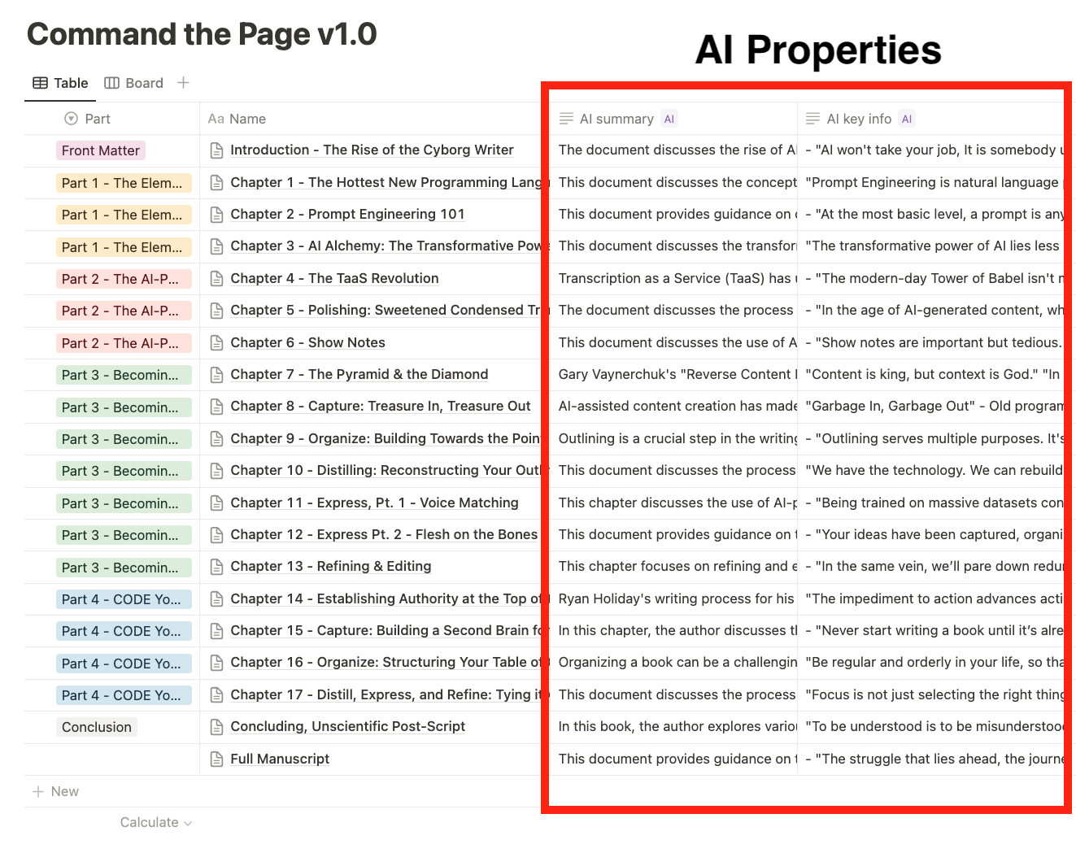

A view of the outline database for this book, with summaries and key info for each chapter. I use this view to provide necessary context on the entire book when starting a new chapter.

As with all hooks and conclusions, transitions between chapters always require special additional attention. For each new chapter that I’m working on, I start a new conversation with Claude. However, it helps provide some context of where we’ve been and are going. Remember that while each chapter will have its own main idea and supporting points, these chapters exist within a broader narrative that serves the Ultimate Main Point that the book is about. One way to retain continuity between chapters is by giving Claude the previous chapter in full and mentioning that you will be continuing from where the previous chapter left off. A more comprehensive method is to create a Notion database with an entry or page for each chapter. Title each chapter and create an AI summary property. Then, copy and paste the chapter names and summaries in chronological order and share this list with Claude at the beginning of the conversation. This way, the conversation is situated within the context of the book, and the model can make connections to previous parts.

With this system, you never have to struggle against writer’s block again. If you do get stuck in the process of writing your chapters, go back and re-read the chapters on expressing and refining in Part 3 for the details of how bring your outline to life in successive stages.

Ask yourself: have you defined the main point of the entire book, as well as the individual chapters? If not, iterate there.

Have you outlined the key points in detail, in a logical order? The bulk of your time should be spent here. You may have to wrestle with your material for a time to see how it all fits together. But it’s better to do this wrestling in the outlining phase than after you’ve invested the time in writing chapter drafts. Once you put the words on the page as anything close to prose, it’s easy to get attached to them. Rewriting becomes a more painful process as you are forced to not only redouble your efforts but also “drown your babies” that no longer fit within the new outline.

An ounce of prevention is worth a pound of cure. The more selective you are in your distillation, the less you’ll have to work to serve your readers with the essential information and none of the fluff.

Conclusion

WHY WRITE A BOOK?

On Becoming Irreplaceable

“The illiterate of the 21st century will not be those who cannot read and write, but those who cannot learn, unlearn, and relearn.”

– Alvin Toffler, American futurist

An author’s primary duty – before setting pen to page – is to act as a conduit for channeling ideas from “out there” in the real world onto the page in a way that renders them useful and actionable to other people. Committing to writing a book is like positioning a lightning rod or antenna atop your head. Your subconscious begins to seek out relevant information. You become attuned to fleeting ideas that might find a permanent home within your book’s pages. Stray thoughts converge into a high-voltage signal that then powers your pen. When the writing begins, your ideas flow from a mind primed to give shape to its vision.

Artificial intelligence, combined with the system of transformation I’ve laid out in this book, makes it easier than ever to write a book. But it still takes time and effort. Before committing, you would be wise to reflect on your motives.

My reasons for writing this book were twofold, and both revolve around the idea that authority is the ultimate resource in the AI era.

First, if I’ve succeeded, this book will convey a sense of my authority on the topic of AI-assisted writing.

But my second and deeper motivation for writing it was to structure and refine my writing method into a step-by-step system – a replicable and useful body of knowledge. In organizing the information, I had to take a detailed inventory of the kinds of prompts and sequences I’ve used to solve my own problems and do my job better. In this way, **it was the act of writing this book that has made me an authority** (at least inasmuch as anyone can be an authority on AI this early in its development).

In several places in the book, I didn’t see a clear way to communicate my system, indicating that I had not yet thought through the steps involved. This forced me to stop and think, often iterating with AI to hone the ideas until they made sense. This struggle is not an obstacle to be avoided. It’s often the missing ingredient that transforms you into the expert – not just *an* expert. *The* expert: the one who “wrote the book on <X>.”

Ryan Holiday was right: the obstacle is the way. Overcoming difficulties unlocks our greatest transformations. Anyone can produce passable prose with AI. But few will invest the rigor needed to craft exceptional, authoritative content. If you want to make your job safe from the coming disruption, you will need to synthesize your own knowledge – apart from the training data – and then figure out how to use AI to make it clear and useful.

## Done-With-You: The Alternative to Ghostwriting

In this book, we’ve navigated a long road filled with diverse tools and prompting techniques to reach this endpoint. The journey to write a book might appear daunting, and the methods presented – from advanced prompting techniques to information architecture – do have a learning curve. Yet, the beauty of the CODER’s approach to writing is that once your systems are in place, it will soon feel natural. Less than a year after writing my first prompts, it’s hard for me to imagine returning to the old writing method. After some initial experimentation, I trust that the same will be true for you.

To bridge the gap between comprehending and applying these concepts, I offer a done-with-you service as a less intensive version of my done-for-you (ghostwriting) offering. In short, I will help you set up the essential databases and walk you through this process in a way that is tailored to your content and vision for your book. In this way, your book will remain *yours* even as we accelerate it to completion.

If you want to dive in on your own, my website – www.Vergili.us –features a digital library of the most up-to-date prompts in this book, and the Notion templates that I use in my workflows. As this system evolves, I will make future versions of this book available to anyone who purchased this first edition.

Stay tuned for the release of my self-paced course featuring detailed over-the-shoulder tutorials so you can see how to apply these steps to your own content.

Lastly, my periodic newsletter will keep you up-to-date on the latest developments in AI that are most relevant for content creators looking to “future-proof” their creative careers in the coming AI/automation era.

## Sharing the Lightning

Even as new tools and more powerful large language models emerge, the fundamental principles will remain the same:

1. A human using a computer as a tool will always be more powerful than a machine alone.
2. AI will always need your guiding hand and unique source material to produce novel content.
3. Transformation, not generation, is the key to unlocking the secrets of AI alchemy.

If I’ve made “the point” clearly, you should now possess a deeper understanding of the magnitude of the change that AI is bringing about in the broader economy, and in writing specifically. However, understanding just these three points will allow you to navigate the future with confidence.

I hope you will embrace this new technology with excitement at the possibilities and a keen awareness of the responsibility of wielding such powerful tools.

Your words can move people to action. All the more so when you augment your abilities to produce a “quantity of quality” content and obtain the authority of a published author. Use your new powers of “Sourcery” for good – don’t squander them on superficial click-bait – churning out heaps of junk articles to appease the SEO gods. Instead, contribute to the body of useful knowledge. Share whatever unique perspective that has remained trapped inside of you until now because the obstacles felt too high.

While AI tools can make the creative process more efficient, the best writing will always result from the human struggle to transform abstract notions in one’s mind into something tangible and legible that can change the reader in some way for the better. I have always embraced this struggle and found writing to be the best aid for thinking.

Technologists and philosophers can debate whether the capabilities of artificial intelligence constitute true thinking and understanding. But a certain kind of thinking is and will remain the exclusive domain and final vocation of humans. Don’t let your best thinking go to waste. This raw stuff of human experience is worth something and, in the end, it may be the *only* thing that matters. So free those captive ideas. Then, use AI as a tool to capture, organize, distill, express, and refine them until the masterpiece within you is liberated. The world will be a much richer place for it.



The Atlas, by Michelangelo

Acknowledgements

I would like to express my deepest gratitude to my wife, Emma, whose patience was my anchor throughout the ebbs and flows of the AI hype cycle. A special acknowledgment must be extended to my mom, Karen, and George Boreas, whose insightful feedback on the early drafts was invaluable. I am indebted to by the intellectual contributions of Joshua Lisec and Tiago Forte, whose frameworks for writing and creativity have been a foundational element in my work. For the numerous stimulating discussions on AI’s first principles, my thanks go to Brownrygg Woolls and Timothy Telleen-Lawton. The team at Anthropic deserves recognition for making Claude accessible to the public and providing me early access in 2023. Finally, I am grateful to my father, John Deist, who instilled in me a love of writing and taught me to omit surplus words.

About the Author

Charlie Deist is a writer, producer, and creator of Vergilius (http://vergili.us) – an AI-first publishing company specializing in transforming podcasts to prose. Charlie has worked in the podcast industry since 2010 and has produced over a dozen books using transcripts as source material for his clients.

In 2020, Charlie published the fitness philosophy book *Hormetics: Physical Fitness for Free People*. He applies the concept of “good stress” – known as hormesis – to exercise, diet, sleep, and lifestyle.

He lives in Northern California with his wife and three children.

1. An observation made by Intel co-founder Gordon Moore that the number of transistors on a microchip doubles approximately every two years, leading to exponential growth in computing power.
2. To enable dictation on a Mac, go to System Settings → Keyboard, and toggle the “Dictation” button. The default shortcut is to double-tap the control key (bottom left key). This allows you to start dictating directly into any document on your computer.
3. If you use [Otter.ai](http://otter.ai/) for transcription, you’ll get an automatically generated timestamped outline along with your transcript. If you’re satisfied with the output, you can paste its outline above your transcript and skip this step.
4. Remember, this prompt, and all the others in this chapter are not meant as copy-paste templates, but as guidelines for you to come up with your own prompts based on your own needs. If the podcast/video features just your own opinions, and no guest, adjust it accordingly.
5. [Swipefile.com](http://Swipefile.com), for example, features real marketing campaigns and viral articles you can study and borrow for your own personal swipe file.
6. Forte, Tiago. *Building a Second Brain: A Proven Method to Organize Your Digital Life and Unlock Your Creative Potential* (p. 172).